AVIAN INFLUENZA
LESSON PLANS

Early Primary
Middle Primary
Upper Primary

UNICEF East Asia and
Pacific Regional Office
UNICEF Regional Office for
South Asia

April 2007

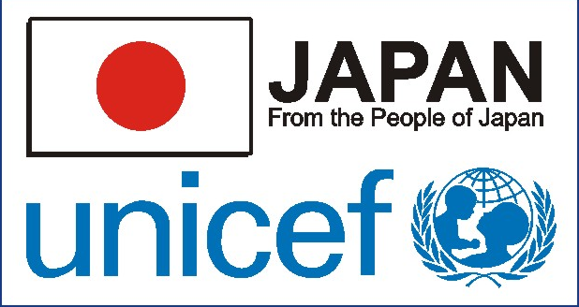

CONTENTS

TEACHER MATERIALS
Teacher Fact Sheet – Definitions (Primary Level)
Teacher Fact Sheet – Germs (Early and Middle Primary Level)
Teacher Fact Sheet – The Basic Facts on Avian Influenza (Early and Middle Primary Level)
Teacher Fact Sheet – Germs (Upper Primary)
Teacher Fact Sheet – The Basic Facts on Avian Influenza (Upper Primary)
Som and Her Friends Power Point
What I Learned Today – Pocket Poultry Cooking Guide
What I Learned Today – Pocket Poultry Guide

EARLY PRIMARY PROGRAMME
1: Germs and the importance of hand washing
2: Som learns about germs
3: The basics of bird flu
4: Ways to prevent the spread of bird flu
5: Bird flu posters

MIDDLE PRIMARY PROGRAMME
1: Germs and viruses
2: The basics of bird flu
3: Routes and prevention of transmission
4: Precaution messages when looking after poultry
5: Bird flu cartoon her story

UPPER PRIMARY PROGRAMME
1: Germ facts
2 & 3: Transmission, prevention and safe poultry
4: Family poultry graph
5: What we can do about bird flu
Teacher Fact Sheet – Definitions:

Antibody A protective protein (molecule) produced in the blood in response a foreign particle (such as a germ).

Asymptomatic There are no symptoms.
Avian Influenza [AI] A viral disease that can be very contagious and even deadly in poultry e.g. chickens. The scientific name for ‘bird flu’. See also Influenza A.

Bacteria A type of germ. A single-celled microscopic organism. Some bacteria can make you sick.

Bird Flu A common name given to Avian Influenza

Biosecurity Any system that prevents the spread of infectious agents from infected to susceptible animals. With reference to avian influenza, biosecurity requires close control over the access of people, animals or materials to the farm or flock.

Contaminate To make something impure by exposure to or addition of a poisonous or polluting substance.

Culling The killing or destroying of living animals. This is one method of eradicating animals that have a disease.

Epidemic A widespread occurrence of a disease. Attacking or affecting many persons simultaneously

Germ A micro-organism, especially one which causes disease. A simple structure that is capable of developing into a complete organism.

Hereditary Derived from ones ancestors. Factors that can be transmitted genetically from one generation to another.

H5N1 The recent avian strain that has been infecting humans. It is a strain of avian influenza A that usually kills poultry, but often does not kill wild birds. H5N1 does not usually infect people, but infections with these viruses have occurred in humans. Most of these cases have resulted in people having direct or very close contact with H5N1-infected poultry or H5N1-contaminated surfaces.

HPAI Highly Pathogenic Avian Influenza. Highly pathogenic refers to a high degree of severity of the disease if contracted by birds or animals.

Incubation Development of disease germs before first symptoms appear.

Infect To contaminate or cause an infection. To pollute.

Influenza A In humans, it is mainly a respiratory virus that usually infects cells of the nose and throat and sometimes lung cells. It spreads when a person touches contaminated surfaces or inhales viruses coughed or sneezed out by an infected person. Influenza A can infect humans, animals and birds. When it infects birds it is called Avian Influenza.

Mortality The number of deaths in a given period.

Mutate To undergo or cause change or alteration. A change in the chromosomes or genes of a cell which may affect the structure and development of the resulting offspring

Pandemic A global infectious disease outbreak, affecting persons over a wide geographical area. An extensive epidemic.

Pathogenic Any agent that can cause disease.

SARS Severe acute respiratory syndrome is a respiratory disease in humans. There has been one major epidemic to date, between November 2002 and July 2003, with over 8000 known cases of the disease and 774 deaths.

Vaccine A substance produced to provide immunity to a disease by stimulating the production of antibodies.

Virus A type of germ that is smaller than bacteria. A virus can also make you sick. A virus is a corrupting or infecting influence. A micro-organism that can cause a variety of diseases when it grows and reproduces in the living cells of another organism.

Wet market A place (permanent or temporary) where community members go to buy and sell small animals and birds. These animals and birds can be (i) live and slaughtered at the market, (ii) live and taken home to be slaughtered, (iii) already slaughtered and sold as meat.
Teacher Fact Sheet – Germs (Early & Middle Primary)

What is a Germ?
Germs are tiny organisms, or living things, that can cause disease. Germs are so tiny that you need to use a microscope to see them. We don’t know they are there until we become sick or show signs of becoming ill.

What Types of Germs Are There?
Germs are found everywhere. There are four major types of germs: bacteria, viruses, fungi, and protozoa. They can invade plants, animals, and people. There are both ‘good’ germs and ‘bad’ germs. ‘Good’ germs are necessary for healthy living. ‘Bad’ germs can sometimes cause illness or in some cases, death.

Bacteria are tiny, one-cell creatures that get nutrients from their environments in order to live. In some cases that environment is a human body. Bacteria can reproduce outside of the body or within the body as they cause infections. Some infections bacteria cause include sore throats, ear infections, and cavities (tooth decay) and pneumonia. . . .
But not all bacteria are bad. Some bacteria are good for our bodies — they help keep things in balance. Good bacteria live in our intestines and help us use the nutrients in the food we eat and make waste from what's left over. Some bacteria are also used by scientists in laboratories to produce medicines and vaccines.

Viruses need to be inside living cells to grow and reproduce. Most viruses can't survive very long if they're not inside a living thing like a plant, animal, or human. Whatever a virus lives in is called its host. When viruses get inside people's bodies, they can spread and make people sick. Viruses cause chickenpox, measles, flu (influenza), and many other diseases. Because some viruses can live for a while on something like a doorknob or countertop, etc., it is important to wash your hands regularly.

Fungi are multi-cell, plant-like organisms. Unlike other plants, fungi cannot make their own food from soil, water, and air. Instead, fungi get their nutrition from plants, people, and animals. They thrive in damp, warm places, and most fungi are not dangerous. An example of something caused by fungi is athlete's foot, an itchy rash that effects feet and toes.

Protozoa are one-cell organisms that love moisture and often spread diseases through water. Some protozoa cause intestinal infections that lead to diarrhoea, nausea, and stomach pain.

What Do Germs Do?
Once germs invade our bodies, they generally stay for a long time. They live on nutrients and energy, and can produce toxins, which are like poisons. Those toxins can cause symptoms of common infections, like fevers, sniffles, rashes, coughing, vomiting, and diarrhoea.

Doctors take and look at samples from sick people, of blood and other fluids under microscopes and/or send these samples to a laboratory for further tests. In this way they can identify which germs are living in our bodies and how they are making us sick.

How Can You Protect Yourself From Germs?
Most germs are spread through the air in sneezes, coughs, or even breaths. Germs can also spread in sweat, saliva, and blood. Some pass from person to person by touching something that is contaminated, like shaking hands with someone who has a cold and then touching your own nose. Important messages to keep from spreading germs, include:
- Cover your nose and mouth when you sneeze
- Cover your mouth when you cough
- Don’t spit
- Wash your hands

Washing hands should take place:
- Every time you cough or sneeze
- Before you eat or prepare foods
- After you use the toilet
- After you touch animals or birds
- After you play outside
- After you visit a sick relative or friend.

Steps for good handwashing:
- Use warm water to wash your hands
- Use soap or ash
- Work up a lather all over your hands, including your wrists, between your fingers and around your nails
- Wash for around 15 – 20 seconds
- Rinse hands and dry with a clean towel

Avian Influenza – Background Information (Early & Middle Primary)

Bird flu is also known as avian influenza. Scientists have named the bird flu virus ‘H5N1’. It is a disease that wild birds and farm birds can get. Farm birds or domestic poultry include chickens, ducks, turkeys, pheasants, geese, pigeons and quails, etc.

Bird-to-bird transmission
Birds generally catch bird flu by coming into contact with infected birds or their faeces, or from water and soil where infected birds have defecated. Bird Flu can be spread very easily among birds. Once birds get this disease, they can become sick and die quickly, usually within 48 hours.

Migration and the spread of bird flu
The migration of is one way the bird flu can be spread. Wild birds can mix with other birds during their seasonal migrations. Some of the migrating birds are carriers of the virus, although they may not show any signs of the disease. Both wild birds and domestic birds that are healthy, can come into contact with the virus.

It is thought that the spread of the virus within countries is also greatly exacerbated by poultry trade.

Bird-to-human transmission
Many households depend on poultry for income and food. Daily contact with poultry is part of daily life. The main route of human infection to date has been through direct contact with infected poultry, or surfaces and objects contaminated with their faeces and other fluids. Furthermore, many families sell or kill and consume birds when signs of illness appear in a flock – this increases exposure through the process of slaughtering, defeathering and preparation of poultry.

To date, the majority of human cases have occurred in rural or periurban areas where many households keep small poultry flocks, which often roam freely, sometimes entering homes or sharing outdoor areas where children play. Opportunities for exposure are greatest here, especially as infected birds shed large quantities of the virus in their faeces.

Countries affected by outbreaks in poultry
From mid-December 2003 through to December 2006, outbreaks have been reported in over 20 countries. Over 150 million birds have died from the disease, either through culling or from the disease.

How to tell if your poultry may have bird flu
The symptoms of Newcastle disease and other bird diseases are very similar to bird flu, so it may be difficult to tell. Bird flu is very contagious and kills birds quickly, therefore if birds show signs of sickness, it should be reported immediately to authorities. Signs of sickness could include:
- Discharge from the nose or eyes
- Lack of energy or appetite
- Watery faeces
- Difficulty breathing
- Not able to walk and stand properly
- Ruffled feathers
- Swelling of head, eyelids, comb, wattles of legs
- Bluish colouring of wattles or combs
- Sudden death

Impact on humans
Two main risks for human health:
- Risk of direct infection when the virus passes from poultry to humans resulting in severe disease and in some cases death.
- If the virus changes into a form that is highly infectious to humans and becomes easily spread from person to person, then such a change could mark the start of a global outbreak (pandemic). Three conditions must be met for a pandemic to occur: a new influenza subtype emerges; it infects humans, causing serious illness; and it spreads easily among humans.

265 human cases have been reported, with more than half of these resulting in death [mid-January, 2007, WHO].

Human cases have been reported in at least 10 countries, including Azerbaijan, Cambodia, China, Djibouti, Egypt, Indonesia, Iraq, Thailand, Turkey and Vietnam

Symptoms of avian influenza in humans have ranged from typical human influenza-type symptoms (e.g. fever, cough, sore throat and muscle aches), to eye infections, pneumonia, severe respiratory diseases and other sever and life-threatening complications. The symptoms of avian influenza may depend on which virus caused the infection.

Vaccines
Vaccines effective against a pandemic virus are not yet available. Vaccines are produced each year for seasonal influenza but will not protect against pandemic influenza. Although a vaccine against the H5N1 virus is under development in several countries, no vaccine is ready for commercial production and no vaccines are expected to be widely available until several months after the start of a pandemic. Because the vaccine needs to closely match the pandemic virus, large-scale commercial production will not start until the new virus has emerged and a pandemic has been declared.

Safe practices for keeping poultry
Avian influenza can occur at any time and any place when there is an outbreak. Limit the number of people responsible for taking care of the poultry farm. If there is any sickness in poultry, alert authorities. Dispose of any dead poultry safely by burying in a pit at least 2 metres deep or burning the carcass. Wear protective clothing such as disposable gloves, mask and eye goggles. Poultry should be housed separately from other birds and animals. All new poultry should be kept separate from existing stocks for 2 weeks to ensure they are not sick (this includes any birds carried to market and then brought back).

Safe consumption of poultry and eggs
Poultry and eggs are safe to eat if handled and prepared in a safe way. Avian influenza is not transmitted through cooked foods. Poultry and eggs should be well cooked (no ‘pink’ meat and no ‘runny’ yolks). Normal temperatures used for cooking (70°C [158°F] in all parts of the food) will kill the virus.

Juices from raw poultry and poultry products should never be allowed, during food preparation, to mix with items eaten raw. When handling raw poultry or raw poultry products, persons involved in food preparation should wash their hands thoroughly and clean and disinfect surfaces in contact with the poultry products Soap and hot water are sufficient for this purpose.

In areas experiencing outbreaks in poultry, raw eggs should not be used in foods that will not be further heat-treated as, for example by cooking or baking.

Never kill and eat sick chickens or sell in the market.

Key Messages to reduce the risk from avian influenza

- Report sick or dead birds to the local authorities. To stop the virus spreading, it is critical that all sudden and unexplained deaths in poultry or wild birds are reported to the authorities so they safely deal with it.

- Keep birds away from children and living areas; keep poultry away from wild birds and separate species. Close contact can put you and your family at risk. Separating species helps prevent transmission, especially from wild birds.

- Wash your hands often with soap and water to kill and remove the virus - especially after handling birds; cooking or preparing poultry products, and before eating. Handwashing should be for 15-20 seconds.

- Eat well-cooked poultry products
- No pink meat
- Make sure the yolk and white of the egg are hard
- Keep raw poultry and eggs away from other foods

- Seek immediate treatment from your local clinic if you have fever after being in contact with sick or dead poultry.

Teacher Fact Sheet – Germs (Upper Primary)

What is a Germ?
Germs are tiny organisms, or living things, that can cause disease. Germs are so tiny that you need to use a microscope to see them. We don’t know they are there until we become sick or show signs of becoming ill.

What Types of Germs Are There?
Germs are found everywhere. There are four major types of germs: bacteria, viruses, fungi, and protozoa. They can invade plants, animals, and people. There are both ‘good’ germs and ‘bad’ germs. ‘Good’ germs are necessary for healthy living.
‘Bad’ germs can sometimes cause illness or in some cases, death.

Bacteria are tiny, one-cell creatures that get nutrients from their environments in order to live. In some cases that environment is a human body. Bacteria can reproduce outside of the body or within the body as they cause infections. Some infections bacteria cause include sore throats, ear infections, and cavities (tooth decay) and pneumonia. . . .
But not all bacteria are bad. Some bacteria are good for our bodies — they help keep things in balance. Good bacteria live in our intestines and help us use the nutrients in the food we eat and make waste from what's left over. Some bacteria are also used by scientists in labs to produce medicines and vaccines.

Viruses need to be inside living cells to grow and reproduce. Most viruses can't survive very long if they're not inside a living thing like a plant, animal, or human. Whatever a virus lives in is called its host. When viruses get inside people's bodies, they can spread and make people sick. Viruses cause chickenpox, measles, flu (influenza), and many other diseases. Because some viruses can live for a while on something like a doorknob or countertop, etc., it is important to wash your hands regularly.

Fungi are multi-cell, plant-like organisms. Unlike other plants, fungi cannot make their own food from soil, water, and air. Instead, fungi get their nutrition from plants, people, and animals. They thrive in damp, warm places, and most fungi are not dangerous. An example of something caused by fungi is athlete's foot, an itchy rash that effects feet and toes.

Protozoa are one-cell organisms that love moisture and often spread diseases through water. Some protozoa cause intestinal infections that lead to diarrhoea, nausea, and stomach pain.

What Do Germs Do?
Once germs invade our bodies, they generally stay for a long time. They live on nutrients and energy, and can produce toxins, which are like poisons. Those toxins can cause symptoms of common infections, like fevers, sniffles, rashes, coughing, vomiting, and diarrhoea.

Doctors take and look at samples from sick people, of blood and other fluids under microscopes and/or send these samples to a laboratory for further tests. In this way they can identify which germs are living in our bodies and how they are making us sick.

How Can You Protect Yourself From Germs?
Most germs are spread through the air in sneezes, coughs, or even breaths. Germs can also spread in sweat, saliva, and blood. Some pass from person to person by touching something that is contaminated, like shaking hands with someone who has a cold and then touching your own nose. Important messages to keep from spreading germs, include:
- Cover your nose and mouth when you sneeze
- Cover your mouth when you cough
- Don’t spit
- Wash your hands

Washing hands should take place:
- Every time you cough or sneeze
- Before you eat or prepare foods
- After you use the toilet
- After you touch animals or birds
- After you play outside
- After you visit a sick relative or friend.

Steps for good handwashing:
- Use warm water to wash your hands
- Use soap or ash
- Work up a lather all over your hands, including your wrists, between your fingers and around your nails
- Wash for around 15 – 20 seconds
- Rinse hands and dry with a clean towel

Science and Medicine:
Doctors or laboratory technicians investigate samples of blood and other fluids under microscopes to determine the types of germs living in our bodies and how they are making us sick. Vaccines can then be produced to prevent the disease. Vaccinations
protect us by giving us only a tiny piece of a disease-causing germ or by giving a version of the germ that is dead or very weak. Giving only this tiny, weakened, or dead part of the germ does not pass on the disease. Instead, just the opposite happens. Our bodies respond to the vaccine by making antibodies. These antibodies are part of our immune system, and they can fight the disease if we come in contact with that particular germ. When our body is protected from a disease in this way, it's called being immune to an illness.

Teacher Fact Sheet – The Basic Facts on Avian Influenza (Upper Primary)

I. WHAT IS INFLUENZA?
Influenza is a viral respiratory infection in humans that is more serious than the common cold. It is commonly called ‘the flu’ and occurs seasonally every year, most often in winter.

II. WHAT IS AVIAN INFLUENZA?
Avian influenza, also known as “bird flu”, is the disease that wild birds and poultry get when they are infected by an avian influenza virus (different from human influenza viruses). There are several types of avian influenza. The strains that cause the greatest number of deaths are called highly pathogenic avian influenza (HPAI). The HPAI strain involved in the current outbreak is called H5N1. Since 2003 H5N1 has been recognized in birds and has spread from Asia to Europe and the Middle East, and now to Africa, affecting over 20 countries. The H5N1 virus spreads very rapidly through poultry flocks and has a mortality rate among infected birds of 90 to 100 per cent, often within 48 hours.

Fortunately, the H5N1 is still a bird virus. It is easily transmissible among birds but currently does not have the right molecules on its surface to enable it to become a human virus. However, it has caused a few human infections, as animal viruses can do without being fully adapted to humans. The H5N1 virus has only caused human infections in a tiny fraction of those exposed to it, and usually requires intense and close exposure to sick birds or their droppings. Children appear to be at increased risk of H5N1 infections and fatality. There is no evidence to date of sustained human-to-human transmission, which is the chain reaction spread of ordinary human seasonal flu.

III. WHAT IS AN INFLUENZA PANDEMIC?
A pandemic is a widespread usually global outbreak of any disease among humans. Pandemic influenza, different from seasonal and avian influenza, is a rare but recurrent event that has occurred every 11 – 42 years in the past few hundred years. Pandemic influenza affects all populations regardless of national boundaries or socio-economic status. Over the past 100 years there have been three pandemics: 1918 (approximately 50 million deaths), 1957 (approximately two million deaths), and 1968 (approximately one million deaths).

IV. WHEN DOES AN INFLUENZA PANDEMIC OCCUR?
Three conditions must be met for a pandemic to occur: a new influenza subtype emerges; it infects humans, causing serious illness; and it spreads easily among humans. The 1918 influenza pandemic was originally an avian influenza virus that underwent a series of mutations that enabled it to become a human virus. The H5N1 virus has undergone some of the same mutations as the 1918 virus. The 1957 and 1968 influenza pandemics emerged from mixing of avian with human influenza viruses rather than by mutation.

Because the H5N1 virus has caused some human infections, it has shown that it has the potential to become a human virus. If it evolves into a human virus (i.e., one that passes easily from person to person), it is likely to cause a human influenza pandemic. Birds will no longer be a concern; people will spread the virus. How the virus will evolve is uncertain: it could happen suddenly; it could take years; or it might never happen.

V. IS THERE A VACCINE FOR THE PANDEMIC?
No. Because the pandemic strain has not emerged, there is no such vaccine currently available. As a pandemic vaccine needs to be a close match to the actual pandemic virus, commercial production for the actual pandemic virus cannot begin prior to the emergence and characterization of the pandemic virus.

Several companies have developed but not yet licensed vaccines for the H5N1 virus. These vaccines for H5N1 would only give partial or no protection against the pandemic strain, as it will differ from the H5N1 that is currently causing the bird outbreaks and the few human cases.

With the technology available today, it would likely take at least six months to produce substantial quantities. Even then, there would not be enough for more than a fraction of the world’s population. Two doses, by injection, are likely to be needed, separated by a 2-4 week interval.

VI. WHY IS IT IMPORTANT TO PREVENT THE SPREAD OF INFECTION IN BIRDS AND FROM BIRDS TO HUMANS?
The more the virus spreads in birds, the more humans are exposed. The more humans exposed to the virus, the greater the chances the avian virus will become a human virus.

VII. DO MY POULTRY HAVE BIRD FLU?
The symptoms of Newcastle disease and other bird diseases are very similar to bird flu, so it may be difficult to tell. Bird flu is very contagious and kills birds quickly, therefore if birds show signs of sickness, it should be reported immediately to authorities. Signs of sickness could include:
- Discharge from the nose or eyes
- Lack of energy or appetite
- Watery faeces
- Difficulty breathing
- Not able to walk and stand properly
- Ruffled feathers
- Swelling of head, eyelids, comb, wattles of legs
- Bluish colouring of wattles or combs
- Sudden death

Safe practices for keeping poultry
Avian influenza can occur at any time and any place when there is an outbreak. Limit the number of people responsible for taking care of the poultry farm. If there is any sickness in poultry, alert authorities. Dispose of any dead poultry safely by burying in a pit at least 2 metres deep or burning the carcass. Wear protective clothing such as disposable gloves, mask and eye goggles. Poultry should be housed separately from other birds and animals. All new poultry should be kept separate from existing stocks for 2 weeks to ensure they are not sick (this includes any birds carried to market and then brought back).

Safe consumption of poultry and eggs
Poultry and eggs are safe to eat if handled and prepared in a safe way. Avian influenza is not transmitted through cooked foods. Poultry and eggs should be well cooked (no ‘pink’ meat and no ‘runny’ yolks). Normal temperatures used for cooking (70°C [158°F] in all parts of the food) will kill the virus.

Juices from raw poultry and poultry products should never be allowed, during food preparation, to mix with items eaten raw. When handling raw poultry or raw poultry products, persons involved in food preparation should wash their hands thoroughly and clean and disinfect surfaces in contact with the poultry products Soap and hot water are sufficient for this purpose.

In areas experiencing outbreaks in poultry, raw eggs should not be used in foods that will not be further heat-treated as, for example by cooking or baking.

Never kill and eat sick chickens or sell in the market.

VIII. WHAT IS THE IMPACT OF AVIAN INFLUENZA?
To date, the virus and culling to stem its spread, has destroyed over 150 million domestic poultry in over 20 countries. The economic impact from the loss of poultry is substantial, estimated – over US $10 billion globally. [January 2006, FAO data]

From mid-December 2003 through to December 2006, outbreaks in poultry or wild birds have been reported in over 20 countries.

In addition to the toll on birds, 265 human cases have been reported in at least 10 countries and killed159 since 2003. Countries reporting human cases include Azerbaijan, Cambodia, China, Djibouti, Egypt, Indonesia, Iraq, Thailand, Turkey and Vietnam.

Symptoms of avian influenza in humans have ranged from typical human influenza-type symptoms (e.g. fever, cough, sore throat and muscle aches), to eye infections, pneumonia, severe respiratory diseases and other sever and life-threatening complications. The symptoms of avian influenza may depend on which virus caused the infection.

The future potential impact of a pandemic is hard to predict, but there will be increased illness because humans will have no immunity to the new virus. Mortality rates are likely to be increased and there may be social and economic disruptions. Children will be directly impacted by infections as well as by the potentially catastrophic social and economic dislocations of a pandemic.

The most immediate economic impacts of a pandemic might arise not from actual death or sickness but from the uncoordinated efforts people will take to avoid becoming infected. This at least was the experience during SARS, when people tried to avoid infection by minimizing face-to-face interactions, resulting in greatly reduced demand for services sectors such as tourism, mass transportation, retail sales, hotels and restaurants, as well as a shortage of essential services and products due to workplace absenteeism, disruption of production processes and shifts to more costly procedures. Additional economic disruption and costs may be caused by emergency public policy measures such as quarantines and restrictions on domestic and international travel and trade.

Key Messages to reduce the risk from avian influenza

- Report sick or dead birds to the local authorities. To stop the virus spreading, it is critical that all sudden and unexplained deaths in poultry or wild birds are reported to the authorities so they safely deal with it.

- Keep birds away from children and living areas; keep poultry away from wild birds and separate species. Close contact can put you and your family at risk. Separating species helps prevent transmission, especially from wild birds.

- Wash your hands often with soap and water to kill and remove the virus - especially after handling birds; cooking or preparing poultry products, and before eating. Handwashing should be for 15-20 seconds.

- Eat well-cooked poultry products
- No pink meat
- Make sure the yolk and white of the egg are hard
- Keep raw poultry and eggs away from other foods

- Seek immediate treatment from your local clinic if you have fever after being in contact with sick or dead poultry.

Avian Influenza – Migration (Upper Primary)

The Migration Factor
Avian influenza or bird flu is a highly contagious disease that affects poultry. Once infected, both domestic and wild birds (including chickens, ducks, geese, turkeys and quail) can become sick and die. Scientists call the virus H5N1. The virus has been largely spread through the migration of wild birds and has spread from Asia to Europe, the Middle East and to Africa, affecting at least 20 countries. The main issue at this stage is to prevent bird-to-bird and bird-to-human transmissions, because if these do not become common, then the virus has less chance to evolve (change) into a human-to-human virus which could cause a lot of sickness and death.
Cases of avian flu in migratory birds that fly along what is known as the East Asia/Australian Flyway (a complicated web of flight paths rather than a single route) have generated substantial concern in the health community. Even if migratory birds do not directly infect people, spreading the virus to domestic birds around the world could have disastrous results. The World Health Organization, the United Nations Food and Agriculture Organization, and other leading international organizations have cited migratory birds as a significant source of concern. Yet they have also noted that attempting to control avian migration is not a realistic option.

The map (below) shows the major flyways of migratory birds.

Experts however, are not uniform in their views on the role that migratory waterfowl might play in spreading H5N1 to other species. One of the greatest fears is that infected migratory birds could pass avian flu to humans, especially through their droppings. Migratory birds travel tremendous distances, and countless humans and other mammals could be exposed to the virus.

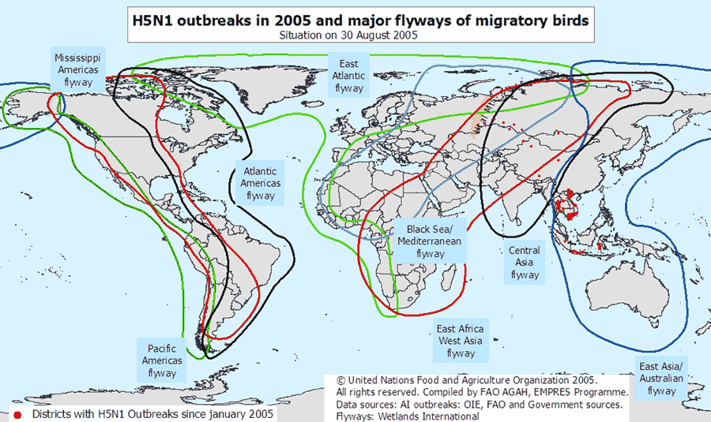

The Human Factor
The exact role that migratory birds have played and will play in the spread of avian flu is still uncertain. What remains undisputed is that millions of cases of H5N1, along with nearly every instance of transmission to humans, have been traced to domestic poultry. Regardless of the level of risk posed by avian migration, human trade -- and illegal trafficking -- of birds can foment the spread of avian flu. While domestic birds are limited in their ability to move themselves over large distances, they are easily transported -- in small and large numbers, by hand or by truck -- from town to town, city to city, and nation to nation. The map (below) indicates prominent land trade routes in Southeast Asia, including regions that have seen outbreaks of H5N1. What is clear on the map is that the overwhelming majority of human cases have occured along these trade corridors.
If the trade and associated transport of birds is a key factor in the spread of avian flu, land routes are not the only potential sources for spreading the virus. In 2004, Indonesia became the first country outside of the Southeast Asian mainland to report cases of H5N1. While it is certainly possible that migrating birds may have carried the virus to Indonesia, the government there has not been aggressive in culling domestic chicken flocks or imposing biosecurity measures to limit the movement of infected chickens, so trade is likely to play a role in the spread of the disease within Indonesia.

As a result, researchers are paying close attention to H5N1's geographical spread. The mechanism of the spread is unclear, however, and hotly debated. Some argue that migratory birds will have more influence on the spread of H5N1 whilst others argue that human trade in birds is a more likely route for the virus.

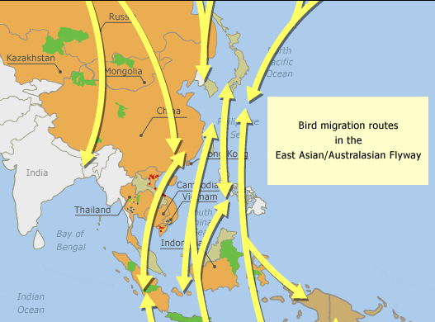

Early Primary Programme

ACTIVITY NO. 1 | ACTIVITY NAME: Germs and the importance of hand washing  Time: 30 minutes

OBJECTIVES:
At the end of the lesson students will be able to:
- State what a germ is
- Understand that germs are present even though we cannot see them
- Explain the importance of washing hands with soap and water
- Demonstrate how to wash hands properly

CURRICULUM FOCUS/ES:
- Health
- Language/Arts
- Science

MATERIALS NEEDED:
- Glitter and handcream (note: if glitter and handcream are not available, use a small amount of cooked potato or cooked rice)
- Access to water and soap
- Paper towel (or dry cloth)

WHAT YOU NEED TO KNOW! | - What germs are  - The importance of washing hands with soap (ash) and water  - How to wash hands thoroughly  [Refer to Teacher Fact Sheet – Germs: Early and Middle Primary Level]

PROCEDURE | - Ask the students: What are germs? How big are they? Are germs good or bad for you?  - Explain to students that germs cause diseases, and even though we can’t see them, they are present everywhere. Although we can’t see germs, we will pretend that the glitter pieces (or rice/potato if used) are all germs and see what happens in this activity. Put a small amount of handcream on each student’s hands and tell them to rub it into the palms and backs of their hands. Pour a small amount of the glitter onto each student’s hands and again tell them to rub their hands to spread the glitter evenly all over their hands. (If using rice or potato, put a small amount on each student’s hands and ask them to rub their hands to spread it evenly over their hands. It is not necessary to use the handcream first).  - Ask a few of the students to use the paper towel or dry cloth to wipe their hands clean  - Ask a few others to use only cold water to get their hands clean  - Now ask all the students to wash their hands with soap and warm water  - Note: Demonstrate good hand washing practices with the students  - When students are back in their seats, ask:  - What did the glitter (or potato / rice represent)? [germs]  - What happened when you tried to clean your hands with the paper towel or dry cloth? [difficult to remove]  - What happened when using cold water? [difficult to get hands properly clean]  - Was it easy to get your hands clean using the towel of cold water? [no]  - What happened when you used the soap and warm water? [easy to clean hands]  - Why do you think it is important to wash your hands properly? [To have clean hands and stop the spread of germs]  - What do you think happens if you do not wash your hands properly? [We transfer germs to other people or we may become sick from the germs]  - Ask students to either draw a picture or write 1 – 2 sentences about germs and the importance of washing hands properly.

ASSESSMENT | Informal assessment based on the following outcomes:  - Students will be able to explain what a germ is and that they can make you sick  - Students will understand that germs can remain (and be spread) by not properly washing their hands  - Students will demonstrate how to wash their hands properly with soap and water

IDEAS TO EXTEND | Think about your home. Is soap or ash available for you and other family members to wash their hands?  - If yes, how will you remind yourself and others to wash their hands properly to get rid of germs?  - If no, who will you ask when you go home about getting soap or ash to wash your hands?
Early Primary Programme 2

ACTIVITY NO. 2 | ACTIVITY NAME: Som learns about germs  Time: 30 minutes

OBJECTIVES:
At the end of the lesson students will be able to:
- Identify times when it is important to wash hands with soap and water
- Know that bad germs can make you sick
- List places where germs can be

CURRICULUM FOCUS/ES:
- Health
- Science
- Language

MATERIALS NEEDED:
- Story: “Som and Her Friends Learn About Germs”

WHAT YOU NEED TO KNOW! | - The times when it is important to wash hands  - The importance of washing hands with soap (ash) and water  [Refer to Teacher Fact Sheet – Germs: Early and Middle Primary Level]

PROCEDURE | - Ask the students: What did you learn (what can you remember) from our lesson on germs and handwashing? If students miss some important points, remind them of these  - Read the students the story “Som and Her Friends Learn About Germs”  - Ask the students:  - What happened in the story?  - When did Som wash her hands?  - What happened to Som’s friend Ake ? [ he got sick]  - Why do you think Ake got sick? Encourage students to talk about the spreading of germs and the places Ake might have picked up ‘bad’ germs.  - When should have Ake washed his hands? List all the times this should take place and why it is important to do so.  - Hold a general discussion encouraging responses from as many of the students as possible, using the following prompt questions:  - Do you have germs on you? [yes] On the desk? [yes], On your pencil? [yes]  - Where else might you find germs? Get responses from several students and then explain to students that germs are everywhere.  - How do you think germs get inside our body? [mouth, nose, eyes, cuts, etc.]  - How do you know if a bad germ gets inside your body? [you may feel sick and pass on the sickness to others]  - Ask students to work in pairs and explain to each other what you would say to Ake about germs and handwashing.  - Move around the room listening to the students and their explanations  - If time allows, ask 1 – 2 pairs to share some of their explanations with the whole class.

ASSESSMENT | Informal assessment based on the following outcomes:  Informal assessment based on the following outcomes:  - Students will be able to list times when it is important to wash their hands and why  - Students will be able to explain to each other how you can ‘catch’ bad germs and that they can make you sick  - Students will be able to state why it is important to wash hands to get rid of germs

IDEAS TO EXTEND | Make a list of the times that you or your family members wash their hands.  - Are there times when you forget to wash your hands?  - How can you remind yourself and your family members to wash their hands?  - Try out at least one of these ways to remember to wash hands when you go home.

Early Primary Programme

ACTIVITY NO. 3 | ACTIVITY NAME: The basics of bird flu  Time: 30 minutes

OBJECTIVES:
At the end of the lesson students will be able to:
- Know basic facts about bird flu
- Identify ways that farm birds can get bird flu
- Identify ways that humans may get bird flu
- Complete a “fill-in-the-gaps” (cloze) activity outlining key facts about bird flu

CURRICULUM FOCUS/ES:
- Health
- Science
- Language

MATERIALS NEEDED:
- Bird Flu “prompt cards” (included below)
- Fill-in-the-gaps (cloze) exercise (included below)

WHAT YOU NEED TO KNOW! | - Key facts about ‘bird flu’ (avian influenza)  - Avian influenza is a deadly disease that can affect wild birds, domestic poultry as well as human beings  - Germs carry disease and this can be passed on from animal to human contact and from human to human contact  - The importance of washing hands with soap (as) and water  [Refer to Teacher Fact Sheet – Avian Influenza: Early and Middle Primary Level]

PROCEDURE | - Remind students that in the last 2 lessons, we have been learning about germs and when to wash out hands. Ask the students: What do you know now about germs and handwashing? Take several responses from different students. Emphasize that germs cause disease and that proper washing of hands with soap and water is one of the best ways to prevent bad germs from spreading and making us sick.  - Explain that this lesson will be on ‘bird flu’. Ask students if they have ever heard of this and if so, what do they know. List these briefly on the board.  - Using the “prompt cards”, explain to students about ‘bird flu’ (avian influenza). After showing each prompt card, encourage discussion on the statements and pictures shown. Simplify any of the words used so students understand the statements and messages. Ask the students if they have any questions or comments.  - Activity: Students work either individually or in pairs, to complete a “fill-in-the-gaps” (cloze) activity. See below for directions.  - Encourage students who finish before the others to draw a picture showing what they know about ‘bird flu’.  - When students have finished, read through the exercise with the whole class, filling in the gaps as you go.

ASSESSMENT | Informal assessment based on the following outcomes:  - Students will learn and be able to discuss key facts about bird flu  - Students will complete a language activity on key information about bird flu

IDEAS TO EXTEND | Students draw a picture showing what they now know about ‘bird flu’ (step 5 above)

PROMPT CARDS – What is Bird Flu?

# 1

Bird flu is also known as avian influenza. It is a disease that wild birds and farm birds can get. What are some of the names of farm birds you know?

Bird flu can be spread very easily among birds. Once birds get this disease, they can become sick and die quickly.

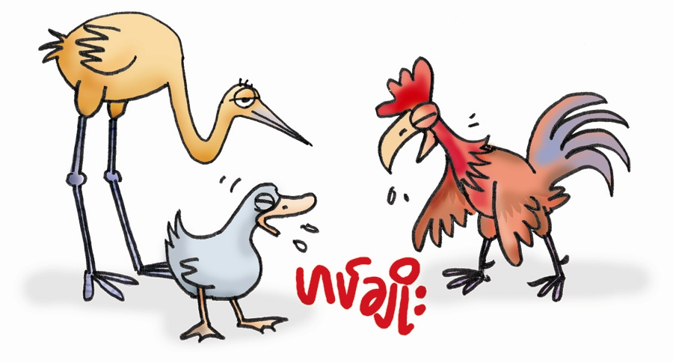
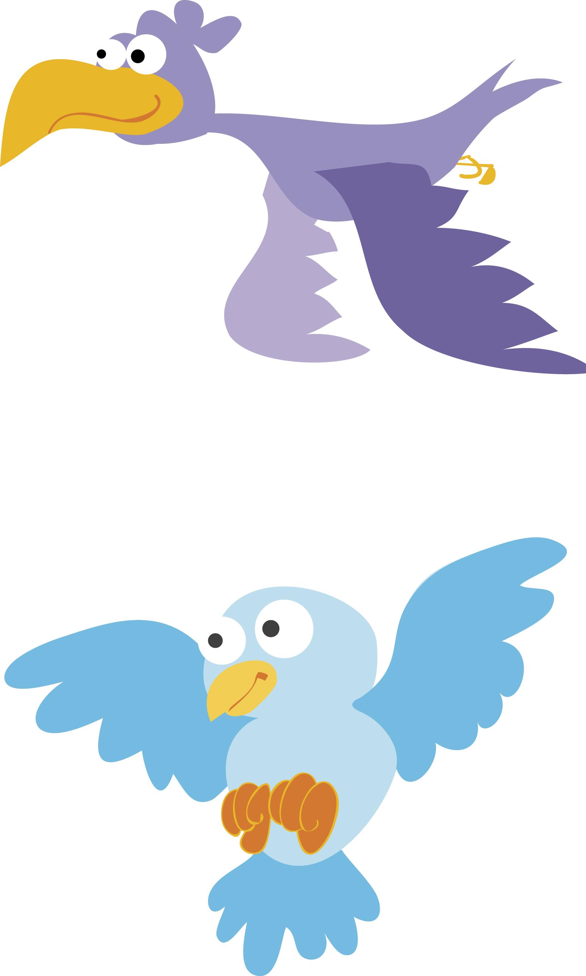

# 2

Bird flu can be passed on from one bird or animal to another, such as cats and dogs and pigs. Ducks can also get the disease without looking sick. But they can still pass it on to chickens and other domestic birds.

Chickens, ducks and other birds can also pick up the disease from contaminated (bad) soil or water through their feet and feathers.

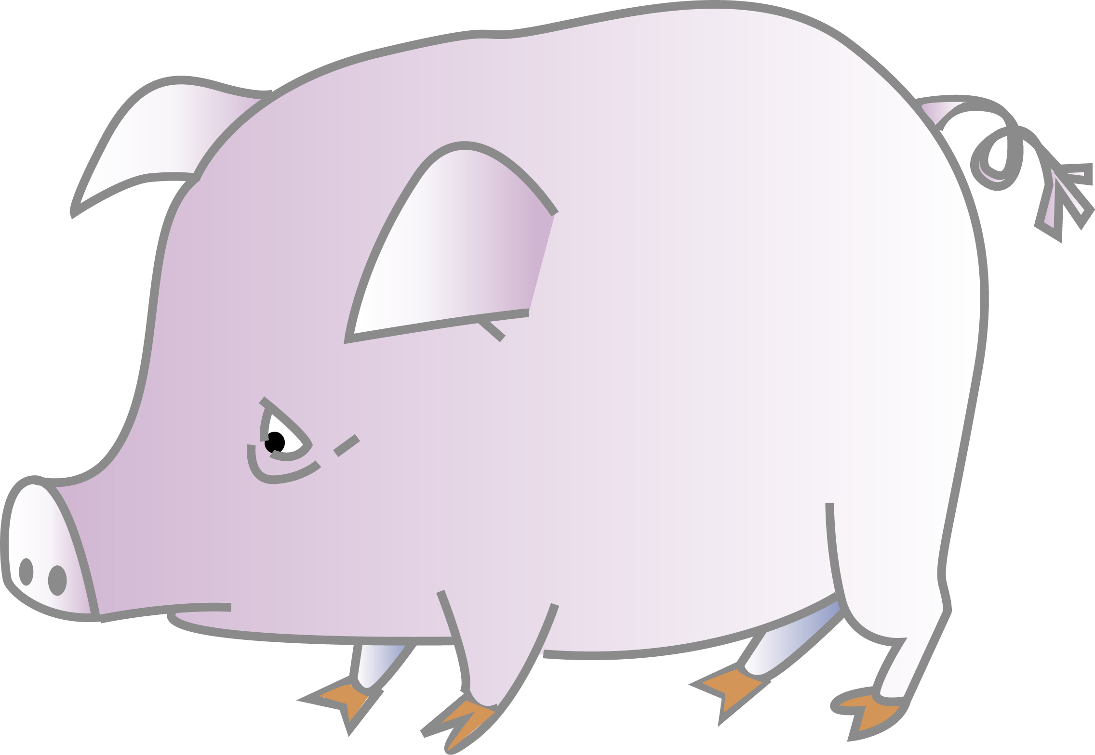
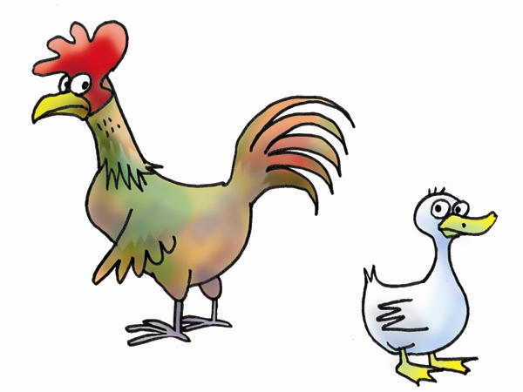

# 3

Humans can also get the bird flu by touching live birds or dead birds, especially through their manure (faeces), urine, nasal fluids, saliva, feathers, internal organs or blood.

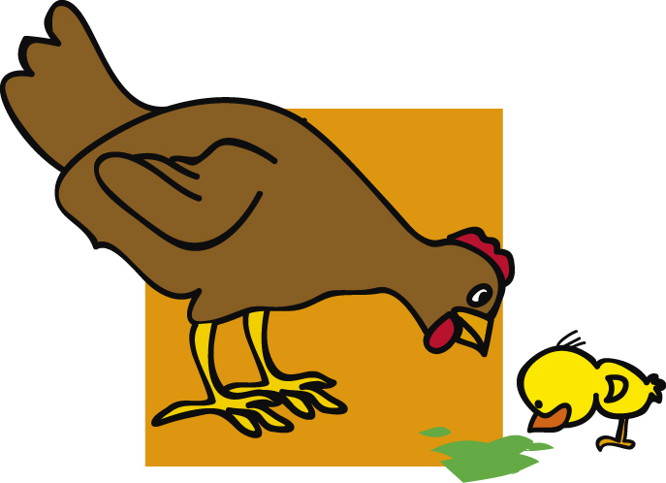
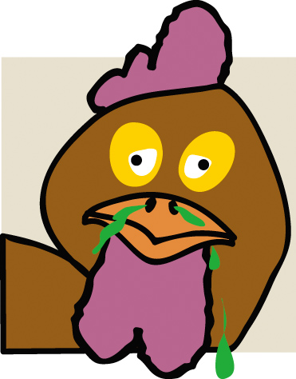
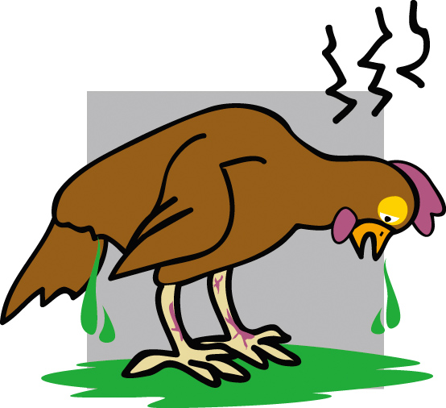

# 4

Bird flu can enter your home and living areas through infected poultry droppings or contaminated (bad) soil brought in on shoes, clothes, or in dirty cages. The disease can also enter your home and living areas on the wheels of bicycles, motorcycles, cars or on tools and other farm equipment.

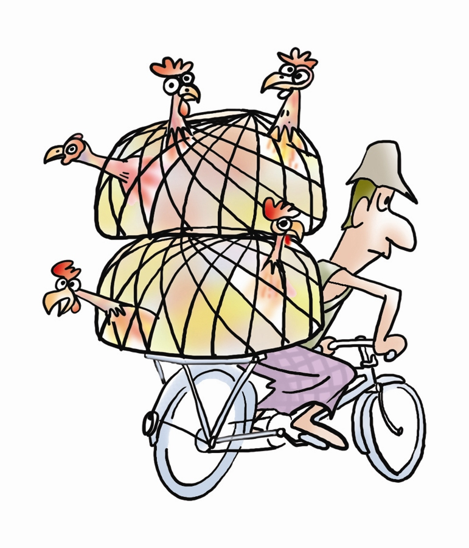

# 5

Chicken and other farm birds and eggs, must be well-cooked before being eaten. Knives and surfaces used to prepare chicken and eggs should be cleaned properly.

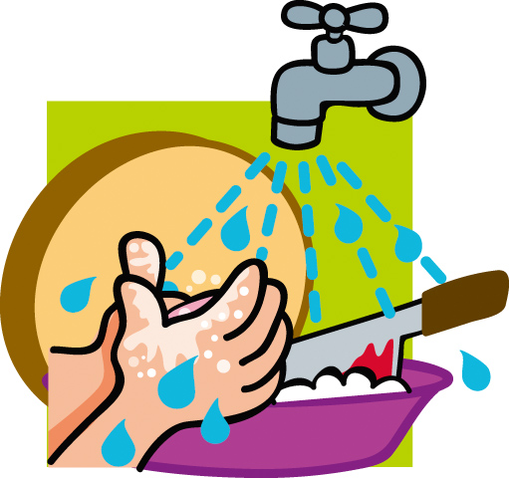
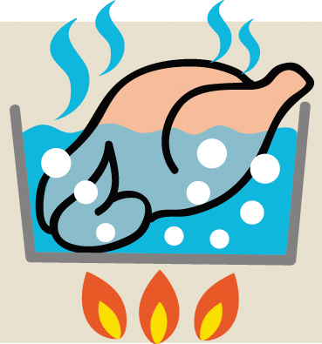

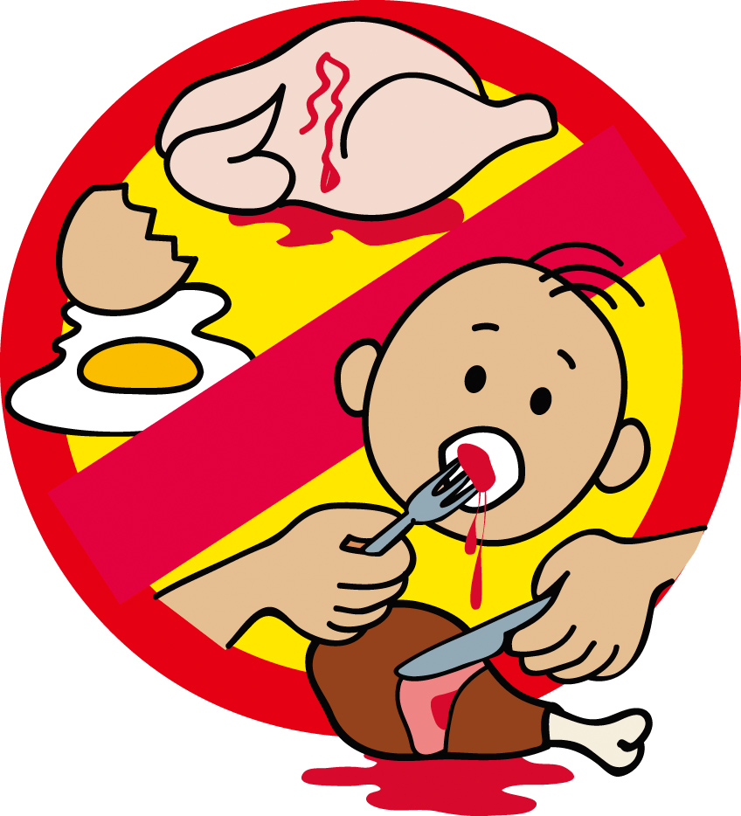

# 6

The biggest risk of getting bird flu is by touching infected farm birds. Hands that have the disease (germs) can carry it into your body through your mouth, nose or eyes. It is very important to wash hands properly with soap and water after touching animals and birds.

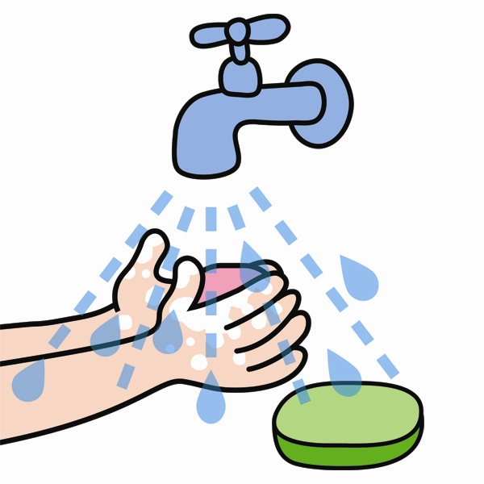
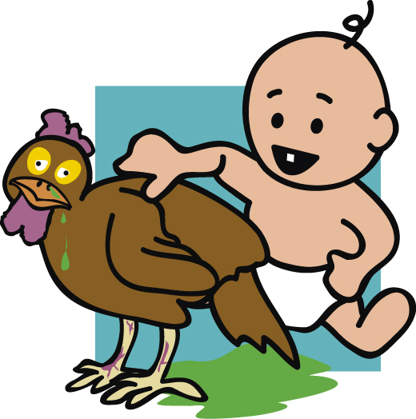

Fill-in-the-gaps (cloze) activity:
For this activity, students can work individually or in pairs. Depending on your resources either give each pair a handout of the cloze activity or if this is not possible, write the activity on the board and ask students to complete in their workbooks.
Encourage students who finish quickly to draw a picture showing what they know about bird flu.

Note: Depending on the level of the students, you can give a choice of words (in brackets) to assist them. If this is not necessary, just omit. Statements 1 – 4 have word choices listed in brackets as an example. Encourage the students to think about the statements carefully. It is not necessary that they list all the ‘answers’ (such as in statement # 8). The answers to the activity are given underneath.

Bird Flu: fill-in-the-gaps

- Bird Flu is something that ______________ (ants, chickens, trees) can get.

- This disease can be very ______________ (easy, hard) to spread among birds.

- If a bird gets Bird Flu it can become __________ (happy, sad, sick) and die.

- Chickens and ducks can get Bird Flu from other sick birds, or from soil or water through their feet and ________ (the sun, their feathers, the rain).

- Humans can also get Bird Flu by _______ live or dead birds.

- It is important to ______________ after touching animals and birds.

- Hands that have bad germs can carry it into your body through __________

- Bird Flu can also enter your home and living areas through ___________

Cloze (completed):
      - Bird Flu is something that chickens can get.

      - This disease can be very easy to spread among birds.

      - If a bird gets Bird Flu it can become sick and die.

      - Chickens and ducks can get Bird Flu from other sick birds, or from soil or water through their feet and their feathers.

      - Humans can also get Bird Flu by touching live or dead birds.

      - It is important to wash hands with soap and water after touching animals and birds.

      - Hands that have bad germs can carry it into your body through your mouth, nose or eyes.

      - Bird Flu can also enter your home and living areas through infected poultry droppings, bad soil brought in on shoes, clothes, in dirty cages, on bicycle / motorcycle / car wheels, and other farm equipment.

Early Primary Programme

ACTIVITY NO. 4 | ACTIVITY NAME: Ways to prevent the spread of bird flu  Time: 30 minutes

OBJECTIVES:
At the end of the lesson students will be able to:
- Identify ways of preventing the spread of bird flu
- Identify safe ways of handling poultry
- Discuss important bird flu messages

CURRICULUM FOCUS/ES:
- Health
- Language and Arts

MATERIALS NEEDED:
- Story “What I Learned Today – Pocket Poultry Cooking Class”
- Role play

WHAT YOU NEED TO KNOW! | - Safe ways of looking after, handling and preparing poultry and eggs  - Key prevention messages to stop the spread of bird flu  [Refer to Teacher Fact Sheet – Avian Influenza: Early and Middle Primary Level]

PROCEDURE | - Briefly ask the students: What did you learn (what can you remember) from our lesson about Bird Flu? Remind students of the ‘prompt cards’ and the pictures that were discussed. If students miss some important points, remind them of these.  - Read the story: “What I Learned Today – Pocket Poultry Cooking Class” to the students. Show them the pictures as you read.  - When you have finished the story, ask students the following questions:  - Which parts of the story did you like the most? Why?  - What important things (messages) did you learn from the story about cooking and eating chicken?  - What important things (messages) did you learn from the story about keeping chickens?  - What else can you do to keep safe?  - How will you do this?  - Discuss further questions as a group: Do you or any of your friends or family members keep chickens or other domestic birds? Who usually looks after them? Who does the cooking in your home? Do you sometimes help? When should you wash your hands when looking after or preparing poultry? Take several responses from different students. Add any key points not stated.  - Role play activity: “Protect yourself, your family and your birds”.  - Ask some students to volunteer to be in the role play. Allocate each student one of the student lines. These are numbered.  - Read the role play to the rest of the class.  - When completed, ask different students to volunteer to say the lines. One of the students can even play the ‘teacher’ role.  Note: If it’s not possible for all students to have a copy of the role play, share between pairs or threes, or write it up on the board so everyone can see.

ASSESSMENT | Informal assessment based on the following outcomes:  - Students able to discuss key points of the story, their favourite parts and what happened in the story  - Students able to identify key messages when looking after or handling poultry

IDEAS TO EXTEND | Teacher could assist or support students to:  - Practise the role play in small groups or in pairs (one student plays the teacher and one student plays all student roles). You can also develop actions to go with each of the statements and do these when you are saying the lines. Teach (or play) the ‘role play’ with your family or friends at home.  - Draw a picture (or pictures) to illustrate the role play.

Role Play: “Protect yourself, your family and your birds”

Teacher: If your family keeps poultry, remember . . . .

Student (1): Don’t touch poultry unless you have to.

Student (2): Keep farm birds away from wild birds

Teacher: If one of your birds looks sick, remember . . .

Student (3): Keep them away from the rest of the birds or other animals.

Student (4): Don’t touch them.

Student (5): Don’t eat them.

Student (6): Don’t sell them.

Teacher: If you find a dead bird or animal, remember . . .

Student (7): Don’t move or touch it.

Student (8): Tell an adult where you saw the dead bird or animal.

Teacher: If you get new poultry, remember . . .

Student (9): Keep them away from your old poultry for at least 2 weeks.

Teacher: Healthy chickens are safe to eat. But remember . . .

Student (10): To cook them really well.

Teacher: Eggs are safe to eat. But remember . . .

Student (11): To fry or boil them well.

Early Primary Programme

ACTIVITY NO. 5 | ACTIVITY NAME: Bird flu posters  Time: 30 minutes

OBJECTIVES:
At the end of the lesson students will be able to:
- Recall key messages about germs and bird flu
- Express a key message about germs or bird flu in a colourful poster
- Discuss ways to pass on health messages to friends and family members

CURRICULUM FOCUS/ES:
- Health
- Science
- Language and Arts

MATERIALS NEEDED:
- Paints, crayons and/or pencils (depending on resources available)
- sheets of paper (large if available)

WHAT YOU NEED TO KNOW! | - Basic facts about germs  - Basic facts about bird flu (avian influenza)  [Refer to Teacher Fact Sheet – Germs and Teacher Fact Sheet – Avian Influenza: Early and Middle Primary Level]

PROCEDURE | - Revise the key messages learnt in the last 4 lessons with students:  - Ask students to recall all the important things they have learnt about germs, disease and bird flu. Encourage students to make the link between germs and disease and the spreading of disease such as bird flu.  - Add any key points they may have forgotten.  - Activity: Depending on resources and the size of the class, get students to either (a) work in small groups, (b) work in pairs, or (c) work individually.  - Give each group/pair/individual one statement and ask them to design a poster illustrating the statement. Note: Use the statements the students have just given (step 1) and/or use the statements listed in this lesson (see below)  - Students should clearly write their statement under their picture  - Allow students access to paints, crayons or pencils (depending on resources available)  - Encourage students to draw big colourful pictures so that everyone will be able to see them and know what to do to help prevent bird flu.  - Display the posters either in the classroom (or outside the classroom for other students to see). Encourage students to look at these and refer to them as they enter or leave class each day. This will help them remember important messages PLUS be able to remind other family members and friends about bird flu.  - When students have finished their posters, ask: What are some of the things you can do to help your family know more about bird flu? Allow students to give as many ideas as they can think of. Some examples might include:  - tell them what you have learnt about bird flu  - re-tell the story “Som and Her Friends Learn About Germs” to family and friends  - remember what you have learnt when you look after your poultry  - help your brothers and sisters to understand the importance of washing hands with soap and water and when to do so  - demonstrate good handwashing practices to others  - Encourage students to do some of these things at home and to tell you what they have done to alert others about bird flu and the importance of handwashing.

ASSESSMENT | Informal assessment based on the following outcomes:  - Students able to identify key messages for preventing the spread of germs  - Students able to identify key messages about bird flu  - Students able to express a message about bird flu in a poster and to explain it. [Teacher should ask questions about the poster students are making as he/she walks around classroom assisting them if necessary]

IDEAS TO EXTEND | Encourage students to do a different activity outside school each week – one that passes on a bird flu message. In class time, allow opportunities for students to share what they have done to spread bird flu messages to others.

Statements about Bird Flu

- Wash your hands with soap and water before eating.

- Wash your hands with soap and water after coughing and sneezing.

- Wash your hands after going to the toilet.

- Cover your mouth and nose when coughing and sneezing.

- Make sure eggs and poultry are well-cooked.

- Wash your hands with soap and water before and after handling eggs and poultry.

- Keep all cooking and eating places clean.

- If someone you know becomes sick with Bird Flu symptoms, make sure they see a doctor or health person.

- Don’t spit.

- Don’t touch or move sick or dead birds.

- Keep poultry away from wild birds.

Middle Primary Programme

ACTIVITY NO. 1 | ACTIVITY NAME: Germs and viruses  Time: 30 minutes

OBJECTIVES:
At the end of the lesson students will be able to:
- State what a germ and virus are.
- Understand that germs are present even though we cannot see them
- Explain how germs can be spread and ways to prevent this spread
- Explain the importance of washing hands with soap and water
- Demonstrate how to wash hands properly

CURRICULUM FOCUS/ES:
- Health
- Science
- Language and Arts

MATERIALS NEEDED:
- Soap, water
- Spray bottle filled with water
- Access to water and soap
- Paper towel (or dry cloth)
- Story: “Som and Her Friends Learn About Germs”

WHAT YOU NEED TO KNOW! | - What germs are and how they can be spread  - The importance of washing hands with soap (ash) and water and the times when it is important to do so  - How to wash hands thoroughly  - Key messages to prevent spreading germs and getting sick  [Refer to Teacher Fact Sheet – Germs: Early and Middle Primary Level]

PROCEDURE | - Ask students: What do you know about germs?  - Write all answers on the board (brainstorm) as many responses as possible  - Clarify any incorrect responses as you go and draw out further information from students. You can do this by prompting students with questions such as: What do you mean? Can you tell me more? How do you know this?, etc.  - Explain that there are 4 major types of germs – bacteria, viruses, fungi and protozoa. Bad germs can cause diseases that make us sick. One disease caused by germs is the flu. Ask:  - What is the word ‘flu’ short for? [influenza]  - Have you had the flu? How does it make you feel?  - Read the story: “Som and Her Friends Learn About Germs” to the students (or if there are enough copies ask the students to read the story together in pairs).  - Ask the students: What happened in the story? Go through the sequence of events from the beginning to the end. Then ask the students:  - When did Som wash her hands?  - What happened to Som’s friend Ake? [ he got sick, he has the flu]  - Why do you think Ake got sick? Encourage students to talk about the spreading of germs and the places Ake might have picked up ‘bad’ germs.  - When should have Ake washed his hands? Why?  - Emphasize how easily it is to spread germs and explain that in the next activity we will look at how this can be done.  - Activity: Use a spray bottle filled with water to demonstrate how germs can be spread through sneezing or having dirty hands. Wet each student’s hands using the spray bottle. Ask them to touch a variety of surfaces throughout the classroom. [each student should have left several wet handprints in the room]. Ask students:  - What does this activity show you? [that the water was present on our hands to make a wet handprint on several surfaces – germs can spread just as quickly and in the same way by touching]  - Where are germs found? Encourage students to list a variety of places and emphasize that germs can be found everywhere.  - How can we prevent the spread of germs from our hands or from sneezing and coughing?  - Emphasise the following key messages:  - Wash hands frequently. Use soap and water and wash hands for 15 seconds.  - Cover your nose and mouth with a tissue when coughing and sneezing.  - Don’t spit.  - Ask students to explain the process of washing their hands properly. Have students demonstrate the process, using soap and water if you have access or acting out the process. Remind students that if it is difficult for them to get soap, that ash can also be used instead.

ASSESSMENT | Informal assessment based on the following outcomes:  - Students will be able to explain what germs are  - Students will demonstrate how to wash their hands properly with soap and water and when it is important to do so  - Students will be able to explain the spread of germs and how to prevent this

IDEAS TO EXTEND | Think about your home. Is soap or ash available for you and other family members to wash their hands?  - If yes, how will you remind yourself and others to wash their hands properly to get rid of germs?  - If no, who will you ask when you go home about getting soap or ash to wash your hands?  - Students tell at least one family member about they have learnt in this lesson when they go home.  Activity: students illustrate how germs spread and what can be done to prevent this. Allow students to do this through (a) writing a paragraph on the process, or (b) drawing a picture of the process.

Middle Primary Programme

ACTIVITY NO. 2 | ACTIVITY NAME: The basics of bird flu  Time: 30 minutes

OBJECTIVES:
At the end of the lesson students will be able to:
- Identify ways of keeping poultry safe from bird flu
- Discuss why it is important to wash hands with soap and water after handling or preparing poultry and eggs
- List ways of preparing poultry and eggs for eating
- Write a poem or prepare a song reflecting safe poultry and egg practices

CURRICULUM FOCUS/ES:
- Health
- Science
- Language

MATERIALS NEEDED:
- Story: “What I Learned Today – Pocket Poultry Guide”

WHAT YOU NEED TO KNOW! | - Key facts about Bird flu (avian influenza)  - How to keep poultry safe from bird flu  - Bird-to-bird transmission of bird flu  - Bird-to-human transmission of bird flu  - How to handle and prepare poultry and eggs for consumption  - The importance of washing hands with soap (ash) and water  [Refer to Teacher Fact Sheet – Avian Influenza: Early and Middle Primary Level]

PROCEDURE | - Ask students to list the important things they learnt from the last lesson on germs, getting sick, and how to stop germs spreading. Revise key points by asking: When do you think it is important for you, your friends and family members to wash their hands? Make a list on the board, e.g.:  - before eating, before preparing food, after coughing or sneezing, after the toilet, after playing with animals or birds, etc.  - Ask: Do you or any of your friends or family members keep chickens or other farm (domestic) birds? Who usually looks after them?  - Now ask: Have you heard of bird flu (avian influenza)? If students have, ask them to tell the class what they know.  - Read the students the story “What I Learned Today – Pocket Poultry Guide”. Show the pictures as you read.  - When you have finished the story, ask students the following questions:  - What did you learn about in this story?  - What parts did you like in the story? Why?  - What important things (messages) did you learn from the story about keeping poultry?  - Why should you keep poultry separate from other birds and animals?  - Should you wash your hands after handling poultry? Why is this important?  - If you don’t wash your hands what might happen?  - Reflect on the earlier questions asked about who keeps chickens and looks after them. Ask students:  - When you look after chickens, what do you do?  - Do you and your family eat chicken or eggs? Who usually prepares these? How are the chicken and eggs cooked in your home?  - Note: Encourage students to give details and be specific with their answers. Add any key points not stated and emphasize the following:  - Ask students to work in pairs and make up a short poem or song about safe handling or preparing of poultry and eggs.
  Chickens and eggs are safe to eat if carefully prepared:
  - Clean hands with soap and water after handling poultry and eggs
  - Clean eggs
  - Keep raw poultry and eggs separate from other foods
  - Clean utensils, chopping boards and work surfaces after preparing chicken and eggs
  - Only eat well-cooked chicken and eggs

ASSESSMENT | Informal assessment based on the following outcomes:  - Students discuss some basic facts about keeping poultry and the importance of keeping poultry separate from other birds  - Students identify ways of keeping poultry safe from bird flu  - Students discuss safe preparation of poultry and eggs and the importance of handwashing  - Students able to make up a poem or song that reflects safe poultry and egg practices

IDEAS TO EXTEND | Allow students time to prepare their poem or song and for students to show the rest of the class what they have done.  Arrange for some of the poems or songs to be ‘performed’ for other classes or shared with students in lower classes.

Middle Primary Programme

ACTIVITY NO. 3 | ACTIVITY NAME: Routes and Prevention of Transmission  Time: 30 minutes

OBJECTIVES:
At the end of the lesson students will be able to:
- Identify and discuss how bird flu is transmitted from birds to birds and birds to humans
- Identify and discuss some ways to prevent the transmission to humans
- Explain why it is important to ‘keep poultry separate’

CURRICULUM FOCUS/ES:
- Health
- Language and Arts
- Science
- Social Studies

MATERIALS NEEDED:
- Photocopies of the teaching handouts
- Large pieces of paper if possible (or use students own workbooks)
- Coloured pencils, pastels or paints

WHAT YOU NEED TO KNOW! | - Key facts about bird flu (avian influenza)  - Routes of transmission of bird flu  - Bird-to-bird transmission of bird flu  - Bird-to-human transmission of bird flu  - Why it is important to keep poultry ‘separate’  [Refer to Teacher Fact Sheet – Avian Influenza: Early and Middle Primary Levels]

PROCEDURE | - Ask students: How can domestic poultry get bird flu (avian influenza)? Remind them of the last lesson and the cards and pictures used.  - Provide students a copy of the ‘Routes of Transmission’ Handout (at least one copy for 3-4 students if possible). Go through the key pictures of the ‘Routes of Transmission’ and ask students how Avian Influenza can actually be transmitted to poultry in each case. Allow time for a short discussion on each ‘picture’ before moving onto the next one.  - Activity: Divide students into small groups and ask them to discuss “how can we prevent transmission to humans”. To do this:  - Ask each group to allocate a ‘recorder’ (someone to write down the key points), a ‘speaker’ (someone who will report to the whole class, and a ‘time-keeper’ (someone to ensure the group keeps time and completes the task).  - Allow 5 minutes for the groups to discuss  - Ask groups to report back to the whole class. Encourage groups to ‘add’ to other groups’ responses rather than just repeating the same responses  - If not already stated by students, add the points mentioned in ‘Prevention of Transmission to Humans’ (outlined below)  - Show students the ‘Separate’ poster – either give each group of students a copy of this or allow a few copies to be circulated between groups. If this is not possible, write the 5 key messages on the board. Go through each message and ask students: Why is it important to separate? Take several student responses for each of the 5 messages and add to these if necessary.  - Poster activity: Either individually or in pairs, ask students to design a poster based on one of the 3 key discussion topics covered in this lesson:  - Routes of Transmission  - Prevention of Transmission to Humans  - Separate  - Request students to be clear in their messages for their posters.

ASSESSMENT | Informal assessment based on the following outcomes:  - Students able to discuss key facts about routes of transmission of avian influenza; how to prevent transmission to humans; and why it is necessary to ‘separate’  - Students express clear message(s) about avian flu through a poster  - Students share information about avian influenza with family and friends

IDEAS TO EXTEND | Each student takes their poster home and explains it to at least 2 members of their family (or relatives/friends). Encourage students to explain the importance of knowing about and preventing the spread of Bird Flu.  - Allow time in the following days, to get feedback from students and ask: Were you able to share your poster and messages to family / relatives and/or friends? Did they know about Bird Flu? Were you able to explain something new to them? What difficulties did you face? How did you (or might you) overcome these in the future?

Handouts and teaching resources:

- Routes of Transmission – Poster
- Routes of Transmission – Teacher notes to accompany diagram
- Prevention of avian influenza (AI) to humans – Poster
- Separate – Poster
- Separate – Teacher notes to accompany diagram

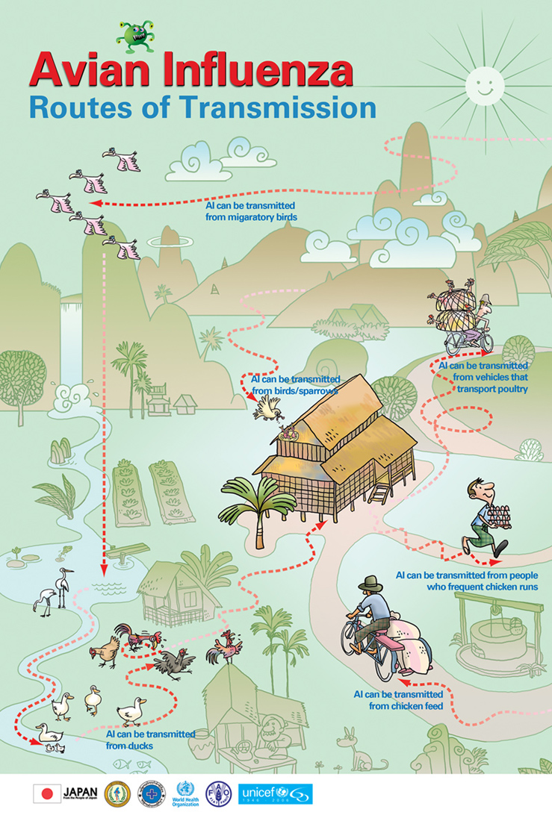
Routes of Transmission – Teacher notes to accompany diagram

Each point below gives some responses to each of the key pictures outlined in “Routes of Transmission”:

Picture: Avian Influenza can be transmitted from migratory (wild) birds:
- Bird droppings, drinking from same water source, nasal or other fluid discharge

Picture: Avian Influenza can be transmitted from vehicles that transport poultry:
- Droppings, feathers, fluids including blood from infected poultry

Picture: Avian Influenza can be transmitted from birds / sparrows / ducks:
- Bird droppings, drinking from same water source, nasal or other fluid discharge

Picture: Avian Influenza can be transmitted from people who frequent chicken runs:
- From clothing and footwear, if people have flu like symptoms (coughing, sneezing, spitting), handling poultry and eggs but not washing hands with running water and soap after contact

Picture: Avian Influenza can be transmitted from chicken feed:
- Contaminated chicken feed, transporting of chicken feed (bicycles, clothing, footwear, etc.)

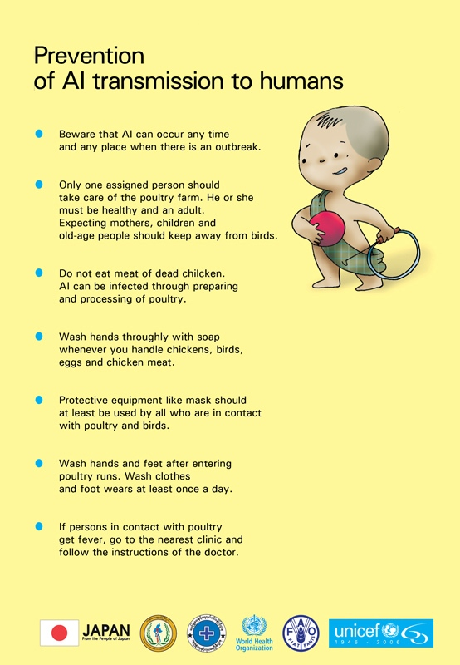
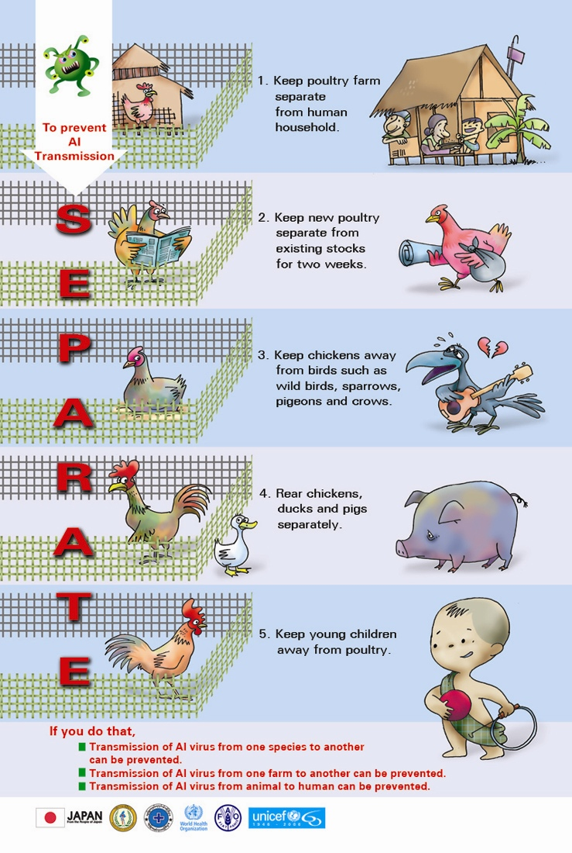
Separate – Teacher notes to accompany diagram

- Keep poultry farm separate from household
- Keep new poultry separate from existing stocks for 2 weeks (with daily observation)
- Keep chickens away from birds such as wild birds, sparrows, pigeons, etc.
- Rear chickens, ducks and pigs separately
- Keep young children away from poultry

Note:
  - Do not bring back birds carried to market for sale – if you have to do so, keep them separated from your other birds for 2 weeks and observe
  - Control (limit) entry of people, animals, feeders into your farm
  - Fence / cage domestic birds if possible
Middle Primary Programme

ACTIVITY NO. 4 | ACTIVITY NAME: Precaution messages when looking after poultry  Time: 30 minutes

OBJECTIVES:
At the end of the lesson students will be able to:
- Identify who looks after domestic birds in the family and the amount of time spent on different tasks
- Determine what precautions should be taken for each of the tasks to protect against bird flu
- List key precaution messages to explain to family members (or friends) about minimising the transmission of bird flu.

CURRICULUM FOCUS/ES:
- Health
- Language and Arts
- Maths

MATERIALS NEEDED:
- Paper or student workbooks
- Pencils

WHAT YOU NEED TO KNOW! | - Key facts about Bird flu (avian influenza)  - How to keep poultry safe from bird flu  - Bird-to-bird transmission of bird flu  - Bird-to-human transmission of bird flu  - How to handle and prepare poultry and eggs for consumption  - The importance of washing hands with soap (ash) and water  [Refer to Teacher Fact Sheet – Avian Influenza: Early and Middle Primary Level]

PROCEDURE | - Briefly review the key points covered in lessons 1 – 3  - Remind students about the lesson #2 and who usually looks after chickens or other farm birds., e.g.  - Who usually looks after them?  - What type of domestic birds do you look after?  - What is involved in looking after them?  - Draw a large circle on the board and explain that this is a “participation” circle. Ask all students to draw a large circle in their books and to do the following:  - Divide the circle to illustrate how much each member of your family comes into contact with the birds  - Write down (or draw pictures of) the types of tasks each of the family members do  - Now write down some precautionary messages to protect each member of the family from bird flu. Remind students of all they have learnt so far about bird flu.  - Note: If some students do not keep poultry, either ask them to pair up with another student who does OR ask them to imagine that their family does keep poultry and continue with the activity  - Note: An example of the participation circle and what it might look like is attached below  - As students are doing this activity, move around the classroom to assist if necessary. Ask ‘prompt’ questions to help those students who are having difficulty thinking of the tasks involved in looking after poultry and/or the precautionary messages.  - Allow a few minutes when students have finished, for them to share their participation circles in a small group.  - Bring the students together in one large group and ask them about who has contact with poultry in their family, the different tasks involved in looking after poultry, and some of the key messages to be remembered.

ASSESSMENT | Informal assessment based on the following outcomes:  - Students complete a ‘participation circle’ and are able to list key precaution messages family members should consider when looking after poultry.  - Students take on responsibility of informing family members or friends about key prevention messages.

IDEAS TO EXTEND | During the next few days, students make time to talk with their family members or friends who look after poultry and explain the appropriate messages to them.

Participation Circle (example)

Divide the circle to illustrate how much each member of your family comes into contact with the birds. Write down (or draw pictures of) the type of tasks each of the family members do. Write down some precautionary messages to protect each member of the family from Bird Flu.

Mother:
- Prepares & cooks chickens for eating
- Cooks eggs for eating
- Sells extra eggs in market and occasionally a chicken
- Disposes of dead chickens

Brother[1]:
- Takes eggs/chickens to market if Mother sick

Brother[2]:
- Goes with Brother[1] to assist

Father:
- Helps with preparing chickens & eggs if mother sick
Me:
- Helps sister to look after chickens after school
- Sometimes collects eggs

Younger Sister:
- Looks after chickens everyday
- Gets water for chickens
- Feeds chickens
- Collects eggs
- Considers them her pets (esp. baby chicks)

Precautionary messages for family members (examples):

Note: These are some examples and may be inter-changeable between different members of a family depending on their contact with poultry.

Mother
- Avoid poultry having contact with wild birds – house poultry in a covered shelter
- Look out for symptoms of sick poultry
- Clean the dirt from the shell of the eggs
- Cook poultry and eggs thoroughly to kill germs
- Separate raw food from cooked food
- After processing poultry, clean knives, chopping boards, bowls, etc.
- Do not eat sick poultry
- Wear protective clothing when disposing of dead birds and wash hands with soap and water afterwards
- Alert authorities of sickness or sudden death of poultry
- Clean hands with soap after handling eggs and poultry
- Clean hands with soap and water before having meals
- Clean hands with soap and water after using the toilet

Father
- Avoid poultry having contact with wild birds – house poultry in a covered shelter
- Look out for symptoms of sick poultry
- Clean hands with soap after handling eggs and poultry
- Clean hands with soap and water before having meals
- Clean hands with soap and water after using the toilet

Brother[1]
- Do not touch feathers or liquid wastes (stool, urine, blood, nasal fluids) from sick or dead poultry
- Clean hands with soap after handling eggs and poultry
- Clean hands with soap and water before having meals
- Clean hands with soap and water after using the toilet

Brother[2]
- Do not touch feathers or liquid wastes (stool, urine, blood, nasal fluids) from sick or dead poultry
- Clean hands with soap after handling eggs and poultry
- Clean hands with soap and water before having meals
- Clean hands with soap and water after using the toilet

Me
- Limit contact with poultry as much as possible
- Do not touch feathers or liquid wastes (stool, urine, blood, nasal fluids) from sick or dead poultry
- Clean hands with soap after handling eggs and poultry
- Clean hands with soap and water before having meals
- Clean hands with soap and water after using the toilet

Younger sister
- Limit contact with poultry as much as possible
- Do not touch feathers or liquid wastes (stool, urine, blood, nasal fluids) from sick or dead poultry
- Look out for symptoms in your poultry
- Clean hands with soap after handling eggs and poultry
- Clean hands with soap and water before having meals
- Clean hands with soap and water after using the toilet
Middle Primary Programme

ACTIVITY NO. 5 | ACTIVITY NAME: Bird flu cartoon hero story  Time: 30 minutes

OBJECTIVES:
At the end of the lesson students will be able to:
- Recall key messages about bird flu and present this in a cartoon story map using ‘good’ and ‘bad’ characters.

CURRICULUM FOCUS/ES:
- Health
- Science
- Language and Arts

MATERIALS NEEDED:
- Handouts x 2 (included below). If it is not possible to produce photocopies of these, draw the diagrams on the board for students to copy.
- Coloured pencils

WHAT YOU NEED TO KNOW! | - What germs are and how they can be spread  - Key messages to prevent spreading germs and getting sick  - Key facts about Bird flu (avian influenza)  [Refer to Teacher Fact Sheet – Germs and Teacher Fact] Sheet – Avian Influenza: Early and Middle Primary Level]

PROCEDURE | - Explain to students that they will be using all the information they now have about bird flu and that they will use this to create characters and a story. Inform them that the local television or radio station has hired them to spread the word about the importance of knowing about and preventing the spread of bird flu. You (the students) have been asked to design a new cartoon series called “Healthy Kids”. You have been asked to do the following (use the handouts attached):  - Handout #1: Draw 2 cartoon sketches of your main characters: (1) the good character who is a hero who knows about bird flu and takes precautionary measures to stop transmission, and (2) the bad character or villain (i.e. the germ) spreading the bird flu virus  - Each character should include a sketch in the circle, a name or label, and a few sentences describing the character  - Handout #2: A story map describing the key points in your cartoon script. In the ‘outcomes’ section, remind students to emphasize some key messages about bird flu.  - Remind students that the station wants to get across clear messages to people about the best ways to protect themselves from bird flu, so they need to make sure this is the clear message in their cartoon.  - Encourage students to be creative in their development of characters and story map. If it helps the development of ideas, allow students to share some of their thoughts in pairs or small groups. Move around the classroom while students are doing this activity and offer encouragement through discussing with individual students the details they are focusing on, who their characters are, etc.

ASSESSMENT | Informal assessment based on the following outcomes:  - Students creativity to use their knowledge on bird flu to develop a story map and key characters for this  - Language and drawing to express key messages about bird flu

IDEAS TO EXTEND | Allow students time – either in this lesson or an additional one – to share their characters and story maps with others. These can be displayed in the classroom and/or shared in small groups.

Handout # 1: My Cartoon Characters

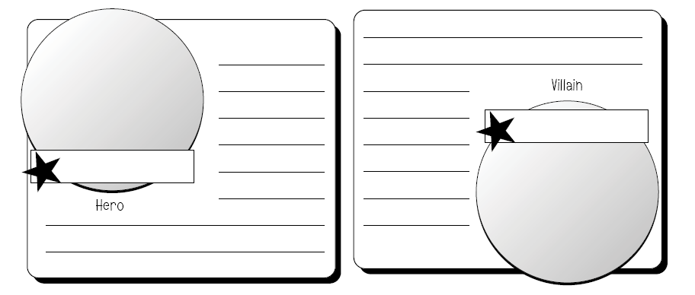

Handout #2: My Story Map – key points

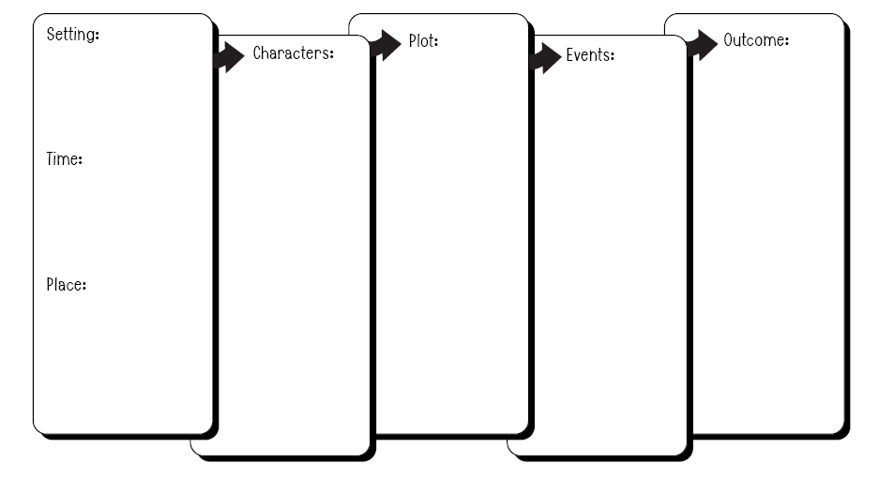

Upper Primary Programme

ACTIVITY NO. 1 | ACTIVITY NAME: Germ Facts  Time: 45 minutes

OBJECTIVES:
At the end of the lesson students will be able to:
- State what a germ and virus are.
- Understand that germs are present even though we cannot see them
- Explain how germs can be spread and ways to prevent this spread
- Explain the importance of washing hands with soap and water

CURRICULUM FOCUS/ES:
- Health
- Science
- Communication
- Language

MATERIALS NEEDED:
- Handout #1: “Did you know?” (included below)
- Quiz questions (included below)
- Spray bottle filled with water
- Handout #2: Wordsearch on germs (included below)

WHAT YOU NEED TO KNOW! | - The 4 major types of germs and how germs spread  - The importance of washing hands with soap (ash) and water properly  - Key messages to prevent spreading germs and getting sick  [Refer to Teacher Fact Sheet – Germs: Upper Primary Level]

PROCEDURE | - Ask students to work in pairs and tell each other what they know about germs and viruses. Give pairs 3 - 5 minutes for this.  - Ask students to keep this in mind as we read some information about germs and viruses. Give each student or pair of students a copy of Handout #1. If this is not possible, just have the one copy for yourself and 1 – 2 copies for the students. The students can circulate their copy to each student who is reading the paragraph. Select a student to read the first paragraph out loud to the class, and then a second student to read the second paragraph, and so on. After each paragraph, ask if students know what some of the more difficult words mean and if necessary, define these words or assist students with pronunciation.  - At the end of the reading, ask students what information they now know that they didn’t know before about germs and viruses (e.g. discussed in Step #1). Take responses from several different students.  - Activity (1): “small group quiz”. Draw a scoring table on the board. Put students into groups of 4 and explain that you will ask each group a number of questions. Each group should first allocate a ‘speaker’, e.g. the person in the group who will answer each question on the group’s behalf. The group is allowed to discuss the answer quietly amongst themselves before answering. Allow only a short time for this discussion so that the group quiz can continue and be interesting to the students.  - Scoring: Ask Group 1 the first question. If correct, allocate 1 point. Ask Group 2 the next question, and so on. If a group gives a wrong answer, then the next group has the chance of answering and if correct receives 1 point as well as the chance to answer the next question.  - After completing the questions, add up the points to see which group won.  - Note: This is supposed to be a fun and learning experience, not a big competition. Praise all groups for working together as a team.  - Note: A list of questions based on the paragraph is included below, as well as an example of the scoring table.  - Activity (2): “spreading germs”: Explain that even though we can’t see them, germs spread very easily through sneezing, coughing or having dirty hands. We will see how this can be done by using a spray bottle filled with water.  - Wet each student’s hands using the spray bottle.  - Ask students to touch a variety of surfaces in the classroom. [each student should have left several wet handprints in the room].  - After students have left several wet ‘handprints’ by touching various surfaces, ask the following:  - What does this activity show you? [that the water was present on our hands to make a wet handprint on several surfaces – germs can easily be spread just as quickly and in the same way by touching]  - How can we prevent the spread of germs from our hands or from sneezing and coughing? [by covering our nose and mouth and by making sure we wash properly with soap and water for 15-20 seconds]  - Ask students to think of at least one important new thing they learnt today about germs. Ask them to make a note of it in their workbooks and tell at least one family member that important thing when they go home and explain why it is something important to remember.

ASSESSMENT | Informal assessment based on the following outcomes:  - Students define (or are given the definition of) difficult or new words in relation to germs  - Students work in a team to answer the quiz questions  - Students can identify new learning points about germs and pass on information to family members.

IDEAS TO EXTEND | Give students a copy of the “wordsearch game” on germs (attached) and ask them to complete. If it’s not possible to photocopy the sheet, write it on the board for students to copy into their workbooks.

Handout # 1 – Did You Know . . . ?
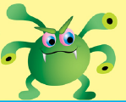

[1]What is a Germ?
Germs are tiny organisms, or living things, that can cause disease. Germs are so tiny that you need to use a microscope to see them. We only know they are there when we have symptoms that usually make us feel bad and/or we become sick.

[2]What Types of Germs Are There?
Germs are found all over the world, in all kinds of places. There are four major types of germs: bacteria, viruses, fungi, and protozoa. They can invade plants, animals, and people, and sometimes they make us sick.

[3]Bacteria are tiny, one-cell creatures that get nutrients from their environments in order to live. In some cases that environment is a human body. Bacteria can reproduce outside of the body or within the body as they cause infections. Some infections bacteria cause include sore throats, ear infections, and holes in our teeth.

[4]But not all bacteria are bad. Some bacteria are good for our bodies — they help keep things in balance. Good bacteria live in our intestines and help us use the nutrients in the food we eat and make waste from what's left over. Some bacteria are also used by scientists in labs to produce medicines and vaccines.

[5]Viruses need to be inside living cells to grow and reproduce. Most viruses can't survive very long if they're not inside a living thing like a plant, animal, or person. Whatever a virus lives in is called its host. When viruses get inside people's bodies, they can spread and make people sick. Viruses cause chickenpox, measles, flu (influenza), and many other diseases. Because some viruses can live for a while on something like a doorknob or countertop, be sure to wash your hands regularly!

[6]Fungi are multi-cell (made of many cells), plant-like organisms. Unlike other plants, fungi cannot make their own food from soil, water, and air. Instead, fungi get their nutrition from plants, people, and animals. They love to live in damp, warm places, and most fungi are not dangerous. An example of something caused by fungi is athlete's foot, that an itchy rash that sometimes effects our feet and toes.

[7]Protozoa are one-cell organisms that love moisture and often spread diseases through water. Some protozoa cause intestinal infections that lead to diarrhoea, nausea, and stomach pain.

[8]What Do Germs Do?

Once germs invade our bodies, they make themselves comfortable for a long stay. They eat up nutrients and energy, and can produce toxins, which are like poisons. Those toxins can cause symptoms of common infections, like fevers, sniffles, rashes, coughing, vomiting, and diarrhoea.

[9]How do doctors figure out what germs are doing? They take a closer look. By looking at samples of blood and other fluids under a microscope or sending these samples to a laboratory for more tests, doctors can tell which germs are living in your body and how they are making you sick.
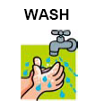

[10]How Can You Protect Yourself From Germs?

Most germs are spread through the air in sneezes, coughs, or even breaths. Germs can also spread in sweat, saliva, and blood. Some pass from person to person by touching something that is contaminated, like shaking hands with someone who has a cold and then touching your own nose. So the best way to protect yourself from germs is to steer clear of the things that can spread them:
Cover your nose and mouth when you sneeze and cover your mouth when you cough to keep from spreading germs. Do not spit.

[11]Remember the two words germs fear — soap and water. Washing your hands well and often is the best way to beat them. Wash your hands every time you cough or sneeze, before you eat or prepare foods, after you use the toilet, after you touch animals and birds, after you play outside, and after you visit a sick relative or friend.

Now that you know the facts about germs, you may still pick up a cough or a cold once in a while, but you'll be ready to keep most of those invading germs from moving in.

NOTE: Numbers in brackets indicate a new ‘speaker’ if reading aloud in class.

Quiz Questions

Note: It is not necessary to use all the questions below.

- Where are germs found? [everywhere]
- Name 2 types of germs? [state 2 of the following: bacteria, viruses, fungi, protozoa]
- What are the other 2 types called? [as above]
- What types of things can germs invade? [plants, animals, people]
- What do you need to use to see germs? [microscope]
- Name one infection that bacteria can cause? [sore throat, ear infection, holes in teeth]
- What can good bacteria do? [help us use nutrients in food . . . ]
- What does a virus live in – what is it called? [host]
- What types of sickness can viruses cause? [chickenpox, measles, flu]
- Where do fungi like to live? [in damp, warm places]
- Protozoa are what type of organisms? [one-cell organisms]
- When do we know we have bad germs? [when we get sick]
- What do bad germs do in our body? [they eat up nutrients and energy and produce toxins or poisons]
- Who can tell what types of germs you have in your body when you are sick? [doctors or laboratory technicians]
- Name 2 ways germs can spread. [through the air in sneezes, coughs or breaths; in sweat, saliva and blood; by touching something that is contaminated]
- Name 1 way to prevent the spread of germs. [cover your nose and mouth when you sneeze; don’t spit; wash your hands]
- Name 2 times when you should wash your hands. [after you cough or sneeze; before you eat or prepare foods; after you use the toilet; after you touch animals and birds; after you play outside; and after you visit a sick relative or friend]
- Name another 2 times when you should wash your hands. [as above]

Scoring Table

Group #1 | Group #2 | Group #3 | Group #4

Handout #2: Wordsearch Game

Wordsearch – Germs
M | H | A | N | D | W | A | S | H | I | N | G | I
T | R | U | V | A | C | C | I | N | E | S | N | N
N | L | D | E | S | A | E | S | I | D | F | D | F
E | B | A | C | T | E | R | I | A | L | U | O | E
V | O | P | Q | S | N | A | M | U | H | N | O | C
E | B | A | R | A | C | V | E | N | M | G | F | T
R | I | C | E | D | E | N | S | H | K | I | A | I
P | R | O | T | O | Z | O | A | O | T | G | B | O
R | D | U | A | A | E | L | I | A | K | U | L | N
O | S | G | W | S | E | N | E | R | G | Y | O | S
T | T | H | G | S | N | W | V | X | Z | I | O | M
E | C | B | H | N | S | A | L | I | V | A | D | R
C | E | P | O | C | S | O | R | C | I | M | R | O
T | A | S | S | E | A | I | S | M | R | E | G | H
V | E | W | T | D | X | O | C | Y | U | W | A | E
A | N | I | M | A | L | S | I | K | S | O | A | P

animals handwashing protozoa
bacteria host saliva
blood humans sick
birds infection sneeze
cough influenza soap
disease microscope sweat
energy mouth vaccines
fungi nose virus
food prevent water
germ protect

Instructions:

Find all the words above hidden in the wordsearch grid. Words can be written horizontally, vertically or diagonally and can be written forwards or backwards.

When you have found all the words in the wordsearch, choose 10 – 15 words fro the list above and write a short paragraph about germs using these words.
Upper Primary Programme

ACTIVITY NO. 2 and 3 | ACTIVITY NAME: Bird Flu Facts – Transmission, Prevention and Safe Poultry  Time: over 2 lessons each of 45 minutes (these can be spread over separate teaching days)

OBJECTIVES:
At the end of the lesson students will be able to:
- State key facts about the bird flu virus
- Identify and discuss how bird flu is transmitted from birds to birds and birds to humans
- Identify and discuss ways to prevent the transmission to humans
- Explain why it is important to ‘keep poultry separate’
- List ways that poultry and eggs can be safe to eat

CURRICULUM FOCUS/ES:
- Health
- Language and Arts
- Science
- Social Studies / Geography

MATERIALS NEEDED:
- World Map (Note: If the class does not have a world map, make some photocopies of the WHO map below)
- Handouts (included below)
- Paper (large size if available) for posters
- A4 paper for pamphlet

WHAT YOU NEED TO KNOW! | - Key facts about Bird flu (avian influenza)  - Basic migration routes of birds (Asia region)  - Countries (and their location) where human cases have been confirmed  - Routes of transmission of bird flu  - Bird-to-bird transmission of bird flu  - Bird-to-human transmission of bird flu  - Why it is important to keep poultry ‘separate’  - How to keep poultry safe from bird flu  [Refer to Teacher Fact Sheet – Avian Influenza: Upper Primary Level and Teacher Fact Sheet – Avian Influenza: Migration]

PROCEDURE | - As an introduction, ask students what they know about avian influenza or bird flu as it is more commonly known. Write answers on the board. Use prompt questions such as:  - What or who can be affected by bird flu? How?  - How can bird flu be transmitted?  - What can be done to prevent the spread of bird flu?  - Note: only spend 3 – 5 minutes on this.  - Explain that avian influenza or bird flu is a highly contagious disease that affects poultry. Once infected, both domestic and wild birds (including chickens, ducks, geese, turkeys and quail) can become sick and die. Scientists call the virus H5N1. The virus has been largely spread through the migration of wild birds and has spread from Asia to Europe, the Middle East and to Africa, affecting at least 20 countries. So far, more than 150 million birds have been killed – either from the disease itself or from culling. At this stage avian influenza is a bird virus which means it can be transmitted from birds-to-birds. However, some cases of bird-to-human cases have also occurred, with some people dying from the virus.  - Show the students a world map and ask them where Asia, Europe, Middle East and Africa are. Get some of the students to come and show this on the map. Ask them if they can also locate their own country and neighbouring countries on the map. Explain that some of the countries where human cases have been reported include: Azerbaijan, Cambodia, China, Djibouti, Egypt, Indonesia, Iraq, Thailand, Turkey and Vietnam. Ask students to locate some of these countries on the map.  - Show students on the world map the migration pattern of wild birds which has helped to spread bird flu. Also explain however, that experts argue whether the migration of wild birds or human trade in poultry is or will be, the greater risk for transmitting the disease in both birds and humans.  - Ask: Why is it important that we should learn about bird flu? Encourage a range of responses including some of the following:  - To stop the spread to our own poultry  - So no more culling can take place and we have chickens for household use and income  - To prevent humans catching bird flu  - To learn how to keep our chickens safe  - To know how to handle and prepare poultry and eggs so they are safe  - Activity: Divide the class into 3 large groups and explain that the groups will each focus on one of the following areas: Routes of Transmission; Prevention of Transmission to Humans; and Separation and Safe Poultry and Eggs  - Within each of the large groups, students should work in smaller groups of 4-5.  - Distribute the appropriate handouts to each group and ask them to use this information for a presentation explaining the important points or messages of their allocated focus area. Allow groups a choice of presentation, such as:  - Presenting a short role play (small drama)  - Writing and illustrating a short story  - Designing a pamphlet  - Composing a short song  - Move around the classroom assisting groups if necessary, e.g. in explanations of some words, any additional questions they have, etc.  - Remind students they have this lesson and one more lesson to complete their work and at the end, they will be sharing their presentation with the whole class.  - If the second 45 minute lesson is to follow on directly, then students can continue with their work. If the lesson is to continue on another day, ask students to store their material safely until then.  - Note: Allow 15 – 20 minutes at the end of the second lesson for groups to present what they have done. In so doing, groups should share key information and messages to their other class members.  - Allow students to ask questions to the ‘presenting’ group to clarify information and messages.

ASSESSMENT | Informal assessment based on the following outcomes:  - Student answers to questions asked in both the large and smaller working groups  - Student teamwork to design, produce and present key information and messages to the group’s assigned focus area

IDEAS TO EXTEND | Students present their work to other classes or the whole school during assembly (or other) time.  Students present their work to parents and community during a parent or community event.

Handouts and Resources
- World Map
- WHO map showing the countries where human cases have been confirmed (Note: January 2007 data updates 22 cases now confirmed in China, and 77 cases confirmed in Indonesia plus 59 deaths now recorded)
- Migration Map (additional information in Teacher Fact Sheet – Avian Influenza: Migration)

Handouts for groups focusing on ‘Routes of Transmission’
- Routes of Transmission – Poster
- Beware of Poultry Waste – Poster
- Bird Flu Transmitted to Chicken – Poster

Handouts for groups focusing on ’Prevention of Transmission to Humans’
- Prevention of avian influenza (AI) to humans – Poster
- What to do with dead birds – Poster
- Protect your birds – Poster
- Bird flu to humans – Poster

Handouts for groups focusing on ‘Separation and Safe Poultry and Eggs’
- Separate: Prevention and Control of Avian Influenza – Poster
- No risk if carefully eaten – Poster
- Do these and be risk free – Poster
- Safe to eat – Poster

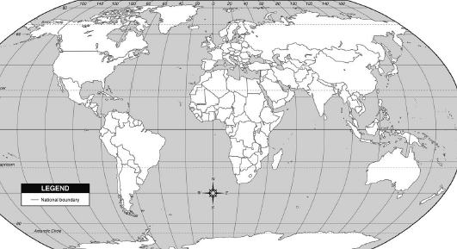

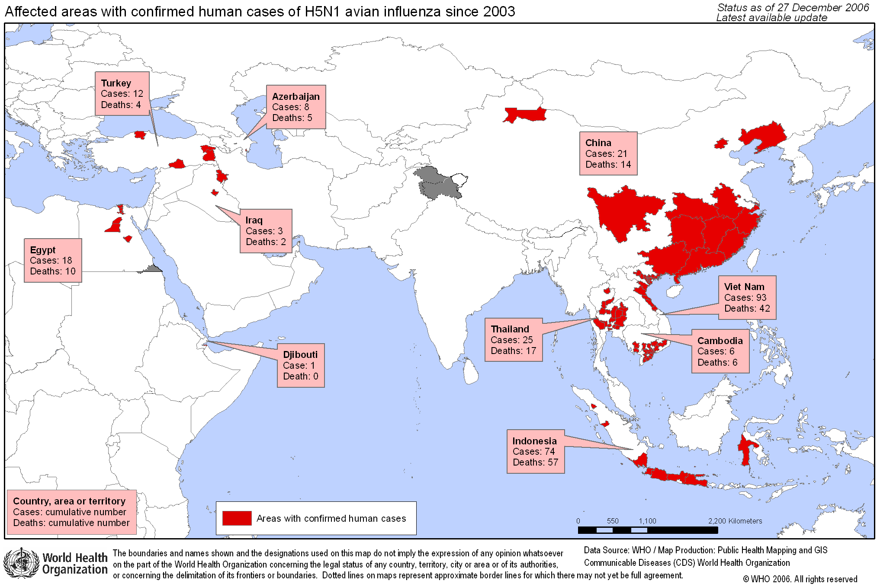
Upper Primary Programme

ACTIVITY NO. 4 | ACTIVITY NAME: Family poultry graph  Time: 45 minutes

OBJECTIVES:
At the end of the lesson students will be able to:
- State the number of children who come into contact with poultry based on class family members
- Interpret graph data and explain what it means
- Discuss how the graph data relates to numbers potentially affected by bird flu

CURRICULUM FOCUS/ES:
- Maths
- Language
- Health

MATERIALS NEEDED:
- Graph paper if available or student workbooks

WHAT YOU NEED TO KNOW! | - How to construct a simple bar graph  - Bird  - Key facts about bird flu (avian influenza)  - Bird-to-human transmission of bird flu  - The importance of clear messages to prevent the spread of bird flu  [Refer to Teacher Fact Sheet – Avian Influenza: Upper Primary Level]

PROCEDURE | - Prior to the lesson, write the following sentences on the board:  - How many children (in your family) feed the family poultry?  - How many children (in your family) collect the eggs?  - How many children (in your family) play with the poultry?  - How many children (in your family) play near the poultry or poultry farm?  - How many children (in your family) collect the poultry dung?  - How many children (in your family) help sell the poultry or eggs in the market?  - Explain to students that in this activity we will look at our own family practices in relation to keeping poultry. Ask: How many children in your family? Tell the students to make sure they include themselves and to write the number of children in their family at the top of their workbook page.  - Now ask students to copy the sentences from the board into their workbooks and to answer each question. Remind students to include themselves in the number they write next to each question.  - When the students have finished answering the questions, go through the questions as a whole class and add up the class numbers for each question. Write the number after each of the sentences on the board.  - Explain to students that they will now draw a bar chart showing the activity and the number of children involved in each. You will need to look at the range of numbers involved in order to decide on the number range to use for the bar chart.  Note: An example of data and a bar chart is given below. It may be necessary to assist or explain some of the steps involved in drawing a bar chart if it is new to students.  - After students have finished their charts, hold a general discussion.  - How many children from families from our class handle or come into contact with poultry? [look at the different poultry activities and numbers involved]  - If that many children just from our own class handle poultry, what numbers would we expect if we did a survey of our school? Our community? Our town or village? [students can estimate this if they want to – the important point is that there will be hundreds, if not thousands or tens of thousands]  - What does this mean about the spread of bird flu and the possibilities of someone we know having their poultry infected by bird flu? What about numbers of people who may also be infected?  - What can and should we do to help communicate what we know about preventing the spread of bird flu? [take a few responses from students and ask them to think about this for our next lesson on bird flu]

ASSESSMENT | Informal assessment based on the following outcomes:  - Student’s calculations about their own family situation to questions about contact with poultry  - Students complete a graph based on class data  - Students interpretation of graph data and how it relates to numbers potentially affected by bird flu

IDEAS TO EXTEND | Invite a health worker (or vet or NGO worker) to the class who knows about bird flu and can give factual information and answer questions children may have about bird flu.  - Alert students to when this person will be coming so they can prepare their questions  - Invite other classes or teachers to come and also take part so that sharing of information can be more widely communicated  - Students can undertake further activities after listening to the visitor such as telling family, friends and/or community members what they know about bird flu and how children and the community can prevent the spread of bird flu.

Teacher Resource – Example of a bar chart reflecting collected data

Children Contact with Poultry (whole class data)
How many children feed the family poultry? |  |  |  | 30
How many children collect the eggs? |  |  |  | 97
How many children play with the poultry? |  |  |  | 88
How many children play near the poultry or poultry farm? |  |  |  | 143
How many children collect the poultry dung? |  |  |  | 126
How many children help sell the poultry or eggs in the market? |  |  |  | 35

Number of students in the class = 40
Total number of children in families (of students in class) = 165

Extension ideas for those students who finish their work quicker than others:
- Assist one of the students who needs help in completing their graph work
- Work out the percentages for each question, e.g. If 30 children feed the family poultry in a total number of 165 children, then 18% of children feed the family poultry (from the total number of children represented by students in this class).
[30/165 x 100/1 = 18]
Upper Primary Programme

ACTIVITY NO. 5 | ACTIVITY NAME: What we can do about bird flu  Time: 45 minutes

OBJECTIVES:
At the end of the lesson students will be able to:
- Prepare and carry out their chosen activity relating to bird flu
- Ensure that correct messages and information about bird flu are conveyed through their activity
- Monitor their activity and work out ways to overcome any ‘challenges’ faced

CURRICULUM FOCUS/ES:
- Health
- Science
- Language and Arts

MATERIALS NEEDED:
- Dependent on student choices and availability of resources

WHAT YOU NEED TO KNOW! | - Key facts about Bird flu (avian influenza)  - Routes of transmission of bird flu  - Bird-to-bird transmission of bird flu  - Bird-to-human transmission of bird flu  - Key messages in preventing the spread of bird flu  [Refer to Teacher Fact Sheet – Avian Influenza: Upper Primary Level]

PROCEDURE | - Remind students of the graph work they did in the last lesson and the concluding question, e.g. What can and should we do to help communicate what we know about preventing the spread of bird flu – in our families and our community? List these on the board.  Note: Students should come up with their own ideas and what is practically possible, however some example ideas are listed here, as follows:  - Plan ways to ensure all your family members know about bird flu and take precautionary action at all times. Monitor this. Identify what is easy to do and what is difficult and work out ideas to overcome the challenges.  - Plan and act out a role play involving messages to prevent the spread of bird flu. Present this to other classes, community groups, etc.  - Write a letter to the local newspaper explaining about the importance of preventing bird flu.  - Start a children’s group that focuses on bird flu awareness and safe practises. Plan how you will do this and what you will need to do to make it happen.  - Develop a monthly newsletter where information on bird flu is presented, such as key messages, latest updates locally and across the world, etc.  - Undertake a local community survey to see who does know about bird flu and share new information with them  - Explain to students that they should choose one of the ideas they listed to share information about bird flu. In the process ask students to do the following:  - make a step-by-step plan in writing that includes what needs to be done, who does it, when it will be done, etc.  - show your plan to your teacher for approval [note: teacher should offer guidance on the plan so that it can actually be undertaken and that information and messages are correct]  - prepare your chosen activity  - involve all members if working in a group  - Allow students to work individually or in small groups (students should nominate the group members they would like to work with).  - Depending on the type of activity chosen by students, be flexible in allocating a further lesson for preparation and/or time to test out their activity in class. Encourage students to work on their activity outside school hours and to report back on progress made, successes and any challenges faced.

ASSESSMENT | Informal assessment based on the following outcomes:  - Student’s individual or teamwork, to plan, prepare and carry out a chosen activity  - Students understanding of bird flu information and communication of correct messages about preventing the spread of bird flu

IDEAS TO EXTEND | Continuation of activity outside of class and involving other school, family and/or community members.  Follow up monitoring of activity by students and further discussions in class about activities completed, successes, challenges faced, and ways to overcome ‘challenges’.

Adapted from http://kidshealth.org/kid/talk/qa/germs.html
Information sources: World Health Organisation (WHO), Unicef
Dept. of Health and Human Services: Centres for Disease Control and Prevention: www.cdc.gov/flu/avian/gen-info/facts.htm
Adapted from http://kidshealth.org/kid/talk/qa/germs.html
Adapted from UNICEF Questions and Answers fact sheet
Dept. of Health and Human Services: Centres for Disease Control and Prevention: www.cdc.gov/flu/avian/gen-info/facts.htm
Resource: http://www.pbs.org/wnet/wideangle/shows/vietnam/map2.html
Adapted from http//:atozteacherstuff.com/pages/334.shtml
Adapted from Science Netlinks, www.sciencenetlinks.com/Lessons.cfm?DocID=49
? Adapted from KidsHealth in the Classroom: www.KidsHealth.org
Adapted from Science Netlinks, www.sciencenetlinks.com/Lessons.cfm?DocID=49
Adapted from http://kidshealth.org/kid/talk/qa/germs.html

