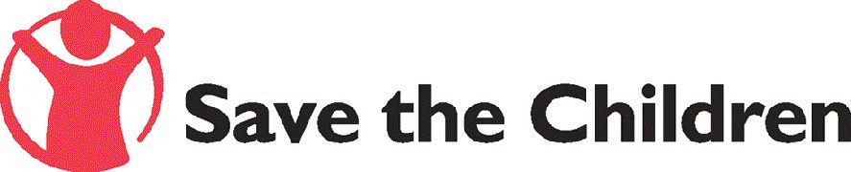

REPORT

Lessons Learned from Child Led Disaster Risk Reduction Project in Thailand

(As of April 30, 2007)
Introduction

Save the Children in Thailand was active in the emergency response phase right after the Tsunami struck the Indian Ocean in December 2004. Since the beginning of 2005, our programme areas included psychosocial support, livelihood, inclusive education, HIV/AIDS as well as promoting children’s participation. In the beginning of 2006, Save the Children Sweden and UK in Thailand have begun to slowly transform our Tsunami Programme from emergency response to a more long-term development approach. This is to ensure that local communities affected by the Tsunami in Southern Thailand can be self - sustained in the future.

Disaster risk reduction is one strategy to which Save the Children gives priority in the post-emergency response period. Having capacity to plan for what to do and how to reduce loss and damages if another disaster strikes will help communities to mitigate the impact of disasters; as well as to feel in control of their lives.

In the Tsunami affected areas – similar to elsewhere, children were usually seen as recipients/victims who need help. Children were also claimed to be abused by aid agencies in the case that aids and services provided to them have come with conditions. As a child-right based organization, Save the Children sees this post-tsunami situation as another platform to ensure that the rights of all children are protected. We have always given priority to promote children’s role as an active citizen who are capable to participate in making a decision and taking an action on issues relevant to their lives. The Child-Led Disaster Reduction Programme in Thailand is a concrete example of how this can be done.

This project is based on our belief that children can play an active role in community’s affairs that is relevant to them including based disaster risk reduction – especially if they are appropriately trained and supported by adults. Inspired by the success of the Save the Children’s Child-Led Disaster Risk Reduction Project in Cuba, Save the Children Sweden and UK in Thailand piloted and adapted the project to the local context of Thailand’s tsunami affected provinces in 2006. The project works with children in around 24 schools in 4 provinces in southern Thailand.

Save the Children, together with our local partners, trained youth leaders so that they could build the capacity of school children - through classroom and community based activities and capacity building camps - to identify disaster risks in their communities; conduct community risk and resource mapping; and develop an educational campaign to raise awareness of communities to reduce those risks.

The end results after six months of this pilot project prove that children, with the right kinds of support and guidance, are able to play a leading role in their communities in order to reduce the risks of disasters. And all children are capable in doing so no matter what are their local norms and cultures. A lesson from implementing this project demonstrates that supports from adults especially teachers, community members and project staff are key to success.

The Report “Lessons Learned from Child Led Disaster Risk Reduction Project in Thailand” is a result of our efforts to document the process, outcomes and lessons that we have learnt from implementing this six-month pilot project in Thailand. Save the Children in Thailand hopes that you will find this report is inspiring and useful in initiating a similar programme in your respective country/region.

Save the Children Sweden and UK in Thailand

Chapter 1
Background and Context

Why Disaster Risk Reduction?

It is widely recognized that preparedness is a better strategy than response to disaster. It helps reducing risk and loss of lives and properties.
Communities are at the frontline of disasters. It has become apparent that top-down approaches to disaster risk management fail to address the specific local needs of vulnerable communities. They often ignore the local capacities and resources, and, at times, further increase the vulnerability of the community. The community-based disaster management therefore emerged as an alternative approach to fill in these gaps.
Community action for disaster risk management is a crucial element in promoting a culture of prevention and creating safer communities. However, it is equally important that the community based disaster risk management/reduction ensures that vulnerable and marginalised groups in the society - who would be most affected by the disaster - are recognized during pre and post disaster activities, and that their needs and rights are addressed while preparing and responding to natural disasters.
Why child-led and child participation?

Save the Children believes that children are as an active citizen who are capable to participate in making a decision and taking an action on issues relevant to their lives. Disaster risk reduction activities are not an exception.

In any emergency children are among the most vulnerable when disaster occurs and has severe effects on children’s lives. It is important that the perspectives of children are taken into account by aid agencies. Empowering children through their participation is an important protection strategy as well as a right.

Children should not be perceived as mere victims but as an active citizen. The disaster risk management/reduction strategy and mechanism should take into account their opinions and capacities, empower them and create opportunities for their full participation.

There is growing evidence that investing in disaster risk reduction programs give economical and psychosocial benefits to communities and families. Children who are taught about natural disasters and hazards play an important role together with adults in protecting members of community at time of disaster. The schools have an important role. Making disaster risk education part of the national primary and secondary school curricula will help children get in control, foster awareness and will help children understand the environment in which children and their families live.

Save the Children’s “Big Idea”

For Save the Children Sweden, its “draft Strategy to Strengthen Save the Children Sweden’s Capacity and Role in Emergency Response Programs in South East Asia and the Pacific” (as of February 2007) specifies Child-Led Disaster Risk Reduction Programme as one of the five priorities that the organization aims to take forward. Under the Child-Led Disaster Risk Reduction, changes in children’s lives that we want to happen are:

- Children who participate in disaster risk reduction programs are aware of their rights, know how to be safe and know where to go for help
- Participation of children builds their self-esteem and self-confidence which helps them contribute to the safety of their families and communities

While the objectives of the programme are:

- Partners, schools, communities and education ministries are actively supporting children’s participation in development of child led disaster risk reduction plans and programs
- Child-led disaster risk reduction knowledge and practice is part of primary and secondary school curricula

Save the Children Alliance members – led by SCUK and SCUK – have agreed that Disaster Risk Reduction (DRR) is one of the “Big Ideas” initiatives which will be implemented in the tsunami-affected countries as a way of “building back better” after the tsunami. A Disaster Risk Reduction Workshop was organized to pursue this “Big Idea” and find ways to transform it into action.

This meeting – held in Hanoi, Vietnam during May 30 – June 2, 2006, brought together the practitioners of Disaster Risk Reduction from Sri Lanka, Thailand, India and Indonesia, and served as a first step in defining what we – Save the Children – mean by Disaster Risk Reduction (DRR), how Save the Children is distinct in its programming and how we can take DRR forward more strategically on a regional level with tsunami-affected countries.

At the end of this workshop, a DRR Working Group for tsunami-affected countries was established. DRR Toolkit was decided to be created in order to help replicate DRR programmes within the region. A suggested DRR Guidelines and Principles document were created by the participants and will be used as a ground document for future programming of Save the Children. Last but not least, the workshop confirmed the desire to promote child-led DRR within the Save the Children Alliance.

The Hanoi Workshop was followed up by an Asia Regional Workshop on Child Led Disaster Risk Reduction Programming organized by the Regional Office for South and Central Asia & Regional Office for Southeast of Save the Children Sweden. The workshop was held in Agra, India during 4-8 December 2006. It provided an opportunity for Save the Children members in the two regions to move forward the efforts on child led disaster risk reduction – taking stock of materials and lessons learned so far, to further develop a disaster risk reduction resource package and develop a regional strategy for Save the Children.

Both workshops reemphasized that “Child-Led Disaster Risk Reduction” has become a prioritized programme area for Save the Children to take forward as our “niche” in child focused/child protection in disaster/emergency programme. We also recognized that the well documented process and lessons learnt from the pilot project in Thailand would contribute to the further development of the same kinds of initiative of Save the Children in other countries and regions.

Disaster risk reduction in Thailand

In Thailand, disaster risk reduction programming is considered a new area of work for child-focused NGOs. The term “disaster risk management/reduction” has become a focus of interest of aid agencies for only a few years after the tsunami – although not much among child-focused agencies. After the tsunami, there has been an effort to develop both national and local emergency/disaster preparedness plan countrywide. However, existing plans are generally top-down, no community’s – not to mention children’s – participation in the development of the plan. Therefore, they are not adjusted to local context, and there is no feeling of ownership by the communities. Although those plans claim to be existed, they are not well known and disseminated among communities.

Save the Children Sweden & UK joint programme

The Child-Led Disaster Risk Reduction Programme in Thailand is a joint project implemented by Save the Children Sweden and UK. Prior to this project, both Save the Children Sweden and UK had separated programmes in the tsunami affected areas in Thailand. However, we both planned a child-focused disaster risk reduction for 2005. In early 2005, programme staff of both organizations discussed the possibility of working together, and a joint project was agreed after a number of discussions and dialogs.

Prior to the development of Programme, we analysed our existing resources to further develop the the Child-Led Disaster Risk Reduction Programme as follow:

- We already have youth groups in tsunami areas
- We already work with schools
- We have expertise/experiences from other programme areas/countries
- We already work on children’s participation
- DRR is good tool to promote children’s participation and vice versa
- Child-Led DRR has potential to further replicate in other areas in Thailand

We then agreed that our strategies are to:

- Initiate child-led community based disaster risk reduction programme
- Learn from/adapt model of Child Led Disaster Risk Reduction Programme implemented by SCUK in Cuba
- Pilot model and document of lessons learned
- Advocate for replication
- Integrate Save the Children’s Child-Led DRR model into non-tsunami affected areas

It is also important to note that discussion on if the programme is “child-focused”, “child-participation”, or “child-led” was the key point for the development of our strategy. It was finally agreed that we aimed for “child-led” DRR programme, to ensure that children are involved in our programming at the highest level of participation – which means children initiate and decision-making is shared between children and adults. We also hope that our project would empower children while at the same time enabling them to access and learn from the life experience and expertise of adults.

While sharing the same goal, work methods, and technical resources, Both Save the Children Sweden and UK separately manage their own programme and made agreements with each of their local partner organizations under separate budgets. Budgets and human resources for joint activities such as training workshops, meetings, and the development of training manuals were shared by both organizations. Timeframe and activities undertaken by each partner organizations were also slightly different.

On the basis of our partner organizations capacity and previous connection with schools, during the six-month pilot programme, Save the Children planned to work with children in 24 schools in four provinces of Thailand affected by the Tsunami.

Chapter 2
Process and Outcome

During July to December 2006, the Child-Led Disaster Risk Reduction Programme in Thailand was getting started. Partner organizations were sought and agreements were reached. The strategy was transferred into a project activities plan. The programme was implemented step by step as detailed as follow:

- Building capacity of youth trainers on child-led disaster risk reduction

The first capacity building of young trainer (CLDRR TOT 1)

A three-day workshop was conducted to introduce Child-led Disaster Risk Reduction project (CLDRR) to Save the Children’s local partners/youth trainers was conducted in June 2006. The workshop also helped strengthen awareness and understanding of Disaster Risk Reduction concept, as well as provided a platform for partners to share experience of their previous work.

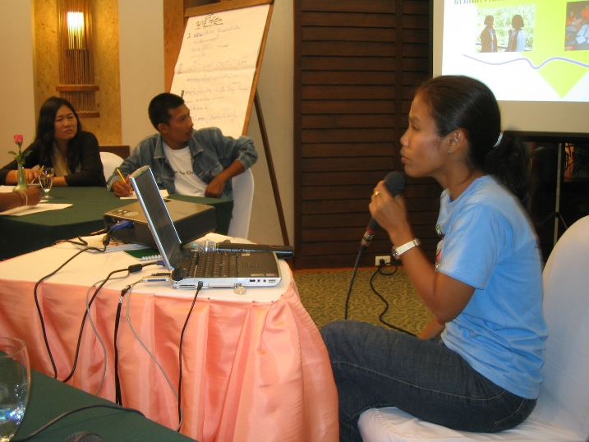 | 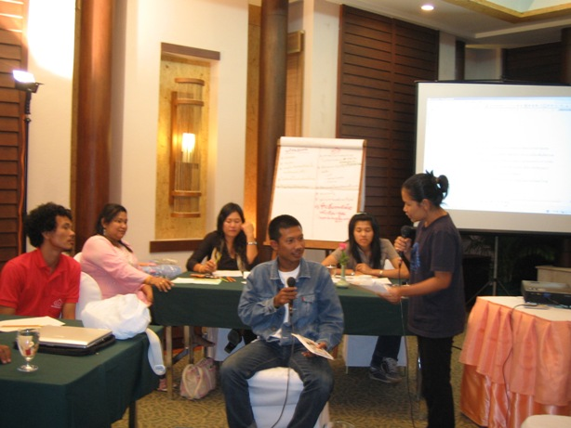

Main topics discussed during the workshop comprised of:

- Key concept of DRR such as hazard & disaster, risk & risk assessment & risk management/reduction, and vulnerability & Capacity.
- Save the Children strategies on disaster risk reduction Programme including why and how we should work with children on disaster risk reduction activities, expected achievement and process to be undertaken by partners.
- Why children’s participation in DRR programme is important. Save the Children believed that children can play a leading role in reducing potential disasters that will affect their lives and communities. Hereby, Save the Children’s seven practice standards of child participation were introduced to our partners.

Case study of children and young people participation in DRR programme in Vietnam and Cuba was presented during the workshop. Partner organizations also took this opportunity to sharing experience among each other on how to work with children, schools and communities. An implementation plan for each organization also arose at the end of the workshop.

Outcome

Partner organizations have a better idea on how to take CLDRR project forward. They also gained a better understanding on meaningful children’s participation that could be taken forward into the programming.

Feedbacks from partners:

“I have better understanding on what ‘children’s participation’ means for Save the Children, and have learnt more about how to work on children’s participation programme from others’ experiences. For those who have been working on children’s participation, the workshop provided a chance for us to review on how progress we have come in terms of working with children. The VDO on Cuba provided a great inspiration and tangible evidences.”

“The workshop also provided an opportunity to share experiences with other partners and to build network.”

The second capacity building of young trainer (CLDRR TOT 2)

Another 5 day training workshop was organized at the end of July 2006 for the same group of youth trainers. This workshop was facilitated by Marta Casamort, an ex-programme coordinator for Save the Children UK’s Child-Led DRR programme in Cuba.

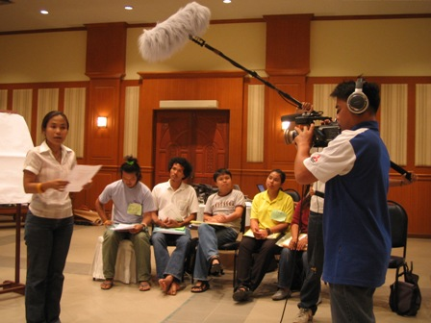 | 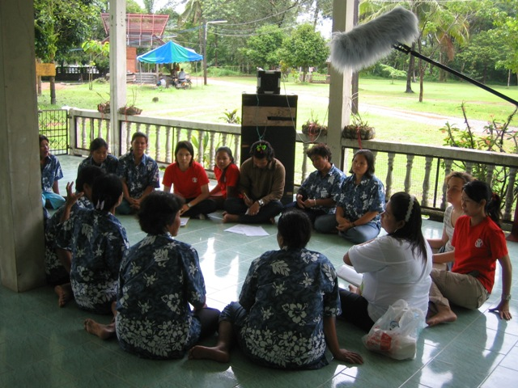

The workshop focused on practical skills that youth trainers would use in conducting activities with schools students:

- Community risk and resource mapping Definition and the value of risk and resource map were explained. Youth trainers learned about the steps in producing community risk and resource map – including community survey, identifying disaster risks in community and producing risk and resource maps. A one day visit trip to Bang Wan Community was also arranged for the youth trainers to practice tools and techniques obtained from the workshop.

- Educational campaign Youth trainers were trained on how to plan and strategise educational campaign to raise awareness on situation at risk and risk behaviour in the community.

Outcomes

Youth trainers/partner organisations have gained knowledge and skills from the practice during this TOT workshop. It was also reflected by youth trainers that participatory approach and “learning through practicing” approach helped them visualise the actual situation that they might faced in the future when they conduct training for students. They also felt that they had more confidence in transfer the knowledge and skills to the young people. Nevertheless, partner organizations also suggested that training module could be further adapted and simplified to suit local context and age group.

Feedbacks from partners:

“I have learned a lot during this week and built on my existing knowledge. For example producing community risk and resource map is something I have never done before.”

“I gained more knowledge on DRR because I have learnt about the process which can be applied to work with school and community.”

- Orientation workshop for schools

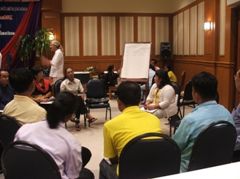 | 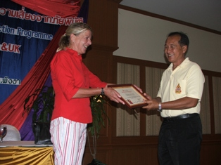

In August 2006, Save the Children Sweden and UK held an orientation workshop on children’s participation for school teachers and management. The workshop intended to to introduce Save the Children and our work in Thailand, our value, and seek schools’ support on the Child-led DRR Programme. Importance of children’s participation and approaches to involve children was also emphasized during the workshop. And to recognize schools that participated in Save the Children’s programme in the previous year, certificates of participation was awarded to 9 schools in 4 tsunami affected provinces. Participants included directors and teachers of 24 schools in Phuket, Phanga, Rannong and Krabi, representatives from the Ministry of Education and Education Service Area Offices, partner organisatons and Save the Children Sweden and UK managers and programme staffs.

Outcomes

Schools, partner organisations and Save the Children have had collective understanding of Child-led Disaster Risk Reduction programme. This positive outcome was clearly evident in an effective cooperative action between schools and partner organisations. School directors and teachers recognised and supported CLDRR activities in schools and saw the value of the project and the capacity of their students. A number of participated schools have taken Child-Led DRR programming forward even the first phase of the project has end. For instance, the school direct of Ban Nam Khem has integrated students’ community risk and resource map into the community emergency preparedness plan.

- Developing Training Manual on Child-Led DRR

After the 2 training workshops for youth trainers/partner organizations, a training manual on child-led DRR was also developed according to the request from youth trainers. The development of training manual was done in cooperation of Save the Children and partner organizations.

The first draft was created by SCUK and SCS programme staff based on contents from the two training workshops. The manual was used by youth trainers and a guidebook to work with children. At the end of the project, in January 2007, the training manual was revised by Save the Children and partner organizations based on the actual use. In general, the language in the manual was adapted into a more user friendly term, steps of implementation process were reduced, and the use of technical terms was simplified.

Contents of the training manual was divided into 4 parts: 1) Preparation stage 2) Child-Led DRR key concepts and terminologies 3) Community Risk and Resource Mapping and 4) Developing an Educational Campaign.

Outcomes

A training manual on child-led DRR was initiated and developed during the implementation period. Copies of the new version of training manual was reproduced and used for training partner organizations in the Phase II of the project. The manual was also translated into English and will be shared among Save the Children Sweden colleagues for wider use.

- Training for Children

After workshops and communicating with schools and students at preparation stage, each partner organization started to work with students in schools that they had originally planned. Among 20 schools, 10 schools are primary, 2 schools are secondary while the other eight are high schools.

In all schools, youth trainers began with conducting training sessions on disaster risk reduction terms and concepts; risk and resource mapping; educational campaign.

Outcomes

After the training, children have had a better understanding of DRR concepts and techniques to assess disaster risks and develop education campaigns. Relationship between youth trainers and children was established and laid a foundation for working together in the next step.

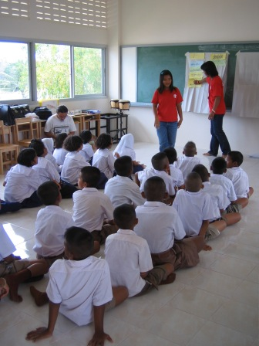 | 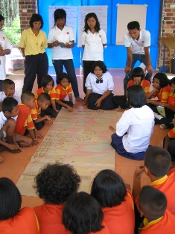 | 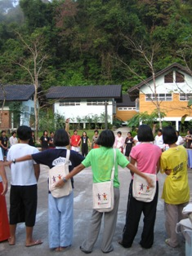

Different approaches of working with children on Child-Led DRR

It is worthwhile to note hear that youth trainers used different approaches to conduct t training for target children.

Duang Pratheep Foundation (DPF) and Asian Resource Foundation (ARF) conduct training with children in schools in a classroom setting. Youth trainers visited target schools once or twice a month and followed each steps in the training manual.

Working with 8 schools in 4 provinces (Ranong, Pang Nga, Krabi and Phuket), it is not feasible for Youth Network and Development (YND) to visit each schools at the same period of time. Two capacity building session for children was organised in a form of three-day training camps – each for 4 schools. Within these three days, children were trained on these three steps: DRR concepts and definitions, community risk and resource mapping, and DRR educational campaign. After the training camp, YND followed up with children at each school by supporting children conduct community risk and resource mapping and educational campaigning.

Rabatbai - a local group embedded in Ranong, has closer and longer relationship with schools that it worked with. Rabatbai previously worked with primary students at Ban Talay Nok School to develop a puppet show and a story book; “Alert Rabbit”. The story of “Alert Rabbit” was composed by students themselves with help of Rabatbai staff in refining the story. The story attempted to explain the vulnerabilities and capacities in a village, and how to reduce risk. The “Alert Rabbit” was used as tool to raise awareness of participating children on DRR before starting its Child-Led DRR training process.

- Youth trainers working with school children on Disaster Risk and Resource Mapping

Community visits were also conducted in nearby communities to provide an opportunity for young students to utilize skills and techniques that were trained by the youth trainers. The youth trainers coached children very closely in developing survey questions to ask community members. During the community visit, divided into 3 groups in accordance with categories of information required for developing risk and resource maps and educational campaign: 1. health group; 2.environmental group; and 3.community and social group respectively.

With support and guidance by youth trainers, children analyse the information gained from community visit and selected a potential disaster as a starting point. From that, children draw the community disaster risk and resource map. They also brought the first draft of their maps to discuss with community members to verify the information on the map. When the map was agreed by all parties, children made copies of their maps, present them to their friends and community meetings and displayed them in public areas within schools and communities. | 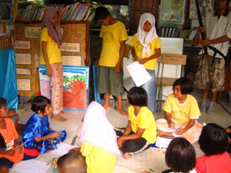

Outcomes

Community visits helped children get to know more about their communities. Children also had an opportunity to “learning by doing” by working through the process of disaster risk analysis and developing the community risk and resource maps. At the end of this process, children have gained understanding of disaster and knowledge on their communities. From participating in the process, children gained self-confidence and capability to transfer knowledge on DRR to their peers and community members. Community also recognized capacity of children especially after they saw the maps. In some communities, children were asked to produce copies of their maps for wider distribution.

Feedbacks from children and teachers:

Obb, a Grade 5 student, from Ban Nam Kem school said,

“Learning about key concept on DRR is very easy and most interesting for me. I understand and learn many new words such as hazard, disaster, vulnerability, capacity and risk reduction. I can explain this to other people. The youth trainers from DPF taught us to learn about these meaningful words thru games and activities so it is very easy to understand.”

Teachers’ notes included the following comment,
“Children have developed leadership skill, gained knowledge, increase life skills and can now present their knowledge to other people. They have learned by practicing to improve their team work and to accept each other’s strengths and weaknesses.”

- Children conduct educational campaign

After children produce community risk and resource maps, they planned to develop an educational campaign. Children identified situation at risk and risk behaviour, select campaign media, plan the campaign, undertake educational campaign production and test the campaign with community members. Among others, a number of stage performances and puppet shows were performed by children. Printed materials such as leaflet, calendar, and story book were produced with support of youth trainers.

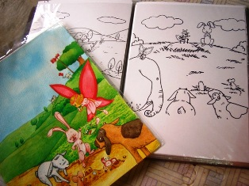 | 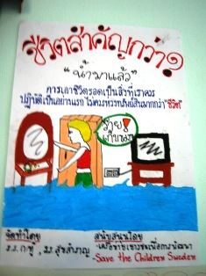

In Ranong, children produced DRR posters, “Alert Rabbit” story book and puppet show for their friends, students in other schools and community members to understand about the potential disaster and how to prepare themselves to avoid the losses. Children in Phuket produced DRR desk calendar by putting warning sentences in the incident of Tsunami outbreak on each month of the calendar.

Outcomes

Children have learnt to initiate a campaign which arisen from the children and community’s perspectives. The DRR knowledge, therefore, belong to the community whereas community members understand how to reduce risk from disaster. The whole process was taken the lead by children.

- Documentation of Child-led DRR process

As this pilot project was an experiment of new ideas and approaches, Save the Children could learn from this process to further refine the programme and replicate into a larger scale. A video team was hired to document the programme’s process through out the six month period. At the end of the process, a 30 minute documentary film was produced for distribution to Save the Children alliance, schools, partners and other interested organizations to advocate ideas of children’s participation in disaster risk reduction programming.

Outcomes

Video on lessons learnt from Child-Led DRR Programme in Thailand was produced and distribution plan was developed. It is hoped that lessons learned from this project will strengthen the understanding of Child-led DRR in Thailand, the region and other countries. Apart from approaches and experiences in promoting DRR in communities, the video could help reemphasise that children’s participation can be done, and how one could involve children in any activities.

- Child-led Disaster Risk Reduction Lesson learning Workshop

In December 2006, at the end of the project period, a lessons-learned workshop was conducted to:

- Allow Save the Children to learn from experience of the pilot child-led DRR project and to develop better program in the next year and future
- Enable Save the Children to advocate for child-led DRR program through Ministry of Education, Save the Children in other countries and other agencies by sharing lessons learned

Workshop participants include representatives of children and designated teachers in participated schools, Educational Service Area Officers, youth trainers/partner organizations, staff members of Save the Children Sweden & UK, and colleagues from NGOs in Thailand and Save the Children in the region (Save the Children Sweden’s South Asian Office, Country Office of India, Indonesia and Sri Lanka.

Process of the Workshop

The workshop began with the opening session presided over by Dr.Panya Kaewkeeyoon, Ministry of education and Mr.Herluf Madsen, representative of the Save the children Sweden, Southeast Asia and the Pacific Regional Office. This followed by the demonstration of an interactive DRR activities by children. For examples, children from Talaynok School of Ranong demonstrated their survival bag, while students of Kuan Sai Ngam School present a game to raise awareness on the importance of preparedness of bird flu. Children also presented child-led DRR process and educational campaigns which they had prepared during the Children forum as well as answer questions from audiences.

A panel discussion was conducted where students, teachers and partner organizations to reflect their views and experiences on participating in this project. Children discussed what they learnt from the activity and how those benefit them and their communities. Teachers shared their views that the program increased the capacity of children. At the same time, partners representatives reflected that the program did not only improved the capacity of the participated children; but it also improved the capacity of youth trainers.

At this workshop, an impact assessment session was also conducted for both adults and children participated in the programme. Framework for impact assessment used for this session is Global Impact Monitoring (GIM) which focuses on the impact of the program in 5 dimensions (change in children’s lives, change in policy and practice, change in non-discrimination, change in children’s participation and change in capacity of civil society and communities).

Last but not least, overall learning and recommendations for taking forward child-led DRR in the future programme were contributed by all participants including children, educational officers and Save the Children’s partners.

Outcomes

From this workshop, Save the Children learned what we have done well and what need to be improved. By involving children, teachers, partners and Save the Children colleagues from other countries in the lessons learned workshop, it helped us to reflect our learning from encompassing perspectives. Learning from this workshop would contributed to improve our Child-Led DRR programming in the year 2007.

- Roles of Save the Children

Save the Children Sweden and UK in Thailand does not work as an implementation NGO, but we work with children through our local partners. However, Save the Children plays a substantial role through out the implementation period. Our roles include:

- Initiate dialog on Child-Led DRR with partner organizations: Child-Led Disaster Risk Reduction Programming is a very new ideas for partner organizations in Thailand and, possibly, this region. This was done through presentation in meetings, organizing study trip to visit existing Save the Children’s DRR projects, and working with them to develop a project framework
- Provide technical support on DRR for partner organizations: This was done through a series of training workshop, on-site coaching while youth trainers work with children on the field; and refreshing training workshop.
- Mobilise cooperation from schools by conducting an orientation workshop for schools. This workshop aimed for creating the common understanding of child participation concept and the core element of Child-Led DRR project implementation.
- Develop guideline and handbook for working on Child-Led DRR activities with inputs from partner organizations.
- Monitoring and evaluation: Save the Children’s programme staffs monitored the project activity regularly in schools and communities. At the end of the first phase, Save the Children organised a workshop to assess the impact of Child-led DRR project. Child-friendly tools used for assessing impacts/changes under the GIM framework were also developed for this purpose.

Outcomes

Save the Children programme staff ensured that key concepts of Child Led DRR as well as way of working were delivered to youth trainers/local partners, hence ensure the effectiveness of the project implementation. Save the Children also contributed to strengthen skills of partner organisation’s on different arenas. Partners reported that they gained more knowledge on DRR, project management skills and important guidelines for working with children.

Chapter 3
Impacts on Children

An impact assessment session was conducted during the Child-led Disaster Risk Reduction Lesson learning Workshop in December 2006. Outcomes which emerged from these detailed consultations with children, teachers and the youth trainers are detailed under each of the five dimensions of change as follows. As such a wealth of information was gathered, it cannot be replicated in this report, therefore a summary of the messages identified is provided, followed by a selection of direct quotations as specific examples of these view points.

DIMENSION 1: CHANGES IN THE LIVES OF CHILDREN AND YOUNG PEOPLE

Because the project’s main activities aim to build capacity of children on disaster risk reduction and empower them to take an active part in school/community based activities. Changes in children themselves are reflected strongly by both children and their teachers.

Changed perspectives, attitudes and behaviours

- It has come out very strongly that the children are more confident to express themselves through various means including public speaking, performing theatre shows and making presentations in groups. Children also reported that they are more confident in talking directly to adults, thinking and doing things by themselves, and presenting ideas and outcomes to others.
- Teachers reflected that children have also learnt skills in daily life such as being more responsible, punctual, and cooperative. Furthermore they identify that children have developed leadership skills and presentation skills; they have learnt to listen to their friends and think more of others and about issues faced by their communities.
- Interestingly, children who do not have good school academic performance are recognised by peers after demonstrating their capacity in this project.

Improved knowledge and skills

- Children reported that they have realised the importance of disaster risk reduction. They gained a better understanding on disaster risk reduction concepts and terminologies.
- Children reflected that they have gained skills that correspond to those provided during the training such as:
  - Conducting community visits and research & developing R&R Mapping,
  - Producing and delivering DRR educational campaign
  - Providing information on DRR to other children in schools
- From the project activities, children also learnt more about their own communities
- With regards to skills, children reported that they have gained more skills in leadership, decision-making, and working as a team. This resulted from the work processes of this project that focus on group work, are open for children’s input, and provide opportunities to express without judgment.
- From youth trainers’ perspective, by acting as a youth leader, children have skills to protect themselves from disaster because they have to practice and disseminate this knowledge to their friends over and over again
- From the teachers’ perspective,
  - Children can compare situational analysis between past and present
  - Children can apply the risk assessment method to other hazards beyond the disaster they explored to threats such as the spread of bird flu.
  - Children have begun to think of how they can play a significant role in the community

Changed status of children and young people

- Children are more effectively interacting with peers and adults. For example, they invited children from other schools to participate in school’s sport day.
- Children have taken on a leading role in conducting activities with far less support from teachers

Changed relationship with significant adults

- Children reported that they are more confident in talking directly to adults
- Teachers think that this project proves that children can play a lead role in DRR

Factors facilitating the changes

- The child-friendly and participatory process of capacity building and working with children taken by partner organisations/ youth trainers.
- The morale boosting support offered to children by partner organisations, teachers and parents.
- The design of the project that opened the way for children to participate in all the steps and experiment in all the activities – such as designing the questions to ask community members and actually conducting the community visits themselves.
- The process is flexible with no absolute right or wrong. It opens and accepts all opinions of children.
- Results & outcomes of the project are concrete and highly visible.
- It is worthwhile to note that, according to some children, their increase in confidence, knowledge and skills has not resulted from this project alone. Some children said that they have previously gained confidence, knowledge and some skills from schools and participation in activities conducted by other NGOs. This project is a part of these overall participation inputs.

What children and teachers say…

Obb, a Grade 5 student, from Ban Nam Kem school said,
“Learning about key concept on DRR is very easy and most interesting for me. I understand and learn many new words such as hazard, disaster, vulnerability, capacity and risk reduction. I can explain this to other people. The youth trainers from DPF taught us to learn about these meaningful words thru games and activities so it is very easy to understand.”

Dream, a Grade 6 student, from Bangmuang school said,
“I have learned and remember the meaning of the words - for example I know hazard mean danger, it can be man-made or even nature made while disaster means the event that actually causes severe danger and great loss.”

Ing a Grade 6 student, told us about their community mapping investigations,
“We prepared lots of questions because if they answered right to the point, we will gain a lot of information and learn about their opinions, their way of life, and their needs, to avoid disasters.”

Teachers’ notes included the following comments:
‘Children have developed leadership skill, gained knowledge, increased life skills and can now present their knowledge to other people. They have learned by practicing to improve their team work and to accept each other’s strengths and weaknesses.’

Nung, youth trainer who turned 18 during the pilot programme said in the panel discussion during the lesson learned workshop,
“I never thought that I would be in this position, I didn’t think I would be able to conduct the DRR activities in schools, did not believe we would be able to coordinate and gain support from schools, but now, my perspective is changed, I believe we as youth trainers can do many things, but we must keep learning.”
“Children have capacity. They can express their ideas so that people know what they wanted to do. I believe this project can be expanded to other disaster affected areas and every areas, with child participation, with children in the leading roles. I feel lots of changes… I feel good, as it’s a development of me and the children.

Sumontha Chutong, Field Worker – Youth Network for Development, said:
“And what I found was that the children could not only achieve what we expected, but more than that, even. The outcome may not so perfect, so great, so grace, but if the creators are happy and can manage to enjoy, I believe it’s a success.
“Children of all ages can do it according to their capacities. The difficult part is managing – to organize groups in school. Now they started to have a work plan – when to sit and plan, when to do mapping, etc - we’ll conduct the field research today and the map must be finished that day, so how should we plan the timing so that it won’t affect our study. I think this kind of group management is quite a skill.”

DIMENSION 2: CHANGES IN POLICIES AND PRACTICES AFFECTING CHILDREN’S AND YOUNG PEOPLE’S RIGHTS

Due to the short period of the pilot phase of this project, and the fact that changes in governmental policies and practices normally take a long time, we did not obtain any concrete evidence for changes in this dimension. However, teachers have reflected a positive attitude towards the project approach and the possibility of integrating it into school plans in the future and community leaders have indicated their approval and welcome of children’s participation in community processes.

Initiative to integrate children’s DRR work in school & community plans

- Some schools and communities are eager for children to further improve the quality of their risk & resource maps, so that it becomes a standardised map to be used as a permanent risk & resource map for communities. However, it is important that Tambon Administration Organisation (sub-district level governmental body) agree to cooperate with schools. So far only one such authority has worked directly with the children and their maps.
- Teachers think that this child-led DRR process can be integrated into a local curriculum for all levels, especially as during this period, the Ministry of Education has established an action plan for schools to teach about DRR, so this provides a good opportunity to apply Save the Children’s process for the benefit of children and schools. Teachers also reflected that they were informed by the Ministry of Education that disaster preparedness should be one priority for schools, however, they were not provided with a process of how to do this, so the process from this project fills the gap.
- This programme has resulted in useful networks with other schools and sharing of experience between schools.

Promote the concept and practice of children’s participation in school classes & activities

- Teachers reported that the approach that the project adopts to build capacity of children could be adapted by teachers in schools.

- Youth trainers’ discussion reflected that child-led DRR programme induced a concrete example of how school can take action on emergency preparedness

What teachers say…

The principal of Bangwan School said,
“I’m quite interested in the process of training, I think it is a participatory way. I asked the teacher to observe the process. I told her that we can use or adapt their training process into our classroom.”

In the Lessons Learned forum, teachers concluded that this process:
‘Increases teachers skill to teach and facilitate participatory lessons; participating schools now have special teachers who have more expertise in DRR; at the same time other teachers also gain more knowledge from children’s presentations and community maps.’

In the teachers group at the DRR LL workshop one teacher said,
“I believe I can use the toolkit to transfer knowledge and skill or even interest to other children who have not been able to participate in this year’s project.”

Teacher Natt of Klongyangnusorn School in Krabi, said,
“Many teachers thought, well, why don’t we integrate this project into the Life Skill subject? Before this, the kids were not active and didn’t participate (in community affairs)…Just like a still water that no one stirred.. No inputs and they didn’t know where to stand. But after the youth trainers had come and showed them the way, they became active and now know how to express their ideas.”

DIMENSION 3: CHANGES IN YOUNG PEOPLE’S PARTICIPATION AND ACTIVE CITIZENSHIP

Children’s participation is the core of this project. Children’s capacity to meaningfully participate is one of the end goals as stated in the project document. Changes in Dimension 3 have evolved strongly according to all stakeholders who participated during the impact assessment process.

Changes in capacity to participate and influence others

- Children have more involvement in a wider range of activities. For example, children can develop campaign materials and distribute them in communities by themselves. Children can think by themselves, assess their own communities and analyse some of the problems faced.
- Teachers reported that communities are aware of the importance of DRR and realise children’s capacity to assist in DRR processes.
- Children reported that they are more confident to talk to their parents on issues concerning them
- Youth trainers said that from implementing this project, it is proved that children can play an active role in issues relevant to them; can work side by side with adults. The activity provided a chance for children to effectively demonstrate their capacity

Collective Action

- Children can work in teams including planning, sharing responsibility, and guidance. However, support and guidance from adults during the working processes is still very crucial. If children have an opportunity to further develop their skills based on this activity, they can participate at even higher levels.

Children’s involvement in decision making processes

- Children reflected that they felt involved at all steps in the project activities and were provided opportunities to think, plan and implement by themselves. However, children’s involvement in decision making processes outside the arena of this Child-Led DRR project is still limited.
- Teachers said that children have been more confident and creative in organising activities during schools’ events such as the school’s New Year party, and teachers let them take the lead having learnt from the project approach themselves. There is not yet evidence to demonstrate the involvement of children in more formal areas such as community meetings.
- Partner organisations/youth trainers reported that children has potential to be involved in the activities done by adults– for an example, in Ranong Province, children are involved in the village committee on disaster preparedness.

Parents and communities recognise capacity of children
- It is clear from both children and teachers that parents and other adults in the communities who have observed activities were very impressed by children’s capacity. Children said that concrete outputs from the project produced by children – such as risk and resource maps and educational campaigns such as puppet shows and print materials – which adults can visually see are strong tools to prove that “children can do it”, rather than just having children make a speech or statement.
- According to the youth trainers, adults changed their attitudes towards children’s capacity, quoted as “children can do and act on big things just like what adults do”
- During the process, a number of adults in communities where children worked with welcomed the idea of children pay attention to communities’ history and knowledge; start something useful for the communities; and put an effort to work with adults

What children and adults say…

Kung, Ratchaprachanokroh School Phuket said,
“I’m glad. At least we can help the community members to gain more information about disaster risk reduction. I’m impressed with the cooperation among friends – we’ve done good work.”

The School Director of Ban Nairai school, Phang-nga concluded,
‘Certainly, the children can help themselves.’

Overall the conclusion is that children CAN participate effectively as seen in this conversation filmed during the child led DRR process:
Student, “Do you think children can participate with adults in meetings?”
Villager 1 “Yes, they can.”
Student, “Why?”
Villager 2 “Because children have equal rights as adults do..
Villager 3 “Because the adults also want the children to participate in meetings.”

Muay, Field Worker - Asian Resource Foundation, said:
“The most important thing for working with children is that we must have confidence in them – that they are capable. Children have capacity and we must help strengthen it so that they can get to another step. Actually, a trainer like me has also learnt a lot from them. For example, our systems of thoughts are too complex, but the kids’ are simple, and they can express it in such a simple but very clear way.”

Sumontha Chutong, Field Worker – Youth Network for Development, said:
“The outcome may not so perfect, so beautiful. But if the children are happy, I believe it’s a success.”

Community Leader at Kamala Beach, Phuket, said:
“I’m glad that the kids have opinions to share with us. This is the only time that the kids came sharing their thoughts and their community maps. I must tell you this is the first time! Actually I’d love to have many groups of kids come, talk, get advice, but they are not interested in. If they come regularly, it’d be good because I also learn from them.

DIMENSION 4: CHANGES IN EQUITY AND NON-DISCRIMINATION OF CHILDREN AND YOUNG PEOPLE

There was no clear evidence to
In conclusions, the process of impact assessment conducted with children and teachers showed that:

- This project was designed to work with children in schools; therefore, it naturally did not involve out-of-school children and non-Thai children. This issue already came out clearly during the impact assessment process as an area which would need to be explored in the future to ensure such inclusion.
- Other groups of children that were not involved in the process are pre-school children. It may be possible to adapt contents/process of the project to suit younger children but it seems more appropriate that the school children include pre-school children in their vulnerability assessments and target their families to reduce risks for those young children.
- Teachers reflected that this project is good for both children with strong/weak academic school performance – which is very useful to boost self-esteem of children who were not accepted as “good students”

DIMENSION 5: CHANGES IN CIVIL SOCIETIES’ AND COMMUNITIES’ CAPACITY TO SUPPORT CHILDREN’S RIGHTS

- The capability of children in campaigning about DRR has helped families, schools, partners and communities to recognise children’s capacity. They commonly assert that they have more positive attitudes towards children now.
- Communities are more eager to work with children than in the past. Some adults have request the children to conduct the process again in other areas. Governmental agencies have asked children to present their work in their events
- Teachers reported that there is a wide range of opportunity to expand the process to other schools nearby and with surrounding communities so that they have become more involved and supportive to children. This effort will however be a big challenge and would need a lot of efforts from different stakeholders.
- For partner organisations, this Child-Led DRR programme has potential to expand into other areas outside of tsunami affected areas. As an example, a TOT on Child-Led DRR programme could be conducted for youth groups and local NGOs in other provinces by youth trainers/partner organisations themselves. Anumber of local NGOs have expressed interest to become involved in this project.

What communities, teachers, and partner organizations say….

Aunty Oy, a villager from Ban Bangwan, Phang-nga, said,
“This is the first time the young ones came. Usually they are at school and do activities only in school. I’m glad this has started in our village. If they want any information that I know or experience, I will give them. I’d like them to do this - to participate with the adult’s community life.

Teacher Natt, commented,
“In my experiences talking with the parents, their reflection was like, “Oh! Our kids can really do this?” When children do something, sometimes the adults just didn’t believe in them. Children do it? Just Children? They can really do it?’

The Community leader of Kamala beach said,
“I’m glad that the kids have opinions to share. … only this time that the kids came sharing their thoughts. I must tell you this is the first time! Actually I’d love to have many groups of kids to come, talk, and get advice …. If they come regularly, it’d be good because I’ve learnt from them.”

The Ban Nairai school director said,
“For the maps that the kids are making, we’ll make use of it and continue. We want to see our community strong. This is my hope for the future.”

Sumontha Chutong, Field Worker – Youth Network for Development, said:
“Why was I interested in joining the program? It must be about our similar ideology. I believe children and youth are part of the society, so regarding whatever affecting them and their communities, they must participate in thinking, expressing ideas, and solve the problems. Children, especially those in disaster- affected areas, didn’t just need help or be all-time receivers. They also want to stand up and fight.

At the end of the day, the highest level of child participation is not when the children work by themselves, but when the children and adults work side by side.”

Chapter 4
Lessons Learnt

Lessons learnt from the six-month experience on implementing Child-Led DRR Programme were derived from discussions among groups of children, teachers/educational personnel, youth trainers/partner organizations, and Save the Children colleagues from the region during the lessons learning workshop in December 2006.

5.1 LESSONS LEARNT

STRENGTHS OF THE PROGRAMME

Programmatic Framework:

- This pilot project started off as a good initiative towards Child-Led DRR
- The programme strongly demonstrated children’s ability to lead DRR.

Support to youth trainers/local partners:

- Trainings are organized in a systematic way – starting off by a series of tranings for youth trainers, orientation to teachers, and training for training.
- The programme also emphasized on established rapport/cooperation with school authorities who got convinced on CLDRR
- There are platforms for cross learning and sharing among the SC partners through various workshops and meetings
- Training manual and training workshops organized by Save the Children proved to be very useful for youth trainers/partner organizations
- The school orientation workshop helped schools to have a collective understanding about the concepts/process of the project; hence help pave way for partner organizations on undertaking project afterwards
- The lessons learning workshop helped partner organizations to gain skills on impact assessment of project, and reflect outcomes and impacts as well as lessons learnt from the past six months. The fact that lessons learning workshop was organized by Save the Children with participation of all partner organizations, this reduced the workload of each partner organizations, and provided an opportunity to learn and share with colleagues

Method and activities to work with children:

- Media campaign is effective. Children proved to be able to choose their medium, got training on how to use it, prepared the script, practiced and demonstrated it.
- Activities maximized children’s strengths in drawing and painting and thus came out with lot of symbols useful for disaster risk mapping.

Level of children’s participation

- Output from the pilot programme strongly suggested that there is high level of participation in many activities during the process including children’s involvement in project impact assessment.
- This project can be used as a show case as an approach to involve children in project activities.

Potential to gain supports from adult stakeholders

- This project is able to enlist the support of adults in the community for CLDRR and has potential to get the support of local governments

Advocacy tools

- The lessons learnt VDO produced during the pilot programme can be used as an advocacy tool to raise awareness of stakeholders that the child-led DRR is possible in Thailand.

CHALLENGES & PRECAUTION

- Time constraint: The Child-Led DRR programme should have a minimum duration of one year to achieve the desired results. For running a school based programme, it is also important to plan the project timetable in accordance with school’s year plan to avoid the constraints of children participation, for example, during exams or school holiday.

- Child participation and DRR: There are 2 components in this project. Children participation (leading) and DRR. It is important that understanding of both children’s participation and DRR are equally emphasized rather than one of them. At the same time, during the process of implementation, children still face the situation where communities do not accept their actions and roles. It is important the ensure that the programme has a component that work with adults in sensitizing them on the importance of children’s participation, and what they can do to support the children.

- Selection of the community / schools: DRR may not be required by all the schools and all the communities, which totally depend on their locality. The community mapping will be good for vulnerable villages, so that the community will respond effectively towards the disaster. Otherwise they will not show interest.

- Adults’ participation: It would be good if community representatives were involved in the project process in a more strategic way. This could be done by increasing an opportunity where adults and children interface more often so that adults realize the potential of children as well as the necessity of DRR. It will pave a way for sustaining the impact with their continued support.

5.2 RECOMMENDATION FOR FUTURE CHILD-LED DRR

Children’s recommendations:

Continuity

- Child-led DRR should be continued in schools so that other children access to such opportunity.
- Children should be supported to continue to take their actions forward; for example, distribution of their maps into a wider audience and launch their educational campaigns

Support system

- A network of children working on DRR should be established as a platform for experience sharing and lessons learnt among children

More inclusive

- Child-led DRR could involve wider groups of children in schools. Among other approaches, DRR activities could be integrated into schools’ curriculum for students in different grades in the same school.
- The programme should seek to reach out to out of school children

Expansion into other areas

- Child-led DRR could be expanded into other regions of Thailand as its principles and activities are relevant to many places. If the children are provided with an opportunity to learn and run the child-led DRR, it will benefit both to the children themselves and the community. The children who participated in this pilot program have a strong will to share their experiences to others.

Teachers’ recommendations:

More inclusive

- The programme should seek to include children from different age groups
- The programme should involve local authorities and community leaders in its planned activities
- The programme should adapt Child-led DRR activities to be able to reach out of school children
- Community risk and resource maps should be disseminated to the community. This is one way to disseminate knowledge to younger children or out of school children

Child-led DRR in school

- Child-led DRR activities could be integrated into school curriculum
- Teachers could be promoted to become a trainer or facilitator so that they can play an active role on promoting Child-led DRR in their own schools.
- Schools participated in the first phase of Child-led DRR programme can take the lead in piloting implementation of Child-led DRR into their school
- Teacher forum could be held for teachers to discuss how to integrate child-led DRR into their school curriculum. This will be more practical in term of adapting Child-led DRR into school curriculum than one school do on its own.
- Network of school who work on child-led DRR should be organized, it will be for sharing at the same time raise more concerns.
- It is important for extra-curriculum programme like this one should be planned with schools to be in line with school’s calendar to avoid overlapping and overload of activities.

Roles of children

- A more active role of children in school and community should be promoted. For example, children can become a member of school/community’s disaster preparedness committee

Quality of training

- Quality of knowledge and skills on DRR could be improved. For example, how to use the compass etc.

Youth trainers/Partner organisations’ recommendation

Expansion into other areas

- Child-Led DRR programme has potential to expand into other areas outside of tsunami affected areas
- TOT on Child-Led DRR programme could be conducted for youth groups and local NGOs in other provinces. This could be done by youth trainers

More community involvement
- Community leaders and other relevant stakeholders in the community should also be invited to the school orientation workshop

Supporting system
- A forum for experience sharing and learning from each other should be facilitated (by SC) for youth trainers/partner organizations in Child-Led DRR workshop

Programme timeframe
- The project should have more flexible timeline, and should be planned to implement in a longer term.

Recommendations from Save the Children’s colleagues from the region:

To improve quality of the programme elements and to ensure the sustainability of the programme, recommendations from Save the Children colleagues include the following aspects:

Advocacy:

- Visual example such as documentary video demonstrating the Cuba’s project and its success is an effective tool to introduce and raise people’s concern about child-led DRR. However, it is different from local context. If the video is used for such purpose, a follow-up discussion on how to apply to Thai context needs to be conducted. The lessons learnt VDO produced during the pilot programme can be used as an advocacy tool to raise awareness of stakeholders that the child-led DRR is possible in Thailand.
- Lobbying and advocacy to MOE at local-provincial level to integrate DRR in the school curriculum officially.
- Develop DRR promotional materials to be disseminated widely in the community level

Supports to partners:

- Output from the pilot programme strongly suggested that there is high level of participation in many activities. However, there is a need to support children to run their child-led DRR activities in school and community.
- The supporting system to youth trainers/local partners needs to be planned ahead.
- There should be a learning forum for trainers, children as well as teachers. The learning forum could support and improve their capability to continue improve their child-led DRR activities

Enhance children’s participation:

- Involve children and youth in the conceptualization, setting of criteria and selection of youth trainers
- Provide other useful skills to children such as presentation skills
- Inclusion of children in a wider different age groups and go beyond schools’ peer to peer teaching
- Promote documentation by children
- Division of responsibility between children, youth trainers and teachers; and between students and adults.
- Broaden project to wider group of children such as children at different age group and out-of-school children

Partnership:

- Build and support partnership among partners, stakeholders, major decision makers
- Establishing links between/among partner organizations, youth trainers and administration.
- Community involvement: More stakeholders should be involved such as teachers, community leader and local authority to make programme more sustainable and expandable

Concepts and context of DRR:

- Responsibility of children: It is important to note that, as discussed among Save the Children programme staff in Agra Workshop, the responsibility to protect children still lies with adults in the community which indicates that they have a major role and they should also be involved in risk mapping.

- Quality of training could be improved in terms of technical knowledge such as direction in maps, how to use the compass

- Disaster risk mapping:
  - Active members from women groups, CBOs, local leaders, etc can be included.
  - As risk mapping is not a one time activity, which has to be updated once in 6 months (at least once in a year), it can be initiated and led by children in the community and 30 – 40% adults should be involved. This will ensure sustainable impact of CLDRR.

- Media campaign:
- Peer-Peer education: The CLDRR children representatives can also perform the shows (eg. puppet) with regular intervals in the schools for peer-peer education as well as in the community for mass awareness.
- Community radio can also be used as a medium for DRR.

Integration of Child-Led DRR into schools:

- Risk mapping for schools: Since most of the schools are situated at vulnerable localities, schools should have disaster mapping (hazard zone and safe zone along with vulnerable section (disabled) within school campus). The map can be displayed within the school campus at the prominent place for information dissemination to other children in the schools.

- Integrate DRR into school safety plan and develop school security system

- Integrate Child-Led DRR into schools’ curriculum: DRR can be disseminated to al children in the schools through the period allocated for local curriculum. DRR can also be integrated into curriculum under the subject of Geography, environmental studies, etc. The foremost responsibility of the children representative should be peer-peer education.

- Age specific: CLDRR should be age specific, for example, 11-13 years and 7-10 years. The DRR curriculum and activities must suit the age group of children, for example, children at 11-13 years of age can be involved more in the community and 7-10 years on individual/family preparedness.

- Training to Teachers: 2 or more teachers in each school should be trained on Child-Led DRR activities. If the teacher who got trained in DRR leaves the school for one or the other reason, there is a chance of discontinuing DRR activities as there will be no facilitator.

- Some schools should be supported to continue to integrate the Child-Led DRR into their own context. Their good practices can be shared with other schools/communities.

Roles of schools

- Appoint school teachers for school DRR activities
- Connecting with parent associations and other community members
- Connecting with teachers unions and conduct teachers training on DRR
- Creating school disaster management committee linked to the community Disaster Risk Management Committee

Programming

- Connect DRR issues and children’s participation issues with larger child rights issues

Activities that could be considered in CLDRR

- Emergency Preparedness:

- Survival kit: One of an activity for raising awareness on DRR is working with children to prepare a survival kit in case of disaster. The contents of survival kit should also include children necessities (in addition to food and clothing), for example, match box, ropes, Napkin, medicines – what type, expiry date, etc. This can be discussed within the community and finalized.

- Three levels of disaster preparedness: Disaster preparedness can be dealt at 3 levels – Individual preparedness, Family preparedness and community preparedness. First of all, the children should know dos and don’ts during emergency. If we teach family preparedness, they will in turn teach the parents which will have effect in the community.

- Not only Tsunami: It is important to emphasise that CLDRR includes other disasters – flood, cyclone, fire, road accidents, etc depending upon its necessity. The children have to decide on the type of disasters based on its frequency of occurrence for which the adults need to participate in risk mapping. When we analyze the history of disasters, the adults will be in a better position to recollect their memories than children.

- Formation of various DRR teams: Children can further form an early warning group, rescue and evacuation group, first aid group, etc for whom training can be given on their roles and responsibilities. These groups will help the other students when disaster occurs when they are in the schools.
If this idea shall be taken to the community, adults need to be involved in these groups for better delivery of services for the ultimate aim to reduce the disaster risks within the school and within the community.

- Simulation exercises: Now and then artificial emergency of flood and tsunami can be set up within the school and ask the children how to respond towards it. It will sustain the impact in the better way since the children always remember what they do, instead of learning what to do. The similar exercise can also be practiced within the community.

- Life Skills: DRR should not be considered as a separated project but could be integrated into life skill learning. These DRR skills make us not to get panic towards a specific situation, how to deal it, what kind of precautions to be taken, etc.

- Culture of the community: DRR should be made as part and parcel of the schools and community. The communities celebrate temple festivals, work for common cause where they share the responsibilities of fund collection, decoration, cultural programs, etc. Nobody taught them about this and it is being transferred from one generation to next. In the same way, DRR committees should exist in the schools and communities forever, making DRR as their culture, as part and parcel of their life.

CONCLUSION

The end results after six months of this pilot project prove that children, with the right kinds of support and guidance, are able to play a leading role in their communities in order to reduce the risks of disasters. And all children are capable in doing so no matter what are their local norms and cultures. A lesson from implementing this project demonstrates that supports from adults especially teachers, community members and project staff are key to success.

We recognize that there are areas for improvement in the next phase, as suggested by the children, teachers, partner organizations and Save the Children colleagues. For example, there is a need to expand in terms of reaching out to out-of-school children. Technical impact on communities such as planting trees, and strengthening bridges/ roads should be emphasised so that adults take an active role working with children reduce risks in their communities. In addition, timeframe for project implementation should be flexible and in-line with school’s calendar.

Participants of this project embrace the Child-Led DRR activities and think that this model should be continued in the tsunami affected areas as well as other areas in the country. They also suggested ways to strengthen the project in the future. For example, a platform/network for experience sharing among children and schools should be created. They also identified that Save the Children’s supports to partner organizations/youth trainers is important, and could be further strengthened in the next phase: learning forum, refreshing training, and on the job coaching

Save the Children will continue to pursue the involvement of the communities in the programme. At the same time, we will follow up plans for integration our Child-Led Disaster Risk Reduction module into the school curriculum and community preparedness plans.

For Save the Children, this Child-Led DRR project has been an invaluable learning experience for its staff, partner organizations and other involved stakeholders. The project also contributes to the programmatic framework of the organization in a longer term. Last but not least, this project has proven that higher levels of child participation can be achieved through such a practical and simple activity.

Lynne Benson
Thailand Tsunami Response Programme Director
Save the Children UK

This piece of work on child-led disaster risk reduction has been a learning experience for Save the Children and for the communities and the children in Southern Thailand.

When we first start doing this, people said, ‘this can’t work in Thailand’, the children in Thailand are not confidence enough, and the adults will not listen to them. And we learnt from this pilot process that that is not the case at all. With careful work to prepare the adults, the community leaders, the education people, they are really willing to support the children and then the children can do very well.

A really good start has been made, but we still have a long way to go. We need to increase the technical input – raise the technical understanding of children. I think this is something that can be expanded, and children in other communities in Thailand can replicate for the benefit of their communities.

Written by: Chitraporn Vanaspong – Senior Regional Programme Officer; Sophapan Ratanachena - Assistant Programme officer (SCS) and Jitlada Rattanaphan (SCUK) with programmatic and strategic contribution from Inger Ostergren (SCS) and Lynne Benson (SCUK).
Other programme areas include child protection, promoting child rights programming, children’s rights to a good physical environment, and quality and inclusive education
From teachers’ group discussion and notes of Tool Station 1
From notes taken from Tool Station 2
From teachers’ group discussion
Information is mostly gained from children and youth trainers
Information from teachers’ group discussion
Asia Regional Workshop on Child Led Disaster Risk Reduction Programming organized by Save the Children Sweden, held in Agra, India during 4-8 December 2006

