Save the children Sweden Norway

Sub office Jalalabad
Education program

The following stories are from different schools students & PTSA members. They are simple but reflect the commitment & responsibility of Parent Teacher, Student Association (PTSA), Student Councils (SC), community elders & other relevant people. The following two stories are stated by two girls when they were invited to Child Friendly Survey. They were member of a group who stated during presentation:

- Shapari D/o Mirza was invited to the program as an out of school girl. She was a student before but was prevented by her mother from schooling when she was at 8th class because her older sister who helped her mother became sick & couldn’t work at home. Shapari was prevented from schooling by her mother. She left school & stayed at home. It was stated by Shapari when she was asked during group work. Some member of group & our SLT encouraged her back to school & they contacted her father & he allowed her daughter to go back to school She was so much happy when she was allowed back to school. Right now she studies & goes to school regularly.

- Suraya D/o Abdul Wazir was also invited to the program as an out of school girl. She was students of grade 4th & left school because her class became quite small, Suraya said : “most students left school for different reasons. The principle of school integrated our class into other grade 4 classes. When I went to school I didn’t find my class then I asked headmaster for my new class but no one help me & no one search my new class & my name. Then I disappointed & forgave schooling & stayed at home. This case was exposed by Suraya during group work. She was encouraged by group members & facilitator & she restarted schooling.

She goes to school regularly right now & she is a regular student of school.

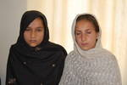

Soraya & Shapari are encouraged & they came back to school.

Ms. Inger Guddal Program coordinator was interested to meet Suraya & Shapaqri when we present report to her. She planned to visit & hear directly from them. This story was written by Inger guddal when she heard about the immediate result of CFSS survey:

(STORRY OF SOROYA AND KHAPERAI – WHY THEY LEFT THEIR EDUCATION AND HOW THEY WERE REINTEGRATED IN THEIR CLASSES BY SAVE THE CHILDREN SWEDEN-NORWAY PROGRAM):
Both girls were students of Kaja Mixes High school in Khogyani District of Nangarhar where SCS-N has operated the QUITE program under Rewrite the Future since January 2006.
In March 2009 our program for boys and girls who had left their education before fulfilling grade 12. Asking what were the obstacles/reasons? And how to prevent& stop more dropout? Soroya and Khaperai participated in the out of schoolgirl group.
Soroy, Daughter of Abdul Wazir’s STORY:
When I was in grade 4 my class became quite small due to several students moved or dropped out for a variation of reasons.
During the Winter Brake the leadership of the school decided to integrate the remaining students into other grade 4 glasses.
When I came back to school and searched for my classmates. I asked the teachers in which class I belonged, but nobody was able to help me to find my name or the name of my new teacher. So I gave up and stayed at home.
When I heard of this program of SCS-N I wanted to attend, and they helped me to find back my classmates and teacher. So now I am back in grade 4, and I want to complete my education until grade 12.
KHAPERAI daughter of Wazir’s STORY:
During the winter break after passing the exam of grade 7, my elder sister, who used to help my mother mostly in the house, and who never had been to school, fell serious ill. My mother then demanded that I should quit school, even if I wanted to continue, since she was in dire need of help in the house.
When I was called for this SCS-N program, I wanted to participate since my elder sister is well again and she urged me to try to continue my education.
After telling my story during the meeting, SCS-N helped to give me a new chance to fulfill my education and I am now in grade 8.
Another girl of grade 4, Shabana, daughter of Zahidullah, had the same problem as Soraya. In addition she was not able to pay Afghanis 100, for the documents she needed to fill inn. Her problems were also solved by SCS-N and she is back in school, but she was too shy to meet me.)

The following cases happened during a survey conducted about identifying barriers that students are faced to. This group pointed out the bellow problems, then they presented to the major barriers to elders & Education representative as bellow:

- The students of Kaja Girl High school raised the problem of toilettes when their representative named Ashuqullah presented the major problems to elders. He added: “The toilets of Kaja High school have used by students for 14 years which are full & not usable. From other side, there are no other toilettes to go there & use them so all students are faced to a serious problem. We request our elders & Education officers to solve our problem & find the way of solution for”. It was really a serious problem particularly for girl students. This demand of children was responded immediately by elders. Elders donated/collected Rs. 2300 at that moment:
- Rs. 1000 was paid by Khan Mohd PTSA member.
- Rs. 1000 was given by Haji Abdul haq head of PTSA.
- Rs. 100 was given by SLT Zabihullah.
- Rs. 100 was paid by Haji Mohd Asif PTSA member.
- Rs. 100 was donated by District Education officer
- And Rs. 2000 was paid by SCSN office. Toilets were cleaned & right now students use them.

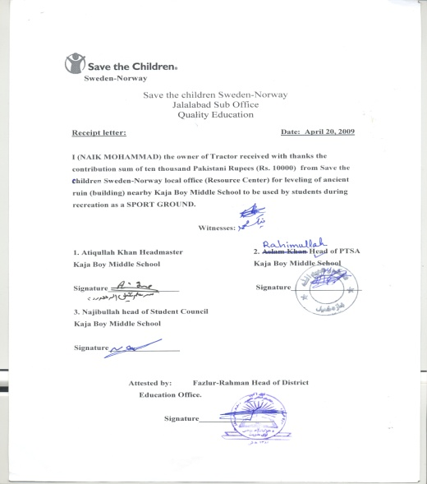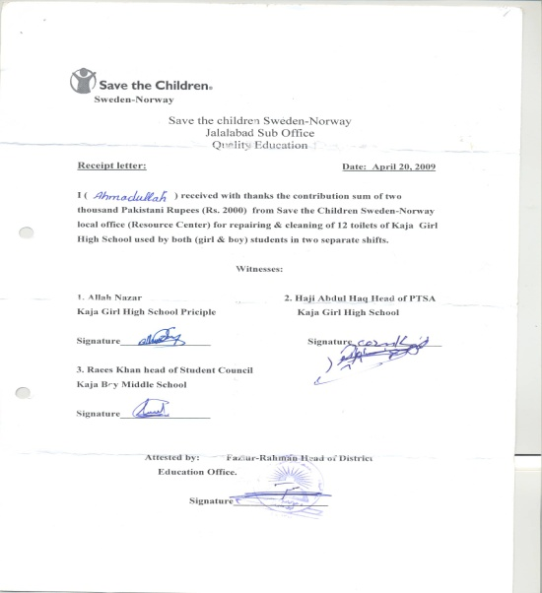
Rs. 10,000 given to Kaja boy Primary School for leveling of play ground Rs. 2000 given to Kaja Girl High School for cleanliness of toilets

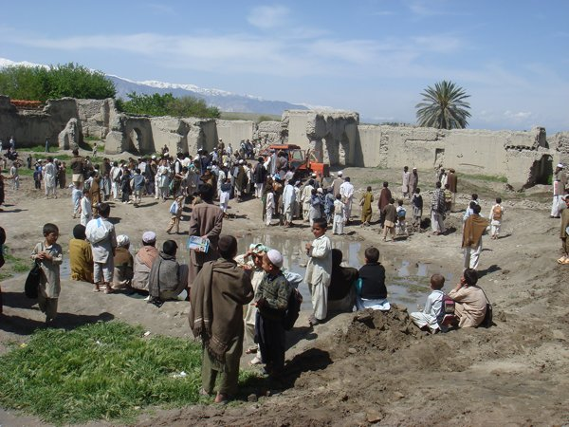
- Elders & PTSA member decided to make a ground for students of Kaja Boy School when children presented the problem of play ground to elders. Elders collected some money as community contribution they spent the collected amount for paving the ancient building located near to school while Rs. 10,000 was given by SCSN. Right now student shave play ground & they play there during recreation.

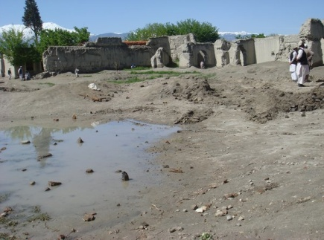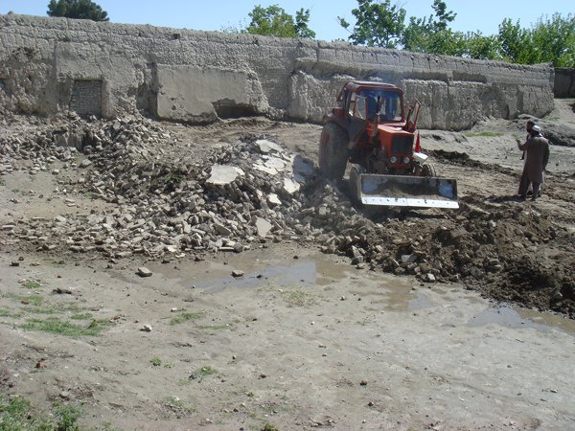

Photoes of leveling of play ground

- When the Friendly services survey groups were asked about the major problem they suffered by, at first they were encouraged to feel free & assured that their statement would be confidential & be kept as secret. It will be shared just with relevant references. Two students of Kaja Girl High School exposed a teacher who was charged in sexual issues. Frequently he asked the two students for such kind immoral relation which was refused by them. When District Education Officer heard this issue, he started inquiry about & he found that the teacher was really involved in. Then the teacher got retribution & was transferred far away to other school by District Education Officer.

- The second teacher of mentioned school named …was also exposed by the same group students He was charged on using of verbal abuse/bad language against students. He also used to humiliate students & call the students by disgrace names. Students expressed their reluctance during presentation to elders & complained to District Education Officer against cited teacher. District Education Officer noted the problem & promised to solve it. Then he (Head of District Education officer) warned the teacher & made him stop bad behavior & using of bad language. Right now the problem is solved & he behaves toward students fairly.

- Mirza Khail is one of Government schools covered by QUITE project at Khugiani District. It is official school but doesn't have school building; students set on the ground under the blue sky. Due to outside noise & intervention, student can't draw attention for learning at classes. SCSN established Parent-Teacher-Student Association (PTSA) to help school administration regarding school development affairs. The related community of Mirza Khail was persuaded by PTSA & they felt that lack of building is a big challenge for students so they decided to purchase a piece of land for school building. They purchased 3500 m² land which costs Rs. 370,000. Out of mentioned amount Rs. 135,000 were given by SCSN office as (cash Grant) & the rest was paid by related community. Said Wali head of PTSA of Mirza Khail School mortgaged his own land on Rs. 65,000 & he devoted this amount for school lend. This action of Said Wali shows that he really felt the importance & value of education & he got enough awareness in this regard. Bringing changes in the mind of people & community practices is an essential goal that is to be achieved through conducting different workshops.

- The second person of mentioned community is Azizur-Rahman s/o Noor-Rahman who has devoted his own fort (Qala) since the beginning of 2008 for winter course of students. Once Azizur-Rahman received night letter of Taliban in which they asked for stopping of using fort for schooling- other-wise the Fort would be burned by Taliban. In spite of that, Azizur -Rahman ignored their threat & he didn't stop winter course there & students came to fort/winter course regularly. It also shows that community is committed to do their best for children especially in education field.

- Khair Maina is another Government school covered by QUITE project in Khugiani District. Both boys & girls are enrolled in this school & study in two separate places. There is one building constructed by …? & used just for boy section. Community rented a fort used for girls education which is temporary not permanent. This School has Student Council established by SCSN & they got CRC & Child Protection trainings. Some members of this council came to school administration & claimed for separate & permanent building at Khair Maina. They forced school headmaster to call on community elders for discussion on mentioned issue so some prominent community elders came to school on December 21 & shared views for solving of this problem. Finally they donated 3000m² land for new building. It also shows that communities are concerned about children rights &committed to do their best for the benefit of children.

- Bar Bihar High School is a government school, covered by QUITE project in 2009. This school doesn't have enough area for recreation or other activities related to teaching & learning. As other school, it also has PTSA committee established by QUITE project staff. The building of this school is located next to the commute way used by all people of Bar Bihar which affects/disturbs student classes. This problem was discussed between school administration & PTSA members & shared widely with community elders. They decided to purchase the part of way/lend located next to school & turn the way of people to other side. They collected Rs. 35000 from community & purchased lend.

- Chino Myagan Middle school is another government school located at Khugiani District & covered by QUITE project in 2009. This school has an active PTSA who attended different workshops conducted by QUITE project for increasing their awareness. This school also doesn't have land for building. PTSA members motivated community elders & collected Rs. 70,000/- & purchased two Jereeb (4000m²) land for school building. Last winter when student were in our winter course classes in the open air shaking from cold, PRT team was passing nearby & the students (including boys and girls) observed their attention and came close to the students. They asked the students for the reason of their coming to the school in winter vacations and also some questions in English and other subjects as well which was answered by students specially girls without fail. So the PRT officials promised them to construct a school building for them. The PTSA followed the issue and got approval of two buildings for school consisted from 24 rooms & right now they are under construction.
wach tangi’s no2 female shura meeting report

- Meeting was conducted on 02/01/2010. Meeting was started by reciting of the holy Quran leaded by meryam’ the head of shura she explained the school student problems some girls are absent there due to some family problems. Reporter said: “We requested the head of Shura to meet the families of those girls who are absent for a long time & find out their problems of absenteeism and try to encourage them for rejoining the school. Mrs. sabara begam ‘ Mrs shirina ‘ Mrs ziba ‘ Mrs norjahan the members of the women shura were assigned to meet the families for mentioned purpose. The families of two girls said that their girls were teased by some boys on the way. They cannot peruse their education because of this problem anymore but after discussion & saying some arguments family allowed their daughters for rejoining of school. Shura reported that 2 girls were encouraged & they came back to school while 3 more were married. Meanwhile the Shura members explained child right to education to the committee and women who were met by Shura members were very pleased & they requested to them for informing their husbands to concern children right to education. The women Shura shared the above mention issue with the men shura. The men Shura not only shared this issue with the local people in masjed but also had talked with mula imam too. The mula imam guided local people to avoid their sons from teasing of girls .now these two girls are the regular students of school.
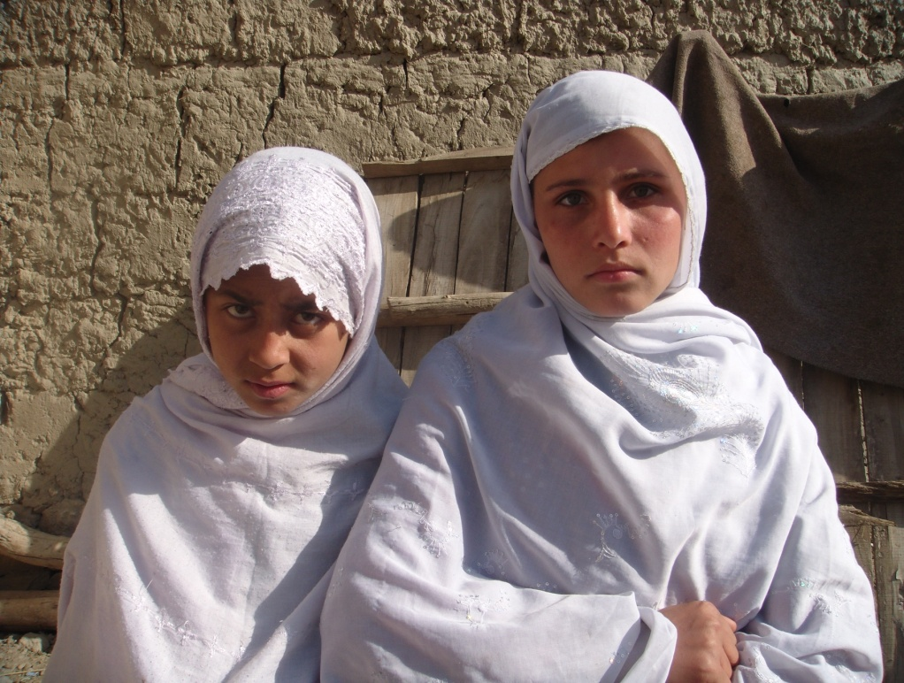
Hadiqa Atifa

