RESEARCH REPORT

Assessment of Teacher Competencies
in Crisis Contexts-Afghanistan
Contents
1 Executive Summary 3
2 Introduction 8
3 Methods 10
3.1 Participants 10
3.2 Instruments 12
3.2.1 The Teacher Competencies in Crisis Contexts Survey 12
3.2.2 Class Observation and Lesson Planning 14
3.2.3 Focus Group Discussion Interviews 16
3.3 Data collection and Analysis 16
3.3.1 Analytic approach. 17
4 Results 21
4.1 Teaching competency frameworks 21
4.1.1 Areas of overlap 21
4.1.2 Areas of difference 22
4.2 To what extent do teachers have the competencies necessary to successfully teach in crisis contexts? 23
4.2.1 Self-reported levels of performance 23
4.2.2 Influence of individual and contextual-level variables on teachers’ performance 35
4.2.3 Class Observations and lesson planning 39
4.3 Perceptions on context and training needs 41
4.3.1 The context and challenges of teaching 42
4.3.2 Training needs and teacher characteristics 50
5 Conclusions 53
6 Recommendations 57
6.1 For program implementers 57
6.1.1 Recommendations related to children attending and remaining in schools 57
6.1.2 Recommendations on teaching 59
6.2 For researchers 60
6.3 For Policymakers, donors and the ministry of education 60
7 References 63
8 Annexes 64
8.1 Annex 1: The Teacher Competencies in Crisis Contexts Survey 64
8.2 Annex 2: Performance levels rationale for subscales 69
8.3 Annex 3: Matching between competencies in the Afghanistan National Framework, INEE and the Teacher Competencies in Crisis Contexts Survey 77
8.4 Annex 4: Focus Group Discussion Interview Protocols 78
8.4.1 Teachers 78
8.4.2 Head Teachers 79
8.4.3 Master trainers 79
8.5 Annex 5: Class Observation Instrument 80
8.6 Annex 6: Descriptive results by teacher characteristic and sub-scales 86
8.6.1 Gender 86
8.6.2 Age (categories) 86
8.6.3 Teacher’s language 87
8.6.4 Teacher’s Level of Education 87
8.6.5 Teacher’s years of experience 88
8.6.6 Type of School 89
8.7 Annex 7: Total survey scores by teacher’s characteristics 90

Tables
Table 1 Survey sample 10
Table 2- Sample for Focus Group Discussions 11
Table 3 Class Observation and planning sample 11
Table 4- Teacher's Survey Reliability 14
Table 5- Structure of the class observation instrument 14
Table 6-Rubric for Lesson Plan Assessment 15
Table 7 Example: self-care scale 18
Table 8 Self-reported levels of performance, from the teacher’s survey (n=297) 19
Table 9 Data missingness for item 11 19
Table 10 Distribution of percentages of teachers by self-reported levels of proficiency in different subscales 24
Table 11 Regression coefficients for survey scores on teacher's characteristics 36
Table 12- Summary of Class Observation and Lesson Planning Scores 39
Table 13- Class Observation Average Scores (out of 100) 39
Table 14- Classroom observation – percentage of attainment relative to maximum scale score 40
Table 15- Lesson Plan Summary Scores 41

Figures
Figure 1 Analysis of the competence frameworks involved 17
Figure 2 Relationship between competence frameworks 22
Figure 3-Self-efficacy: performance levels for the study sample 25
Figure 4- Performace levels by region 25
Figure 5-Levels of work-related Stress – whole sample 26
Figure 6- Work-Related Stress: Levels by region 27
Figure 7- Self-care levels – whole sample 28
Figure 8- Self-Care: Proficiency levels by region 28
Figure 9- Teacher’s code of conduct knowledge and attitudes – whole sample 29
Figure 10- Teacher’s Code of Conduct Knowledge and Attitudes: levels by region 30
Figure 11- Child Protection & Well-being knowledge subscale: percentage of teachers by level 31
Figure 12- Child-Protection and well-being knowledge: levels by region 31
Figure 13- Curricular Framework Knowledge: percentage of teachers by level - whole sample 32
Figure 14- Curricular Framework Knowledge: levels by region 33
Figure 15- Self-Assessment of Teacher training subscale: percentage of teachers by level - whole sample 34
Figure 16- Self-Assessment of Teacher Training Knowledge: levels by region 34

Executive Summary
The present study has four goals 1) Characterizing a framework for teaching competencies in crisis contexts in Afghanistan, 2) Generating valid and reliable instruments to assess this framework, 3) Assess teachers’ needs and competencies based on classroom observations and self-reports, and 4) Identify how contextual and individual teaching characteristics are associated with teachers’ competencies, and 5) Understand the lived experiences of teachers working in contexts of crisis. Participants in this study are 296 teachers, 12 head teachers and 10 master trainers in four provinces in Afghanistan: Badghis, Kandahar, Kunduz and Nangarhar. The main findings of this study are the following:

Frameworks for teaching competencies:
The Afghanistan national framework for teaching competencies (Potvin, 2015) is a wide-ranging teaching framework that includes typical aspects related to professional teaching as defined in the specialized literature (Thorpe, 2014). When compared with INEE’s (2016) framework for teaching in emergency contexts it can be seen that there are important areas where we observe overlap, and other areas that the Afghanistan framework still needs to consider to adequately address teaching in these contexts. Areas of overlap among the ATCF and INEE TiCC framework include pedagogy, curriculum and planning and subject knowledge. Areas included in INEE’s TiCC framework not currently considered by the ATCF include teacher’s well-being, attention to the needs of students whose first language is other than the language of instruction, and the education of girls. It is recommended that the ATCF be expanded to include relevant aspects for teaching in emergency contexts. In particular, it is necessary to include criteria related to teacher’s well-being (e.g. Teacher understands and practices the terms of the Teacher Code of Conduct, Teacher understands his/her legal and ethical responsibility for the well-being and learning achievement of all children in his/her classroom and school, etc.), and child-protections (e.g. Teacher uses psychosocial support strategies to help students regain a sense of stability in contexts of displacement and conflict, Teacher supports students’ development and maintenance of healthy interpersonal relationships, cooperation, and acceptance of differences, etc.).

Validity and reliability of assessment instruments
Due to the many aspects involved in this project, several measurement instruments were developed: a survey for teachers, a class observation rubric, a lesson plan assessment rubric and several protocols for structured interviews for teachers, head teachers and master trainers. Due to Covid-19, we were only able to collect a small percentage of the classroom observations and lesson plans initially planned for this study but managed to obtain the entire sample of teachers’ surveys where they assess their own competencies in self-reports.
The psychometric analysis of the classroom observations show that the scale for the classroom observation instrument achieved good levels of reliability but the rubric for lesson plans did not. We suggest revising the scale of the lesson plan for future projects by including more items, reviewing the wording of the items and the descriptions in the scale, and improving the training for enumerators. The psychometric analysis of the teacher survey showed that the instrument has 7 distinct factors, with low inter-correlations. This makes suitable reporting not only a total survey score, but also sub-scale scores. There is good evidence of reliability at the scale and sub-scale levels. The interview protocols provided a rich framework to understand the context and needs of teachers in crisis contexts.

Assessment of teachers’ competencies
Due to Covid-19, we were only able to collect a small percentage of the classroom observations initially planned for this study but managed to obtain the entire sample of teachers’ surveys where they assess their own competencies in self-reports.
Classroom Observations
Despite the limitations in measurement involved in class observations, the results show trends that are not to be ignored. We found that classroom environments show adequate conditions for learning (children are protected from the elements, there are teaching and learning materials available, there isn’t significant noise interference, etc.). These findings are in stark contrast with the information obtained from interviews with teachers, master trainers and head teachers. Another contrasting result between observations and teacher surveys is related to teachers’ knowledge of their subject area, lesson planning, classroom management and formative evaluation strategies. Observations, although limited to small samples in the provinces of Badghis and Nangarhar, provided some evidence that contradicts the findings of high levels in these areas found on the self-reports by teachers

Teacher surveys
The self-report data coming from the surveys shows a panorama of contradiction between percentages of teachers showing high levels of self-efficacy (56%), knowledge about the teacher’s code of conduct (57%), knowledge about child protections (75%) and knowledge about curricular frameworks (55%) with their training and experience. 57% of them have had at most, one day of training in these matters. 72% of them have less than three years of experience, and 60% of them reporting high school as maximum education level attained. A strong bias for social desirability in answering the items is a probable cause for this contradiction. With regard to other relevant aspects to teaching in crisis contexts such as teacher well-being and self-care, work-related stress seems to be an issue for half of the teachers. Fortunately, in this regard, the vast majority of teachers (94%) declare having an adequate social network of support for addressing the stressors they might experience in their workplace.

The individual and contextual factors associated with teachers’ competences
We examined the factors associated with teachers’ competencies, and specifically, the region in which they work, their gender, age, language, teaching experience, level of education and type of school. The province where teachers were located was significantly associated to their achievement in the subscales used in this project, particularly with work-related stress, knowledge of teacher’s code of conduct, knowledge of child protections and curricular frameworks, and amount of training received. In general terms, respondents in Kunduz scored the highest in these scales, followed by teachers in the provinces of Kandahar, Nangarhar and Badghis. Females scored higher than males in their knowledge of child protections, and Dari-speakers reported higher levels of stress and self-efficacy than their Pashei-speaking counterparts. Age, years of experience, education and number of students in the classroom have no practical significant association with the subscale scores reported here.

Afghan teachers’ experiences working in crisis contexts
The context where teaching takes place in the four provinces in this study is a complex scenario where classical features of crisis contexts interact with cultural and political factors that poses serious challenges to the provision of education, particularly for girls.
Among the common challenges in crisis contexts that teachers must face are several limitations in the timely provision of teaching and learning materials, and an inadequate classroom environment (lack of windows, chairs, fans, carpets). Poverty and child-labor affects families, students and teachers. With regard to families and students, poverty lowers their commitment to have children attending school instead of working, and makes children anxious and easily distracted. On the teacher’s side, there are several reports of low and delayed salaries. Often teachers have to pay for educational materials for their students from their own salaries.
Teachers in this sample have to address particular challenges specific to the Afghanistan context that add onto the difficulties just described. On the one hand, the armed conflict imposes restrictions in security that are out of teacher’s control. On the other hand, there are cultural factors that make the education of girls particularly difficult, including the lack of female teachers.
Head teachers and Master trainers face challenges in finding qualified teaching candidates, female teachers, mathematics teachers, and teachers trained to work with students with special needs.

Recommendations
This study offers the following recommendations for program implementers, researchers and policy makers/ authorities on the ministry of education:
For program implementers
Recommendations related to children attending and remaining in schools
- Advocate in the community for the attendance of girls and children with moderate special needs to schools.
- Advocate for the presence of female teachers in schools.
- Advertise in the community that conditions for the attendance of girls to schools have been met.
- Advertise in the community that general conditions for the attendance of girls to schools have been met.
- Advocate for the benefits of education to highly vulnerable children with their families and local and religious authorities.
- Reach out to local community leaders to resolve pressing and relatively easy to solve limitations in resources and infrastructure.

Recommendations on teaching

- Promote student centered approaches to teaching.
- Train teachers in classroom management strategies and positive discipline.
- Promote training of teachers in the INEE framework, specifically on issues of teacher wellbeing and child protections.

For researchers
- Refine the instruments used in the current study to improve evidence of validity and reliability
- Conduct a more extensive mixed-methods study using representative samples of schools and teachers
- Conduct feasibility, design, implementation studies and impact evaluations
- Provide quality training for enumerators so they can collect reliable and quality data.

For Policymakers, donors and the ministry of education

- Strengthen the teacher-workforce with female teachers.
- Provide schools and children with teaching and learning supplies, in a timely way
- Increase capacity of government schools and expand the capacity of CBEs. There
- Develop and support teacher professional development programs for pre-service and in-service teachers
- Support the development of valid and reliable assessments to evaluate teachers’ needs and performance
- Improve teacher salaries, timely payment and provide stipends for addressing immediate and urgent needs. There are several reports of teachers that consider that.

Introduction
Afghanistan was chosen as an Education Cannot Wait Programme fund recipient in 2019. A comprehensive multi-year proposal was finalized by partners in 2018 and has been endorsed by the education Secretariat. The 2018 Education Cannot Wait (ECW) Multi-Year Resilience Program (MYRP) targets the most vulnerable emergency-affected populations in Afghanistan, with a particular focus on girls and displaced populations.
Interventions aim to improve access to education through community based and innovative approaches; create an inclusive teaching and learning environment for emergency affected girls and boys; improve continuity of education by facilitating opportunities for students to transition to from lower to higher grades; improve the quality of learning; and create safer and more protective learning environments.
The MYRP is closely aligned to the ECW Global Strategy, Afghanistan Humanitarian Response Plan (HRP), Afghanistan’s National Priority Programmes (NPP), Citizen’s Charter, National Peace and Development Framework (ANPDF), National Education Strategic Plan (NESP III, 2017-2021), as well as Sustainable Development Goal (SDG) goal 4, 5 and 10, and the Government – One UN Mutual Accountability Framework. UNICEF has taken on the role of the grantee for the ECW MYRP for the first-year and channels funds to implementing partners, namely NGOs as recommended by the in-country ECW Steering Committee.
Within a consortium led by Save the Children, the IRC leads activities conducted under Outcome #4, which aim to achieve “Improved quality of learning and life skills for emergency-affected girls and boys”. The strategy is to provide teachers tailored and regular professional development through training and mentoring. More specifically under Output 4.2.1, “Conduct a comprehensive Teacher Competency Assessment, the Afghanistan Consortium Community based Education & Learning program ACCEL was expected to conduct a Teacher Competencies Assessment in Crises Context in target provinces. The present study addresses this need.
Teacher competencies -which can be understood as the set of skills that allows an individual to be successful at a task or role-, take a particular meaning in crisis contexts. This meaning is situated at the intersection between two distinct sets of competencies: “regular” teaching competencies and competencies that are relevant in crisis contexts. Regular teaching competencies are understood as the competencies each teacher should have independent of the context. Managing groups, planning learning activities and knowing about their subject area are examples of such competencies. These professional competencies are well-established in the educational research literature (Thorpe, 2014) and can be seen in several teaching competencies frameworks, including that of the government of Afghanistan (Potvin, 2015). Competencies relevant to teaching in crisis contexts have been conceptualized by practitioners, notably the International Network for Education in Emergencies (INEE). Besides regular teaching competencies related to classroom management, formative and summative assessment, subject knowledge, etc., the INEE framework includes two distinct areas that are particularly relevant to teaching in crisis contexts: competencies related to the role of the teachers and their well-being, and child-protection, well-being and inclusion.
The present study aims to a) develop a framework where teacher competencies in crisis contexts can be measured, by taking elements of frameworks developed specifically for this end, as well as the national teaching framework from Afghanistan, b) develop and pilot a teacher competency assessment toolkit, with attention to teacher characteristics that might show significant association with teachers’ performance levels, c) understand the context and needs of Afghan teachers in crisis-contexts. We hope that the information will help to inform the development of an improved teacher professional development package for teachers in low-resource, crisis and conflict contexts. Specifically, we ask the following research questions:
- How do the frameworks for teaching competencies of the government of Afghanistan and the INEE framework for teaching in crisis contexts relate to each other? How do these two frameworks overlap? Are there areas where one framework addresses relevant aspects to this project that the other does not?
- To what extent do teachers have the competencies necessary to successfully teach in crisis contexts?
- What individual (e.g.: sex, level of education, years of experience, etc.) and contextual factors (e.g. province, class size, etc.) are associated with teachers' needs and levels of competence?)
- What are the perceptions of teachers and headteachers about their needs, and support they need to effectively respond to education challenges in the contexts of conflict and crisis where they exercise their work?

Methods

Participants
Participants in this study were selected from four provinces in Afghanistan: Badghis, Kandahar, Kunduz and Nangarhar. These provinces were selected in consultation with the Ministry of Education and Education Cannot Wait (ECW) consortium, based on the fact that ECW consortium members –Save the Children, the Citizens' Organization for Advocacy & Resilience (CoAR), the Afghan Women’s Education Center (AWEC), the The Welfare Association for the Development of Afghanistan (WADAN) and the IRC, - operate in these regions. In total, 297 teachers were surveyed with an instrument to measure teaching competencies, and 77 people including master trainers, head teachers and teachers participated in focus group interviews aimed at understanding the context, challenges and needs involved in teaching in crisis contexts in Afghanistan. 26 teachers were observed while teaching in classrooms, and their planning was assessed using a rubric designed for this purpose. Participant teachers came from a sample of randomly selected CBEs and Moe hub schools in these regions. The distribution of participants by province and data collection instrument is shown in Table 1, Table 2, and Table 3.

Table 1 Survey sample
Province | N Female | N Male | Mean Age | % Experience 0 – 3 years | % Education High School or lower | % of teachers in CBE
Badghis | 38 | 26 | 26 | 79 | 86 | 100
Kunduz | 37 | 34 | 26 | 69 | 35 | 92
Kandahar | 24 | 56 | 23 | 62 | 70 | 100
Nangarhar | 47 | 35 | 24 | 78 | 52 | 76
Total | 146 | 151 | 25 | 72 | 60 | 91
 | 297

Table 2- Sample for Focus Group Discussions
Location | Kind of school | N female | N male | Role | Total
Badghis | CBE | 2 | 3 | Master trainer | 5
Kandahar | CBE | 6 | 6 | Teacher | 24
 |  | 2 | 4 | Master trainer
 |  | 0 | 6 | Head teacher
Kunduz | Moe | 0 | 6 | Teacher | 17
 | CBE | 2 | 3 | Master trainer
 |  | 0 | 6 | Teacher
Nangarhar | CBE | 6 | 6 | Teacher | 31
 | Moe | 4 | 3 | Teacher
 |  | 6 | 6 | Head teacher
Total |  | 28 | 49 |  | 77

Table 3 Class Observation and planning sample
Province | N Female | N Male | N Students | N Experience 0 – 3 years | N Education High School or lower | % of teachers in CBE
Badghis | 7 | 6 | 313 | 4 | 12 | 100
Nangarhar | 6 | 7 | 318 | 9 | 7 | 100
Total | 13 | 13 | 631 | 13 | 60 | 91

Instruments
This evaluation project involved four different types of instruments: a survey for teachers, interview guides for teachers, head teachers and master trainers, and a class observation instrument used in tandem with a lesson plan rubric. These two last instruments, the class observation instrument and the corresponding lesson plan rubric had a limited use because classes were suspended due the COVID-19 pandemic. The structure and psychometric properties of the instruments (when applicable) are provided below.

The Teacher Competencies in Crisis Contexts Survey
The Teacher Competencies in Crisis Contexts Survey (see section 8.1) was designed to address relevant aspects related to teacher self-care and student rights that are not specifically addressed in the National Teaching Competency Framework of Afghanistan. It uses sections of instruments with psychometric properties that have been already examined in the peer-reviewed literature, as well as questions specifically designed based on the Afghanistan Teacher Competency Framework (ATCF) and the INEE framework. The survey included:
- The teacher self-efficacy scale (Schwarzer & Hallum, 2008), a scale that measures self-efficacy, i.e. “an individual's belief in his or her capacity to execute behaviors necessary to produce specific performance attainments”. An example item here asks teachers how much they consider to be true that “When I try really hard, I am able to reach even the most difficult students.”(APA, 2020)
- Work -related stress (Boyle et al., 1995): a measure of how often (from never to every day) do teachers experience different stressors related to their job (i.e. “Little time to prepare”).
- Self-care: An ad hoc scale designed specifically for this project on the basis of recommendations from the INEE “Training for Primary School Teachers In Crisis Contexts”, Teacher’s Role and Well-being, Module 1 (INEE, 2016). This scale inquiries about teacher’s support network with regard to the stress they might experience at work ( i.e. “I have colleagues that I can ask for guidance when I face challenges in the classroom)
- Attitudes toward and knowledge about the teacher’s code of conduct: A scale asking teachers about their knowledge and willingness to act on different aspects of the teacher’s code of conduct, i.e. would the teacher know how to report if he or she saw a colleague being mistreated by a peer?
- Self-assessment on knowledge of child-protection and inclusion aspects: A scale asking teachers how much do they think they know about aspects related to child protection and well-being (for instance “I have the training and the tools to provide support to the emotional/psychological needs of children under my care.”)
- Curricular aspects knowledge: This scale ask teachers about the degree to which they are familiar with curricular aspects pertinent to their teaching, for example “I had specific training to teach the subject I am teaching to the children under my care”
- Self-Assessment of Teacher Training Knowledge: This scale inquiries about how much training have teachers had (One day at most, Between 2 and 5 days) in a series of aspects relevant to teaching in crisis contexts (i.e. “The status and protections of returnees or internally displaced children”)
The instrument was reviewed by technical personnel from the CoAR, AWEC, WADAN, IRC, Save the Children, ECW and the MoE of Afghanistan for face validity. A pilot study with a sample of 53 teachers from Kabul was conducted and resulted in conventionally good reliability values for all the subscales involved (Cronbach’s alpha between 0.7 and 0.8). For the final 297-teachers sample, an Exploratory Factor Analysis (Muthen & Muthen, 2017) was done to provide evidence that the constructs included in the survey mapped to psychometrically distinct factors. The EFA (non-orthogonal Geomin rotation) showed that all of the constructs loaded distinctively on an 7-factor-structure. Fit for the EFA was acceptable (CFI = 0.95, TLI = 0.93): the CFI was at the conventional 0.95 fit threshold for EFA models. In addition, correlations between factors were very low (0.07 on the average). The EFA also showed that item 21 did not load significantly on any factor and was thus eliminated.
The factors matched exactly all of the constructs included in the survey, with the sole exception of the self-assessment on knowledge of child-protection and inclusion aspects, which loaded on two factors showing a low correlation (0.165). However, the Cronbach’s alpha for this “broken” factor resulted in a low value for the smaller factor and hence it was decided to keep it undivided.
A Confirmatory Factor Analysis CFA) was done in order to test if the conceptual structure of the instrument (i.e., the structure of subscales as they were designed) had a good fit with the data. This study resulted in a model with fit indices that do not meet most of the conventional thresholds for extensively tested, theory-driven models (i.e. CFI and TLI <0.95, but RMSEA = 0.045, with p =0.995) (Brown, 2015) . These indices can be considered acceptable for a model that has been tested for the first time (Hooper et al., 2007; Kline, 2011). In view of these considerations, the conceptual structure of factors initially proposed for the survey will be used to report results.
For each of these factors and for the whole survey, Cronbach’s alpha was calculated to assess reliability. All of the reliability values for the factors fall in the conventional threshold indicating good reliability (between 0.7 and 0.9). Cronbach’s alpha for the overall instrument is slightly above this threshold (0.91), hence indicating a possible redundancy of the items (Tavakol & Dennick, 2011). This issue could be further revised if the instrument is used in larger or different samples.

Table 4- Teacher's Survey Reliability
Scale | Items | Cronbach’s alpha | Average Inter-item correlation
Self-Efficacy | 10 | 0.82 | 0.32
Work-related Stress | 6 | 0.81 | 0.42
Self-care | 4 | 0.77 | 0.46
Teacher Code of Conduct - Self assessment of willingness and Knowledge to report misbehavior | 9 | 0.84 | 0.37
Teacher’s Role and Well-being - Self-assessment of resources to address the needs of children in Crisis Contexts | 11 | 0.82 | 0.30
Self-assessment of curricular knowledge resources to addressing the needs of children in Crisis Contexts | 8 | 0.85 | 0.42
Self-Assessment of Teacher training Knowledge | 10 | 0.88 | 0.42
Overall scale | 58 | 0.91 | 0.15

Class Observation and Lesson Planning
A small sample of teachers was observed in classes by using a MoE-designed instrument based on the National Framework for Teaching Competencies in Afghanistan (Potvin, 2015). This instrument, which can be seen in section 8.5 (Annex 5: Class Observation Instrument). The instrument has the following structure:

Table 5- Structure of the class observation instrument
Section | Available Items | Used items | Scale | Goal
- Environmental Scan | 8 | 8 | Yes/No | Assessing if there are conditions that are conductive for learning in the classroom (order, teaching and learning materials, noise, weathering, etc.)
- Time management | 4 | 4 | Yes/No, open | Assessing teacher’s time management
- Subject Knowledge | 5 | 4 | Exemplary = 3  Competent = 2  Needs improvement = 1 | Assessing teacher’s knowledge of the subject matter he/she teaches and clarity of explanations
- Lesson Planning | 6 | 6 | Same as previous | Assessing whether class activities follow a plan and are designed to engage students in learning
- Classroom management | 5 | 5 | Same as previous | Assessing the degree to which the teacher creates a classroom environment conducive to learning
- Teaching and Learning assessments | 5 | 5 | Same as previous | Assessing whether the teachers uses formative evaluation strategies
- Professional Learning | 5 | 0 | Same as previous | Assessing teacher’s ability to integrate feedback into her/his practice
- Community engagement | 5 | 2 | Same as previous | Assessing the degree to which the teacher creates and maintains engaging relationships with students and the community that strengthen student learning and community outreach.

As the class observations involved a one-time assessment for this study, some of the criteria were not directly observable. This led to the exclusion of one item in section 3, the whole section 7 (5 items), and three items of section 8. The resulting 22 questions instrument has an internal consistency of 0.92 which is evidence of good reliability. Teacher observations were performed by four observers and only in two regions (Badghis and Nangarhar). There are no significant differences between the ratings by observer (F(3,25) = 2.19, p > 0.05).
The observed teachers had their lesson plan assessed by means of a brief ad hoc rubric designed for this project:
Table 6-Rubric for Lesson Plan Assessment
Planning | 3 Meeting or exceeding expectations | 2 Developing | 1 Not present – very low
Structure | The teacher follows a conventional planning framework where goals, activities, and evaluation are described in detail. | The teacher has some written record, like handwritten notes, a dedicated notebook, a special format where some planning of classroom activities is available, although it does not follow a consistent structure | There is no physical, electronic or other evidence of planning.
Sequence | The plans follow an ordered sequence of learning activities that specifies when these activities are supposed to happen in an extended period of time (one month at least) | The plans follow an ordered sequence of learning activities that specifies when these activities are supposed to happen in the short term (less than a month) | There is no register of a sequence of learning activities
Alignment with national curricula | There is clear and explicit alignment with national curricula. | There is evidence of some alignment with national curricula. | There is no evidence, explicit or implicit of any intent of alignment with national curricula

This rubric has a very low value for its Cronbach’s alpha (0.52), -most likely as a result of the very limited number of questions- which suggest that it is not a reliable instrument.

Focus Group Discussion Interviews
Three different interview protocols were developed to conduct focus group discussions with teachers, head teachers and master trainers. The interviews aimed to explore participant’s perceptions of their needs and context, particularly with regards to their training and other teaching and learning related needs, as well as knowing the lived experience of field operatives when teaching in crisis contexts. Interview protocols are available in section 8.3 (Focus Group Discussion Interview Protocols).

Data collection and Analysis
All data collected were anonymous; no identifying information of any kind was collected in this investigation. Despite the suspension of activities due to the COVID-19 pandemic, the goals of data collection for surveys and interviews were almost met in their entirety: out of 320 expected surveys, 297 were completed (92%), as well as 77 of a minimum of 144 interviews planned (53%). These high percentages, given the pandemic, are the result of a great outreach effort by the data collection team that even used messaging applications to conduct the surveys when necessary.
With regard to class observations and lesson plan analyses, the collection of these data was greatly impacted by the concomitant suspension of teaching activities. This information was collected by IRC’s education specialist and by trained enumerators. Focus group discussion interviews from teachers, headteachers and master trainers, was collected using voice recorders, transcribed to Dari or Pashto, and then translated to English to be analyzed.

Analytic approach.
To answer research question 1 the two teaching competencies frameworks involved (INEE and Afghanistan) were compared using content analysis to identify the dimensions and competencies included in each framework and finding aspects where there were coincidences and differences. To facilitate the involved comparisons, a matrix was constructed where one framework of competencies and sub-competencies was arranged as rows, while the other was in the columns. Then an in-depth qualitative analysis of this matrix was done by comparing each of the 42 descriptors for the 6 areas of competency of the Afghanistan framework, versus each of the 28 descriptors for the five main areas of the INEE framework. An ad hoc scoring scheme was adopted using a scale from 0 to 3 where 3 indicated a very close or almost literal agreement of the two criteria compared, while zero indicated that criteria were totally semantically disjoint. Figure 1 below represents this process:

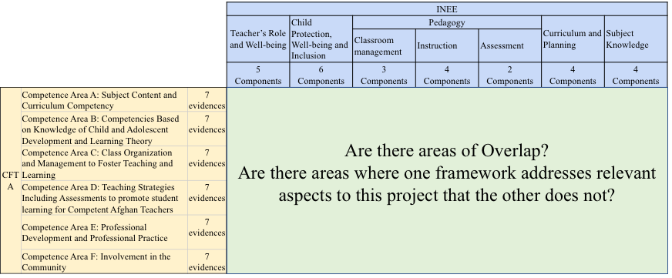
Figure 1 Analysis of the competence frameworks involved
Agreement scores were calculated for all intersections. Lack of coverage was indicated by low row or column total scores. Particularly, low column scores indicated low coverage of aspects of the INEE framework in the Afghanistan competency framework.

To answer research question 2 - “To what extent do teachers have the competencies necessary to successfully teach in crisis contexts?”- teachers’ surveys were analyzed as we were able to collect the entire sample of surveys planned for this study. The classroom observation data and the lesson plan data were used as well but with caution given the small sample sizes involved and the results of the psychometric analyses. Please note that the study design included classroom observations to provide an external assessment of teachers’ competencies.. However, due to Covid-19 we were unable to collect all classroom observations and have to rely on teachers’ self-reports, which can be highly biased.
Additionally, as this is the first time classroom observations and teacher surveys were used in Afghanistan to assess competency levels, there are limitations with regard to what can be considered as a high or low level of performance in a given scale, because there are no previous applications or known population parameters that can be used as a benchmark. In the absence of such benchmarks for determining performance levels, this study used a scenario-based perspective considering the relative contribution of each item-response option to the subscale score, and a descriptive-statistics-based perspective to check on the first perspective. On this basis, three performance levels were defined: low, medium and high. As an example, consider the self-care scale, a short scale of 5 questions graded on a 1 to 4 scale:

Table 7. Example: self-care scale
Please let us know about your support network and well-being related activities
 | None  (1) | One or two  (2) | Three or four  (3) | Five or more  (4)
- I have colleagues that I can ask for guidance when I need professional advice
- I have colleagues that I can ask for guidance when I face challenges in the classroom
- I have colleagues that I can ask for guidance when I face challenges with peers or supervisors
- I have friends or family members that I can ask for guidance when I face challenges at the workplace

A score of below 5 points corresponds to a scenario where the respondent claims to have no support network. Hence, such scores can be considered as low. On the other hand, a score of 16 in indication of a very rich network of support. In order to build intervals for levels of performance the descriptive statistics of the scale are taken into consideration. In this case the mean is 9 and standard deviation of 3. Scores as low as 6 (9-3) are indicative of having at least two people to talk to about challenges in the classroom, which can be considered acceptable (performance level: middle). Scores of 14 points and above are thus considered as high. Similar considerations were done for all other subscales. These considerations are detailed in section 8.2 (Annex 2: Performance levels rationale for subscales). In general, scale scores for all sub-scales are very skewed to the left. Hence, the performance level “high” is in general at or above the mean for the scale. The analysis of the subscales resulted in the following intervals of proficiency:

Table 8 Self-reported levels of performance, from the teacher’s survey (n=297)
Scale | Low | Middle | High
Self-Efficacy (SE) | 0-30 | 31-36 | 37-40
Work-Related Stress (WRS) | 0-22 | 23-32 | 33-42
Self-Care (SFC) | 0-5 | 6-13 | 33-42
Teacher’s Code of Conduct (TCC) | 0-26 | 27-31 | 32-36
Child-protection, well-being and inclusion (CP) | 0-30 | 31-37 | 38-44
Curricular-knowledge self-assessment (CK) | 0-28 | 29-30 | 31-32
Self-Assessment of Teacher training Knowledge (SATK) | 0-29 | 30-38 | 39-50

Scales were set so that high scores corresponded to desirable characteristics: with regard to stress, the scale was reverse coded for analysis so that higher scores corresponded to lower levels of stress (desirable outcome). For the other sub-scales, (self-efficacy, self-care, knowledge of child protections and teacher’s code of conduct, and curricular aspects and training received), higher scores were indicative of scoring in a desirable direction.
There data collected included 297 surveys, one of which only had responses for the last 10 questions and hence was eliminated. Data missingness for all items in the survey was very low in general: less than 3% on the average for all items, excepting item 11, the first question of the Work-Related Stress scale. The pattern of data missingness for this item revealed that it was ignored in all provinces but Kunduz:

Table 9. Data missingness for item 11
Province: | Missing | Total
Kunduz | 1 | 71
Kandahar | 76 | 80
Nangarhar | 79 | 81
Badghis | 25 | 64
Total | 181 | 296

The fact that only Kunduz respondents engaged with this question unlike the respondents in other provinces means that the Work-Related Stress score in the other provinces will be underestimated due to missing data. Hence, this question was removed from the regression analysis to keep Work-Related Stress regression coefficients comparable.

To answer research question 3 -“What individual and contextual factors help in explaining the levels of competence achieved”- we used different background variables from the teacher’s survey as regressors in a multivariate regression analysis. Such variables include age, gender, level of education, years of teaching experience, etc.), and contextual variables such as school type (formal/CBE), and province (Nangarhar, Kandahar, Kunduz and Badghis).

To answer research question 4 -“What are the perceptions of teachers and headteachers about their needs,and supports they need to effectively respond to education challenges in the contexts of conflict and crisis where they exercise their work?- data from focus groups and interviews were used. Data were collected in the local languages, and then transcribed and translated into English. Transcriptions were coded and thematically analyzed using both pre-existing and emergent categories of analysis relevant to teacher’s views and context in relation to the proposed framework of competences. The themes were compared and contrasted with the information obtained from the other research questions. This qualitative data analysis was supported with software (ATLAS.ti Scientific Software Development GmbH). The general coding strategy involved creating codes for each question and region, and then examine code co-occurrence tables to identify recurrent themes by question and geographic location.

Results

Teaching competency frameworks
These results pertain to the first research question in this project, e.g. “How do the frameworks for teaching competencies of the government of Afghanistan and the INEE framework for teaching in crisis contexts relate to each other? Are the areas of overlap? Are there areas where one framework addresses relevant aspects to this project that the other does not?
The framework of teaching competencies in Afghanistan comprehensively covers many aspects that are expected to be present in professional teaching (Potvin, 2015; Thorpe, 2014). In this regard, this framework provides a comprehensive context to assess high-quality teaching with standards that could be transferable to conflict-free contexts. The framework of competencies for teaching in contexts of crisis developed by the INEE intends to guide the provision of teaching in contexts that are far from ideal, i.e., where teachers might come with little no formal training in teaching, or where there is a rapidly changing population of IDPs or returnee students. As such, the INEE framework particularly emphasizes aspects relevant to contexts of conflict and crisis like teacher and student’s well-being, but it is not intended to be as comprehensive and detailed as a national framework for teaching competencies should be. Even more, the INEE framework is aimed at primary education teachers (INEE, 2016). On this basis, the areas of overlap and difference between these two frameworks are presented in the next sub-sections.

Areas of overlap
The INEE framework has five main areas: teacher’s role and well-being, child protection, well-being and inclusion, pedagogy, curriculum and planning and subject knowledge. The last three areas (pedagogy, curriculum and planning and subject knowledge) are all included in the Afghanistan teaching framework. The Afghanistan Teacher Competency Framework (ATCF) defines aspects related to these categories in the INEE framework and it goes into greater detail. Hence, there is considerable overlap in these areas, as shown in figure x below:

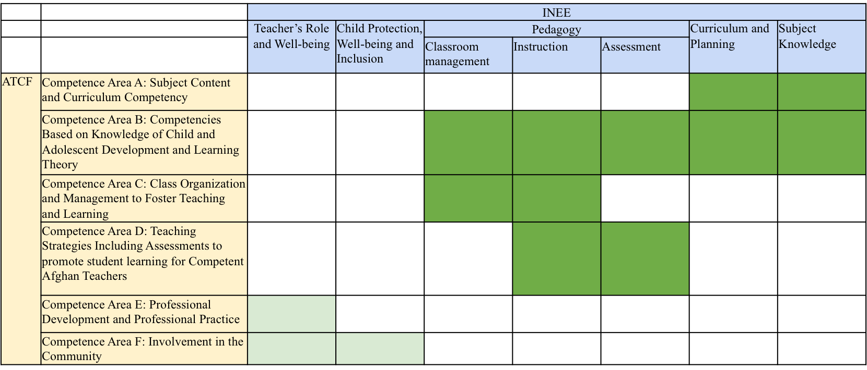
Figure 2. Relationship between competence frameworks
Overlap is stronger in the areas marked in a darker shade of green. The ATFC has multiple areas where it addresses issues about classroom management and instruction. For instance, one of the standards in Competence Area B (Competencies Based on Knowledge of Child and Adolescent Development and Learning Theory) states that the competent teacher “Designs, utilizes and revises short term and long term teaching (unit / lesson) plans and learning goals based on the key concepts and structure of the subject matter, while taking into account the learning needs and abilities of students, and connecting students’ prior and emergent knowledge, experiences and understandings with new knowledge and unfamiliar experiences.” Undoubtedly, this is a level of competence towards which teaching training must strive and it is an example of how detailed the Afghanistan framework of competencies can be.

Areas of difference
The framework of competencies for teaching in contexts of crisis developed by the INEE is not as detailed as the ATFC with regard to high-quality practices of teachers. However, it touches on several important baseline achievements that are to be guaranteed in order to provide quality instruction that takes into account the needs of children in crisis contexts.
Despite not being as overarching as the ATFC framework the INEE framework offers important guidelines that are relevant to teaching in crisis contexts that are not addressed either in detail or at all in the competence framework for teaching in Afghanistan.
Notable among those missing factors are those related to Teacher’s Role and Well Being. An aspect such as “Teacher understands the importance of his/her well-being as a factor influencing student well-being, and practices strategies to maintain well-being including mindfulness, conflict resolution and stress management techniques” has no correlate in the Afghanistan national framework. However, this aspect is of key importance in crisis contexts. Something similar happens with aspects related to Child well-being and protection. An aspect such as “Teacher demonstrates understanding of and promotes context appropriate life skills (social-emotional well-being, health education, mine-risk awareness, self-protection from sexual and gender-based violence and exploitation, etc.)”. That such a criterion is not present in the Afghanistan national framework is not in itself a shortcoming of the framework. However, it is a good example of the kind of aspects that are important in crisis factors that are easy to miss when considering teaching in conflict-free contexts.
Not all aspects missed by the Afghanistan teaching competency framework are related to the most evidently conflict-related parts of the INEE framework. There are specific curricular aspects that are important to consider as well. For example, the INEE framework considers as a part of the competencies related to subject knowledge that “Teacher uses techniques to support second language learners (routine use of keywords, phrases; use of text and images; opportunities for learners to produce content with correction/ feedback, etc.)”. Given the multi-ethnic and multi-cultural nature of Afghanistan, plus the difficulties derived from the constant flux of internally displaced populations, the need for teachers to specialize in bilingual education and strategies to support second-language learners is particularly important.

To what extent do teachers have the competencies necessary to successfully teach in crisis contexts?
This section shows the results of the teacher’s survey. These results show self-reported levels of performance in the subscales defined in the instrument. Table 8 below shows the percentage of teachers at each performance level as defined by each sub-scale, as defined in section 3.3.1 (Analytic approach.:

Table 10. Distribution of percentages of teachers by self-reported levels of proficiency in different subscales
Performance level | Self-  Efficacy | Work Related Stress | Self-  Care | Teacher’s code of conduct | Child Protection and well being | Curricular Framework Knowledge | Self-Assessment of Teacher Training Knowledge
Low | 11 | 52 | 6 | 21 | 9 | 32 | 57
Middle | 32 | 26 | 85 | 24 | 16 | 13 | 32
High | 56 | 22 | 9 | 55 | 75 | 55 | 11
***Note: The largest percentages are indicated by the grayed cells in the table.

We observe that more than half of teachers in the sample report high levels of self-efficacy, and high levels of performance in their self-reported knowledge of teachers’ code of conduct, and self-reported knowledge of curricular aspects relevant to their practice. More than 75% of teachers in the sample report being highly knowledgeable about aspects related to child protection and wellbeing in crisis contexts. Additionally, we observe that 52% and 57% of teachers in the sample report high levels of work-related stress, and little training (one day at most) pertaining to teaching in crisis contexts. In order to further examine the results obtained by teachers in the different subscales in this study, we present here performance levels by region and subscale, while the results by background variable and subscale are presented in section 8.6(Annex 6: Descriptive results by teacher characteristic and sub-scales)

Performance levels by region and subscale
Region is an important characteristic in the design of this study. The figures below provide a perspective on each of the sub-scales in the teacher’s survey on the overall sample and by region. With regards to self-efficacy (see Figure 3 and Figure 4), we observe that 56% of teachers report high levels of it, meaning that they feel well-equipped and capable of overcoming successfully the most common challenges in the classroom (getting students to learn, manage student’s behavior, carry our projects, etc.) 33% report middle levels of self-efficacy and only 11% low levels. At the region level, we can see that 14% of teachers in Kandahar, 13% of teachers Badghis, 12% of teachers in Kandahar and 6% of teachers in Kunduz report low levels of self-efficacy, which mean that they do not feel prepared to teach relevant content knowledge, carry out relevant projects or maintain positive relationships with parents and students.

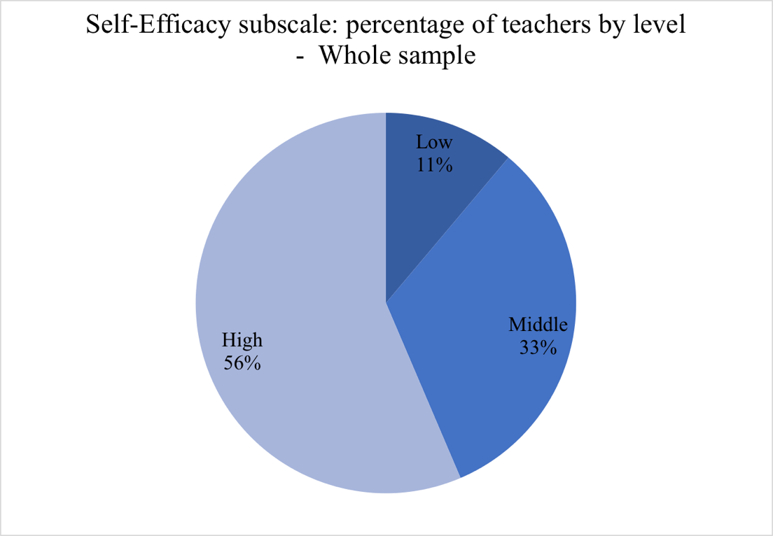
Figure 3-Self-efficacy: performance levels for the study sample

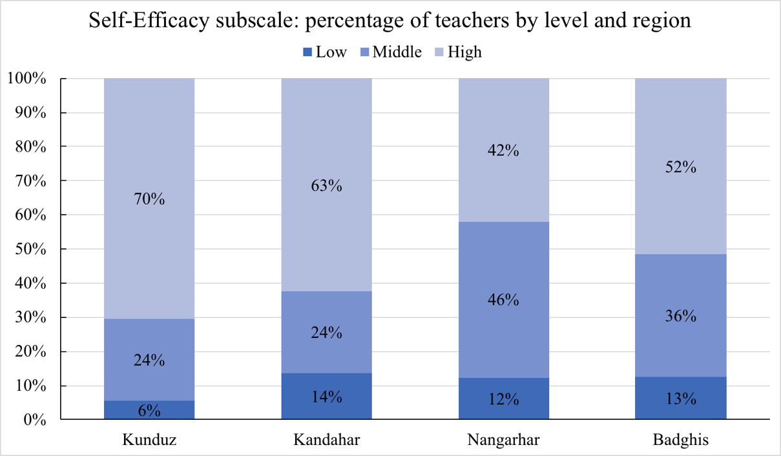
Figure 4- Performance levels by region
Proficiency levels by region

With regards to work-related stress (see Figure 5 and Figure 6), we observe that more than a little over a half of the teachers in the sample (52%) report high levels of work-related stress, while the remaining of the sample reports middle (26%) and low (22%) levels of it. Comparing regions, 68% of teachers in Kandahar, 57% of teachers in Nangarhar, 52% of teachers in Badghis, and 30% of teachers in Kunduz report having high work-related stress, which means that they report having little time to prepare, too much work to do, a very high workload, a school day pace that is too fast, etc.

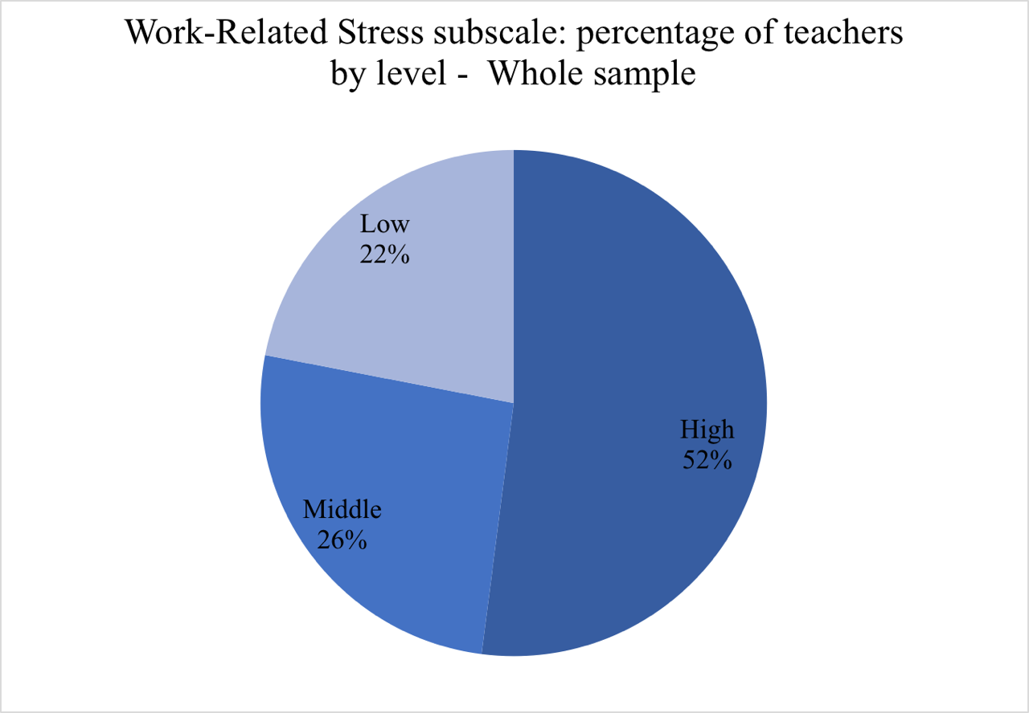
Figure 5-Levels of work-related Stress – whole sample

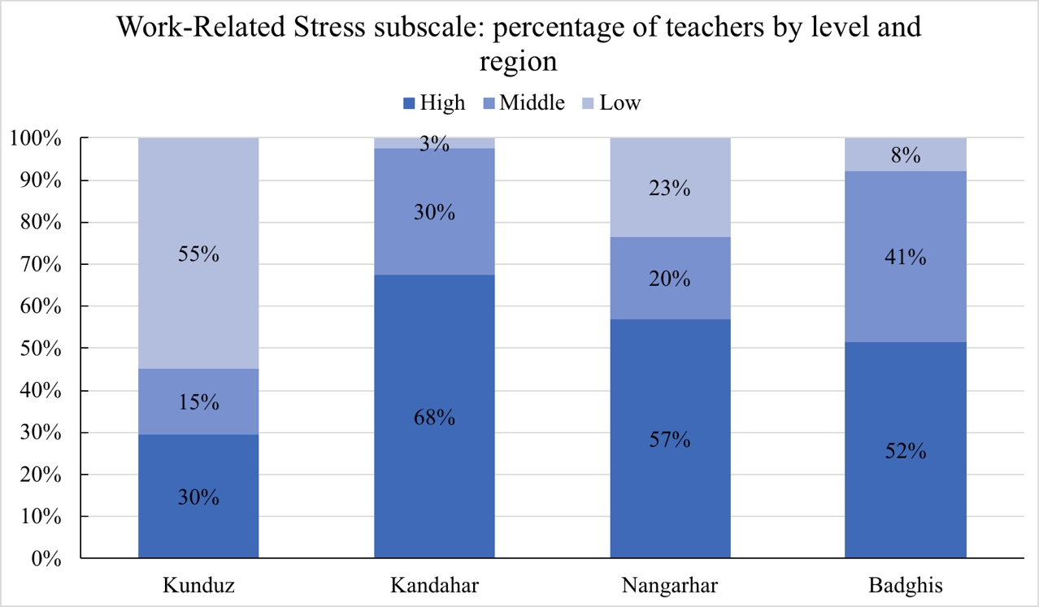
Figure 6- Work-Related Stress: Levels by region

With regards to self-care (Figure 7), we observe that a great majority of teachers (85%) report a middle level of performance in this scale, which is indicative of having at least one people to discuss and look for guidance in regards to the challenges faced by teachers at work, which can be considered as a minimally acceptable level of support. When examining regionsit can be seen that 15% of teachers in Nangarhar, 6% of teachers in Kunduz and 5% of teachers in Badghis report low levels of self-care (Figure 8) , which means that that they do not have colleagues they can ask for advice of guidance when they face challenges in the classroom, with supervisors or challenges at their workplace, and also, that they do not practice strategies to reduce stress levels.

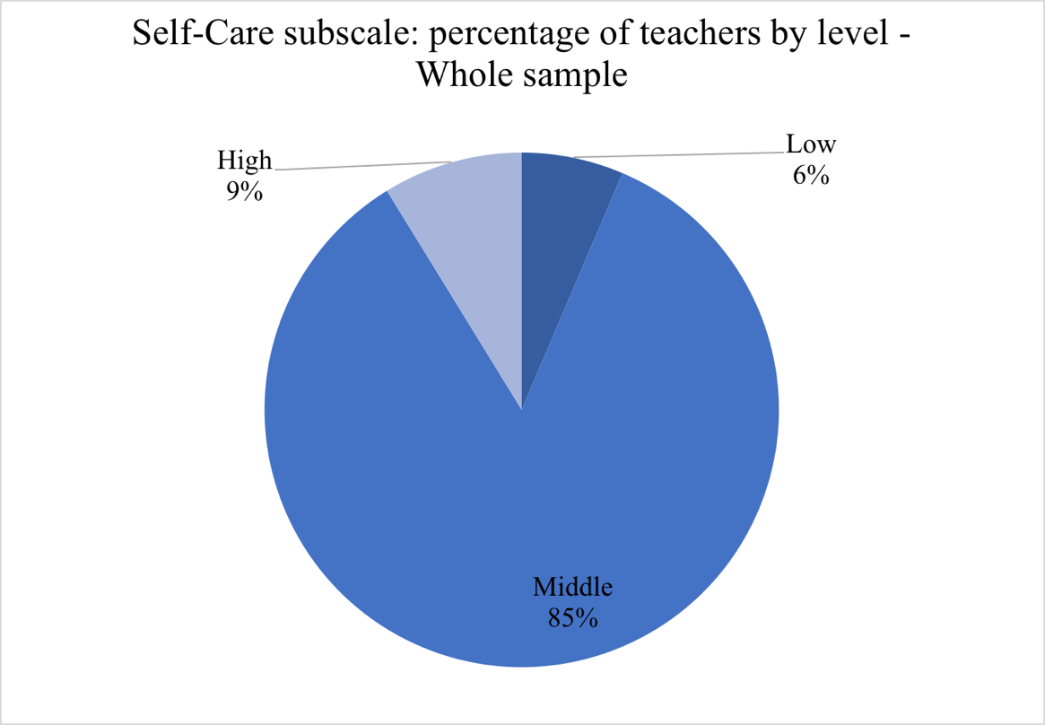
Figure 7- Self-care levels – whole sample

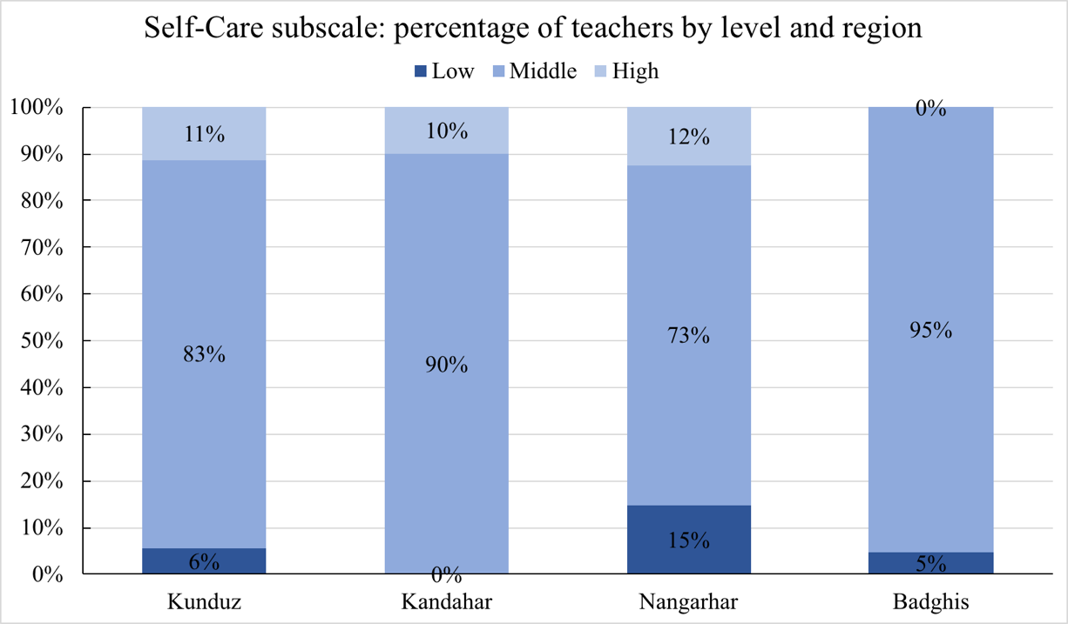
Figure 8- Self-Care: levels by region

With regards to teachers’ code of conduct knowledge and attitudes, more than half (55%) of the teachers report having a high-performance level on this construct. This means that they consider that if they were witness to a contravention of the code, such as seeing a colleague being mistreated or discriminated by a superior, they would be willing and would know how to report this incidence. (see Figure 9). With regard to the regions in the study (Figure 10) we observe that 47% of teachers in Badghis, 20% of teachers in Kunduz, 19% of teachers in Nangarhar and 5% of teachers in Kandahar report not having adequate knowledge of the code of conduct, which suggest that if they observed a colleague, a supervisor of a student mistreating another person, they would not be likely to report the incident and/or would not know how to report it.

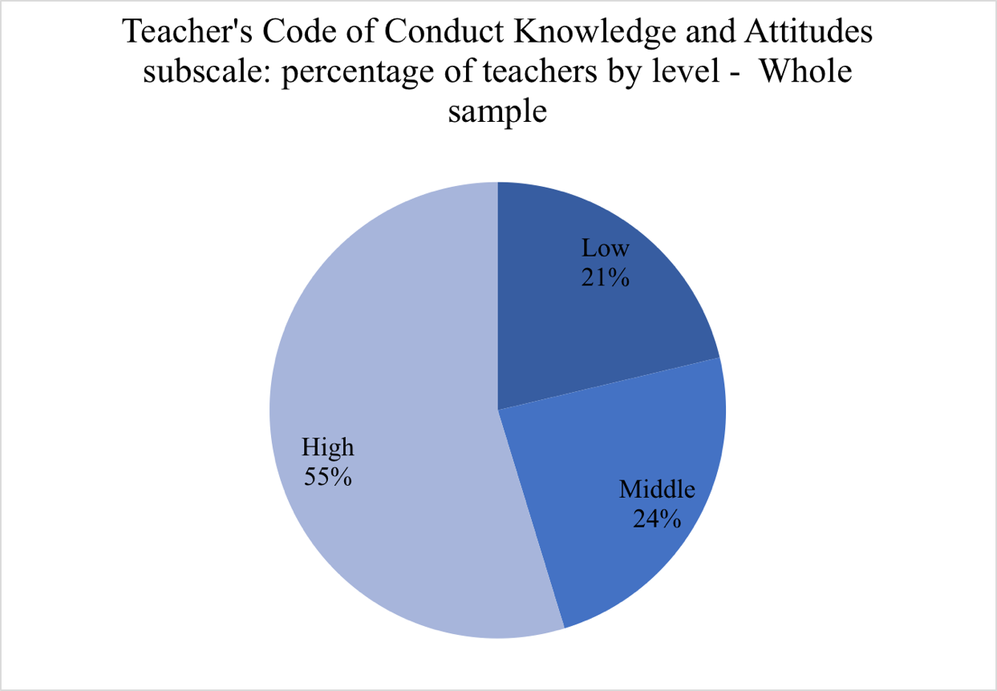
Figure 9- Teacher’s code of conduct knowledge and attitudes levels – whole sample

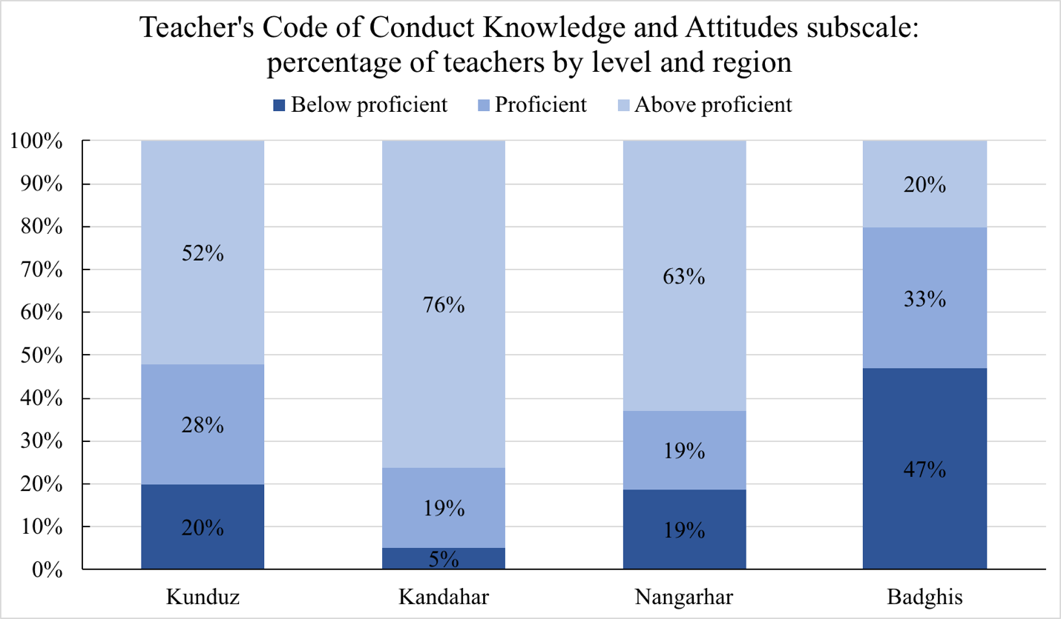
Figure 10- Teacher’s Code of Conduct Knowledge and Attitudes: levels by region

With regards to knowledge of child protections, wellbeing and inclusion (See Figure 11), 3 out of 4 teachers report being highly knowledgeable in these matters, meaning that they are highly familiar with different measures that need to be taken to better address the needs of children in contexts of crisis. In the regions in the study, we observe that 21% of teachers in Nangarhar, 11% of teachers in Badghis, 4% of teachers in Kandahar, and 1% of teachers in Kunduz report now having the competencies and the resources they need to support children’s social, emotional and psychological needs.

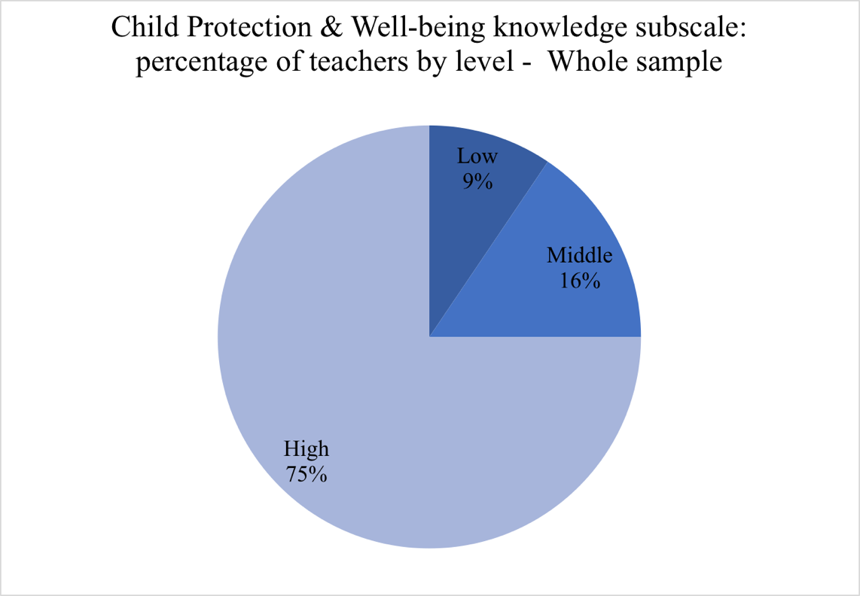
Figure 11- Child Protection & Well-being knowledge subscale: percentage of teachers by level

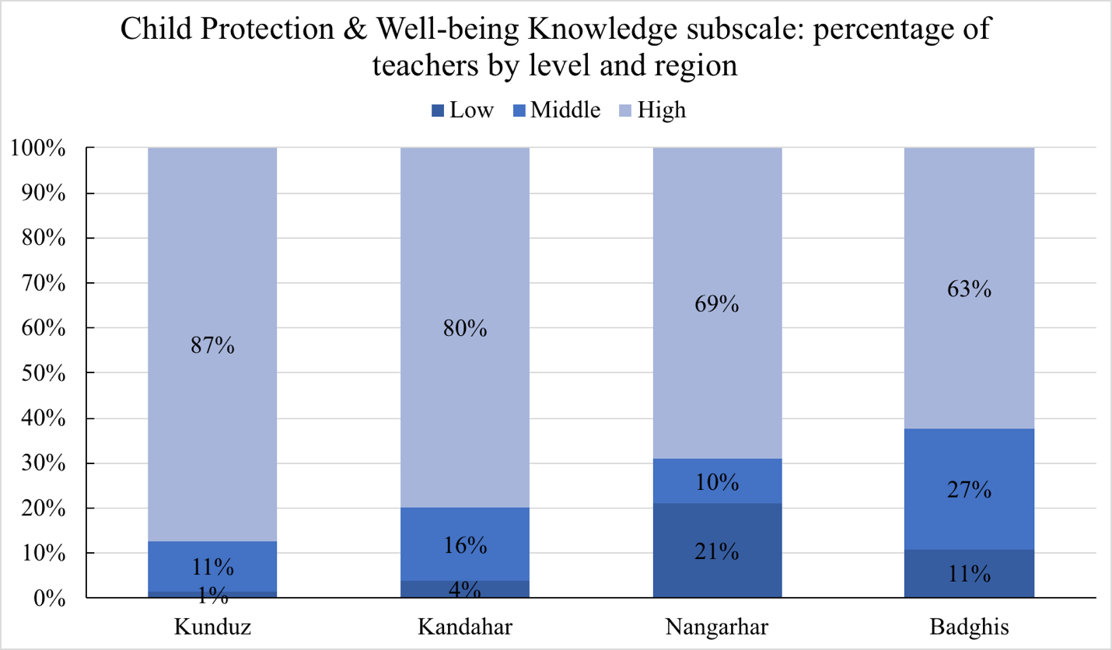
Figure 12- Child-Protection and well-being knowledge: levels by region

With regards to the curricular framework knowledge subscale (see Figure 13), over a half of the teachers (55%) self-report high levels of it meaning that they consider they have the subject area and national curricular regulations knowledge necessary to teach their subjects. By region (, we observe that 47% of teachers in Nangarhar, 45% of teachers in Badghis, 24% of teachers in Kandahar, and 13% of teachers in Kunduz report having low levels of knowledge about the curriculum framework, which means that they do not feel they have the competencies they need to teach the subject they are expected to teach, and that they do not know the local and national regulations and standards relevant to that subject.

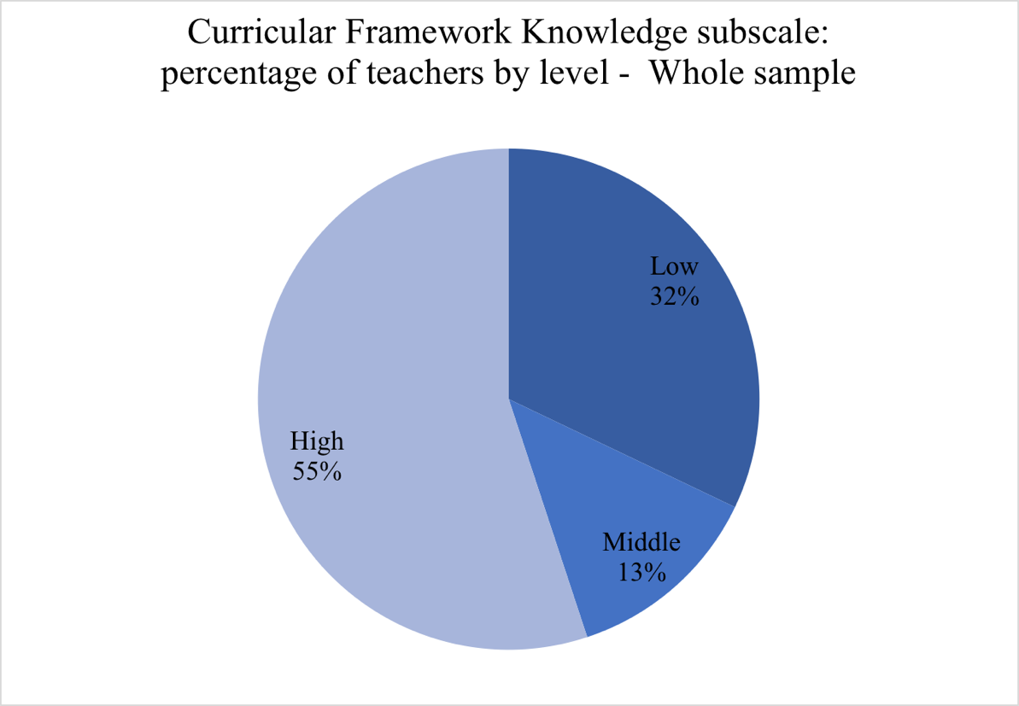
Figure 13- Curricular Framework Knowledge: percentage of teachers by level - whole sample

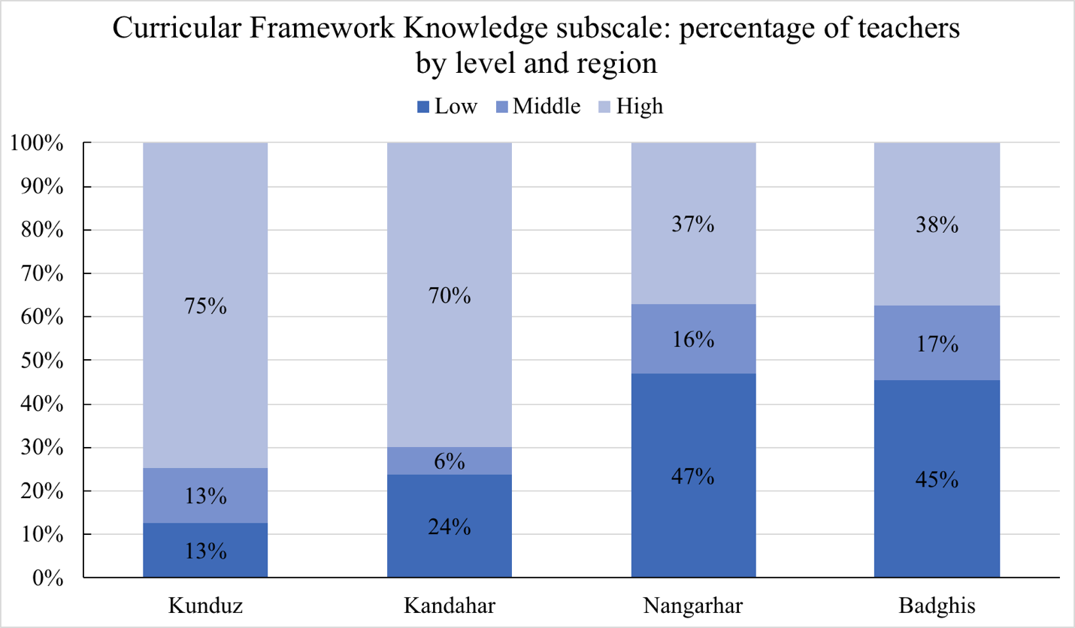
Figure 14- Curricular Framework Knowledge: levels by region

Teachers were required to provide a self-assessment of the amount of training they have received in several issues related to teacher training. As can be seen in Figure 15, 57% of the teachers report having had at most a day of training in these matters, while and additional 32% reports having had between 2 to 5 days of training. Approximately, only 1 out 10 teachers reports having been trained for more than 5 days in issues relevant to the teaching profession. By region, we see marked differences between the provinces of Kunduz and Kandahar versus Nangarhar and Badghis. While in the first two provinces teachers report that approximately half of them have received between 2 to five days of training, in Nangarhar and Badghis less than 40% and 30% of teachers, respectively, report being at this level. This means that the majority of the teachers in these two provinces have only had at most, one day of training in issues relevant to teaching and teaching in contexts of crisis. (Figure 16)

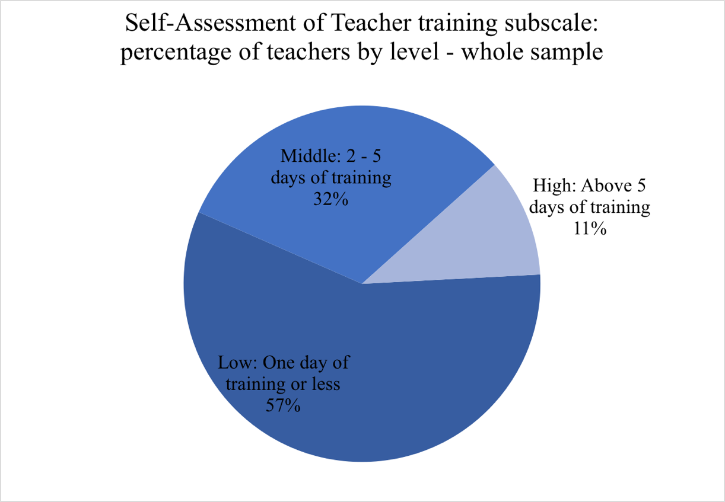
Figure 15- Self-Assessment of Teacher training subscale: percentage of teachers by level - whole sample

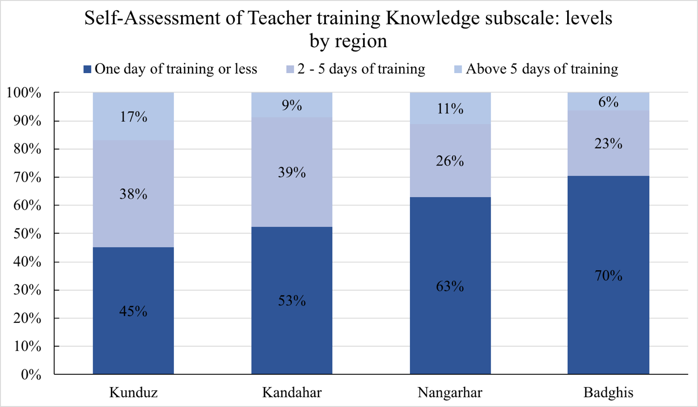
Figure 16- Self-Assessment of Teacher Training Knowledge: levels by region

Influence of individual and contextual-level variables on teachers’ performance
Research question 4 of this study asked about the influence of individual and contextual-level background characteristics in survey scores that help explain teachers’ levels of competence. To address this question, several multiple regression models were implemented using the total survey and each subscale score as outcome variable and teacher’s characteristics as regressors. The goal of these analyses is detecting teacher characteristics that are important either at the total score level but also at the level of each factor. The following table summarizes this information. Descriptive results for each subscale and background characteristic are available in section 8.6 (Annex 6: Descriptive results by teacher characteristic and sub-scales).

Table 11 Regression coefficients for survey scores on teacher's characteristics
VARIABLES | Total Survey Score | Self Efficacy | Work Related Stress | Self Care | Teachers’ Code of Conduct | Child Protection | Curricular Knowledge | Self-Assessment Teacher Training
Province (Reference: Kunduz)
Kandahar | -8.508 | -1.147 | -9.234*** | 1.306** | 3.355*** | 0.143 | -1.144 | -1.787
 | (5.205) | (1.179) | (1.896) | (0.623) | (1.256) | (1.564) | (0.848) | (2.151)
Nangarhar | -19.771*** | -1.598 | -5.232*** | -0.017 | 0.269 | -7.170*** | -1.113 | -4.910**
 | (5.275) | (1.195) | (1.922) | (0.632) | (1.273) | (1.585) | (0.860) | (2.181)
Badghis | -26.256*** | -1.765 | -10.816*** | -1.323** | -3.777*** | -1.821 | -2.194*** | -4.560**
 | (5.153) | (1.167) | (1.878) | (0.617) | (1.244) | (1.549) | (0.840) | (2.130)
Gender (Reference: Female)
Male | -7.183** | -0.501 | -1.292 | 0.406 | -0.586 | -3.776*** | 0.328 | -1.760
 | (3.516) | (0.796) | (1.281) | (0.421) | (0.849) | (1.056) | (0.573) | (1.453)
Age | -0.107 | -0.015 | 0.018 | -0.001 | -0.011 | -0.044 | 0.010 | -0.064
 | (0.272) | (0.062) | (0.099) | (0.033) | (0.066) | (0.082) | (0.044) | (0.113)
Language (Reference: Dari)
Pashto | 0.845 | -0.699 | -0.831 | -0.228 | 0.432 | 1.946 | 0.046 | 0.179
 | (5.063) | (1.147) | (1.845) | (0.606) | (1.222) | (1.522) | (0.825) | (2.093)
Uzbeki | -0.047 | 1.620 | 0.610 | -1.398 | 1.316 | 1.106 | -0.001 | -3.300
 | (8.058) | (1.825) | (2.936) | (0.965) | (1.945) | (2.422) | (1.313) | (3.331)
Pashei | -14.359 | -4.666* | -10.642** | -0.292 | -1.639 | 4.946 | -1.863 | -0.202
 | (11.762) | (2.664) | (4.285) | (1.408) | (2.839) | (3.534) | (1.917) | (4.862)
Education (Reference: below high-school)
H.S. Grad. | 1.271 | 1.095 | -1.257 | 0.372 | 0.254 | -0.102 | 0.847 | 0.062
 | (4.404) | (0.998) | (1.605) | (0.527) | (1.063) | (1.324) | (0.718) | (1.821)
TTC | 5.305 | 1.487 | -0.798 | 1.185** | 0.393 | 1.392 | 0.914 | 0.730
 | (4.865) | (1.102) | (1.773) | (0.583) | (1.174) | (1.462) | (0.793) | (2.011)
Bachellor | 5.491 | 1.486 | -0.501 | 0.873 | 0.576 | 1.431 | 0.230 | 1.396
 | (6.343) | (1.437) | (2.311) | (0.760) | (1.531) | (1.906) | (1.034) | (2.622)
Experience (Reference: Below 3 years)
4-6 Years | 0.204 | 0.092 | -0.497 | -0.282 | -1.761 | -0.525 | -0.391 | 3.568*
 | (4.765) | (1.079) | (1.736) | (0.571) | (1.150) | (1.432) | (0.776) | (1.970)
> 6 Years | 0.169 | -0.743 | -1.541 | -1.717*** | -0.321 | 0.697 | 0.817 | 2.978
 | (5.516) | (1.249) | (2.010) | (0.660) | (1.332) | (1.658) | (0.899) | (2.280)
N_Students | -0.125 | -0.026 | -0.076 | -0.011 | 0.005 | -0.056 | -0.018 | 0.058
 | (0.211) | (0.048) | (0.077) | (0.025) | (0.051) | (0.063) | (0.034) | (0.087)
Type of school (Reference: public school)
CBE | 11.905* | 0.159 | 4.976** | 1.473* | -0.808 | 0.816 | 0.888 | 4.402
 | (6.464) | (1.464) | (2.355) | (0.774) | (1.560) | (1.942) | (1.053) | (2.672)
Constant | 204.475*** | 37.821*** | 29.170*** | 8.125*** | 31.336*** | 43.273*** | 29.639*** | 25.112***
 | (14.094) | (3.193) | (5.135) | (1.688) | (3.402) | (4.235) | (2.296) | (5.826)
Observations | 276 | 276 | 276 | 276 | 276 | 276 | 276 | 276
R-squared | 0.212 | 0.070 | 0.230 | 0.151 | 0.182 | 0.194 | 0.071 | 0.092
Note: Regression coefficients are relative to reference categories for each characteristic. For example, the reference category for region is Kunduz. The coefficient for Nangarhar of -19.771 means that scores in this province are lower by that amount relative to Kunduz. * p <0.05, ** p< 0.01, ***p < 0.001

Age and Number of students did not have any significant association with the total survey score or any of its subscales. All other variables had significant associations with total and subscale scores. These associations are as follows:

Province
Teachers from the province of Kunduz scored significatively higher than their counterparts in all other provinces by a statistically significant margin: 26 points over Badghis, 19 points over Nangarhar and 8 points over Kandahar. At the sub-scale level, all constructs, with the exception of Self-Efficacy showed variations associated with province. Work-related stress was the main driver for the overall scale difference: teachers in Kunduz exhibited significantly less work-related stress than their counterparts by a large margin: 11 more points compared to Badghis, 9 more points relative to Kandahar and 5 more points more than Nangarhar. In the case of Self-Care, the differences were small and likely of no practical significance. The same is the case for the score on the Teacher’s Code of Conduct factor. There was a significant difference for the teachers in Nangarhar relative to those on Kunduz; the first scored 7 points below their counterparts. There were also significant differences in Curricular Knowledge (teachers in Badghis scored 2 points below those in Kunduz) and in their assessment of background knowledge, where teachers in Nangarhar and Badghis scored 5 and 4.5 points below those in Kunduz, respectively.

Gender
Gender showed a significant association with total survey scores of the participants, with female teachers scoring 7 points above their male counterparts in the average. Females scored almost 4 points above their male counterparts in the Child Protection factor.

Language
In general, there were no significant differences between teachers associated with the language they spoke either as reflected by the total survey score or the involved subscales. However, there were two aspects in which Pashei speakers differed from their counterpart Dari speakers: Pashei speakers scored lower on Self-Efficacy (4.6 points below) and higher in Work-Related Stress (10.6 points below). Pashei speakers in this study were only present in the Nangarhar province.

Teacher’s level of Education
Compared to teachers that did not complete High School, the level of education of teachers was not significantly associated with survey scores. With regard to sub-scale scores, there was only one exception: Teachers with TTC training showed a positive 1.2 score-points difference in Self-Care relative to their counterparts who did not complete High School. The difference seems small, but in the context of the Self-Care factor (average score 8 points) it is relatively important.

Teacher’s Experience
In general terms, experience did not determine substantial differences in the total survey score and in most of the factors identified in the survey. The only two exceptions were a negative difference of close to 2 points (1.7) between the teachers with 6 or more years of experience with regard to Self-Care, and a positive difference of 3.6 points in favor of teachers with between 4 to 6 years of experience relative to teachers with three or less years of experience.

Type of school
Teachers in CBEs had an average total survey score that was significantly higher than that of their counterparts in MoE schools in this study. The difference was of 12 points. CBE teachers had significantly less Work-Related stress than their counterparts (5 points), and also a higher Self-Care score (1.5 points).

Class Observations and lesson planning
Class observation and lesson planning were assessed with the instruments described in section 3.2.2. (Class Observation and Lesson Planning). Total scores for each instrument are shown in the table below:

Table 12- Summary of Class Observation and Lesson Planning Scores
Variable | N | Mean | Std. Dev. | Min | Max
Class Observation Score | 26 | 82 | 11 | 45 | 105
Lesson Planning Score | 26 | 5 | 2 | 0 | 8

Data to calculate these scores was collected in two provinces, Bagdhis and Nangarhar, by eight observers, two for each observed teacher. The observers averaged their observation scores and submitted it as one single score. The average of these scores obtained by each observer in each province are presented in Table 10:

Table 13- Class Observation Average Scores (out of 100)
Province | Observer 1 | Observer 2 | Observer 3 | Observer 4 | Average
Badghis | 81 | 74 | . | . | 77
Nangarhar | . | . | 87 | 86 | 87

It can be seen that there are differences between observers and provinces; however, these differences are not statistically significant (see section 3.2.2). Given the small sample sizes involved, this results only describe trends and cannot be extrapolated to the wider population of teachers. The fact that there were not repeated observations of teachers forbids deciding whether any eventual differences are real or an artifact of the observation instrument. In this context however, it is possible to describe differences found in the different dimensions included in the class observation instrument. The table below shows the scores for each dimension expressed as percentage of the maximum points it was possible in each criteria of the observation rubric:

Table 14- Classroom observation – percentage of attainment relative to maximum scale score
 | Readiness | Subject Knowledge | Lesson Planning | Classroom Management | Teaching and Learning Assessment
Badghis | 94% | 50% | 53% | 49% | 43%
Nangarhar | 86% | 84% | 76% | 74% | 67%
Total | 90% | 67% | 65% | 62% | 55%

The score of 94% for readiness (an aggregate score summarizing 8 yes/no questions about whether the classroom is clean, students are ready to start activities i.e. they have pencils, books, etc.) in Badghis means for example, that out of the 8 possible points to be earned in readiness (i.e. if the classroom was clean, students had learning materials, room was adequately ventilated, etc.), on the average, teachers obtained 94% of these points, which means that the majority of teachers obtained all 8 score points.
For the remaining aspects in this instrument, it should be noted that the scale score of 2, which was heavily used by enumerators, results in a percentage of attainment of 67% (2/3). Hence, scores below this threshold can be considered comparatively low. With this context, it can be seen that there are important differences between the two provinces for which there is data for classroom observations. Despite being not too different with regard to readiness, there are marked differences with regard to all other areas, with teachers in Badghis showing below proficient scores while those in Nangarhar showing proficient scores. Aggregating results for both provinces as shown in line three of table 11 shows that teachers are not proficient with regards to subject knowledge, lesson planning, classroom management and teaching and learning (formative) assessment. Scores for readiness are above the threshold to be considered proficient in this regard.
One of the background variables for this instrument asks for how much of the class time is devoted to instructional and non-instructional activities. It can be seen that on the average, almost a fifth of the time in each class is devoted to non-academic activities.

The other instrument used to observe classes was a rubric to evaluate the teacher’s lesson plans. As discussed before, there is a restriction of range for this instrument (section 3.2.3) that resulted in a low reliability. The descriptive statistics for this data are presented below:

Table 15- Lesson Plan Summary Scores
 | Plan Total Score | Structure | Sequence | Alignment with National Curricula
Badghis | 4.5 | 1.8 | 1 | 2
Nangarhar | 5.2 | 2.4 | 1.8 | 1.4
Average | 4.8 | 2.1 | 1.4 | 1.7
Min | 0 | 1 | 1 | 1
Max | 8 | 3 | 3 | 2

There is little variation in scores to draw valid conclusions. It seems however that the sequencing of activities in Badghis is relatively problematic compared with the other areas.
A final comment with regard to these instruments is that they are paired, i.e. each class observation is matched with a corresponding lesson plan. It is noteworthy mentioning that the correlation between both variables is very low (0.03). Whether this is a consequence of the psychometric limitations of the instruments or evidence that planning and execution are not positively correlated is an issue that deserves further investigation.

Perceptions on context and training needs
This section pertains to research question 5 for this project, i.e. What are the perceptions of teachers and headteachers about their needs, levels of competence, and supports they need to effectively respond to education challenges in the contexts of conflict and crisis where they exercise their work? Information to answer this question comes from different interviews to teachers, master trainers and head teachers as described in section 3.1(Participants), Table 2 Sample for Focus Group Discussions)

The context and challenges of teaching
As described by teachers, master trainers, and head teachers, the context where teaching takes place is characterized by a series of circumstances and challenges that reflect a context of emergency and crisis: civil disturbance, large movements of people and a difficult political and security environment for implementing solutions (Wisner et al., 2002); refugee/IDP camps, conflict-affected areas, and/or with highly vulnerable populations (INEE, 2016). In addition to these circumstances and challenges , there are particular cultural and political factors that add to the difficulties of these contexts. Both sets of factors, conventional and cultural-political, will be described next.

Conventional Crisis Contexts Features
For the four provinces included in this study, the most salient factors that configure the context and challenges where teaching occurs are the lack of basic infrastructure and materials in schools, unstable/poor security, child labor and poverty related learning difficulties, and high levels of illiteracy in the communities. These factors combine in different ways configuring challenges for teaching and learning that teachers and communities are able to overcome in some cases; in other cases, despite their best efforts there is not much teachers can do. Under-registration of students, particularly IDPs and the subsequent crowding of classrooms, is one of such situations. All of these factors show similar manifestations in all the provinces, with exception of security in the province of Nangarhar (see in section: “Security”)

Infrastructure and resource limitations
Besides normal wear and tear, there is a point where shortcomings in infrastructure, or the lack of it, becomes a major impediment to teaching and learning. When analyzing the different testimonies provided by teachers, head teachers and master trainers, it was evident that lack of basic infrastructure in schools is a major concern for all interviewees in all regions, because the lack of it has a concrete impact in common learning situations. Everyday regular activities like going to the bathroom, drinking water or paying attention to the teacher can turn incredibly difficult if a particular combination of limitations occur. Unfortunately, these combinations of limitations are frequent in the provinces examined. Concrete examples of these limitations are lack of toilets, windows, walls, doors, carpets, chairs, windows, and fans or heaters. The situation with the windows is so bad that schools where all windows are intact are something that deserves mention: “But the other school that was newly built has a very strong management. In this school if someone damages something, he or she has to change it, or rebuild it. You have to come and see it. All windows have glasses.” (From a participant in Nangarhar). Walls and windows are required not only to keep proper temperature inside the classrooms, but to isolate students from external disturbances. When diverse infrastructure and resource limitations combine, they create serious disturbances for learning.

“…first our school does not have any wall, you are teaching in the class and the people are passing from your side. Sometimes they talk very loudly, they fight with each other and students forget that they are in the class. They disturb and interrupt the class. Sometimes we don’t have water, when students get thirsty, they go to drink water outside the school, sometimes it takes a long time until they come back. For ladies we don’t have separate toilets and they don’t want go to men’s toilet then, they go home and I can’t tell her anything or I can’t stop her because she is right…” (From a participant in Nanganhar)

It is not usual that there are chairs for students. In this context, carpets are particularly important, because students need them to sit especially during the winter; understandably students will get distracted if the weather gets too cold or too hot; fans are needed in the summer and not every classroom has one. Fans, heaters and carpets are required to maintain a classroom in a temperature such that students are able to engage in learning activities without distractions.
Access to drinking water is uncommon. The simple action of drinking water in a hot day can involve a serious disruption in learning. Students sometimes have to walk 100 meters to the next place where they can access drinking water; water bottles are also scarce. In addition to these challenges, teaching materials are not delivered on time: “one of our big challenges is books. We receive the books for students very late, mostly after two or three months and sometimes until the end of the year there is no book for student” (From a participant in Kandahar). When the books arrive, they are insufficient for students. At times, all of these limitations combine in a single school:

“In our area the biggest problem is lack of teaching and learning materials. We don’t have grade 2,3 textbook, we don’t have drinking water, last year we activated this school first we officially opened it and after three months I brought the carpet personally for students, teacher and support staff, there is no support from the MoE. We don’t have toilets. In the school we have one toilet this... like in open areas it is on the second floor with no walls like seating in the street. We don’t have blackboards, we hang board which is not usable properly.” (From a participant in Kandahar)

The combination of limitations in infrastructure and resources creates a very challenging environment for teaching and learning. Teachers have been proactive in solving these challenges:

“We use our capacities. As mentioned earlier we do not have toilets and we constructed ourselves. The class has no door and window, we used plastic to cover the window and use a thick curtain to cover the door. We went to a second hand selling market and purchased a thick curtain to prevent cold weather coming in; and we made the heater warmer to keep the class warm. We used our available capacities and tried to solve those issues that we could, and for those issues that support needed we shared it with the office to address them” (From a participant in Kunduz)

Infrastructure seems to lack not only in quality but in quantity. Descriptions of crowded classrooms are common across all the provinces. This problem is specially amplified in locations where the IDP population is high. Families send their children to CBEs disregarding whether they are properly enrolled or not. Teachers have no choice but to make room for everyone that needs it.

Security
Security is a prime concern for everyone in the communities. The decades-long armed conflict in Afghanistan (Geneva Academy of International Humanitarian Law and Human Rights, 2019) has left a mark in the collective psyche, and has become part of the usual background of everyday life in many places, even in places where people are isolated from it or where it is low in intensity. People have become used to it to a point. However, the fear of consequences looms over:

“Fortunately, I am teaching in an area that is safer although we hear rocket noises and firing almost every day. The day after when students come to class, they ask me whether the Taliban are coming or other AOGs and what would happen to us? they will kill us?” (From a teacher in a CBE in Kunduz)

Depictions of conflict by stakeholders in the sample were common to all the provinces in this study, except for Nangarhar, despite the fact it is one of the provinces with one of the highest levels of insecurity in recent years. Conflict can take a direct form (evidence of shooting, firing, etc.) or a more indirect but equally real form. In Kandahar, for instance, the Taliban could ask teachers for their salary, and check if they wear proper attire. In the sample, teachers’ descriptions of the conflict in Kunduz depict a situation of particularly strong intensity. One of the participants recalled how the city has fallen under Taliban control twice in the past five years. Shooting and firing are common and even in the absence of prolonged fight between opposite factions, there are localized security threats that remain. For instance, a participant in Kunduz mentions “...there is a hill close to class and sometimes there is security threat and students cannot come to class and go back. Sometime there is shooting sounds. My role as a teacher is to take students to their houses when there is any threat”. This happens in a community that this same participant has previously identified as safe. The standard for security is very low. Teachers have managed to gain some security by reaching out to the different factions in conflict: “We are coordinating with both the government and Taliban. From security point of view our students have less problems because the classes are close to their houses” (From a participant in Badghis).
Conflict takes a heavy toll on teachers’ and students’ mental health: “…students minds disturbed and when they come to class after the conflict they are not mentally in class and worried whether the conflict will be repeated” (from a participant in Baghdis); students “…are sad and ask why there is fight, there should be no fight that they can go to school and continue their education.” (from a participant in Kunduz). Violence leaves a scar on communities, particularly when it touches them directly. In Badghis during a bombardment a student was killed. Families didn’t want to send their students to the school anymore, students didn’t want to return either. Teachers then had to recruit students again across the villages.
Descriptions of conflict from sampled participants from Nangarhar province are qualitatively different than those of other provinces. There are no mentions of negotiations or interference with the Taliban or other Armed Opposition Groups. While there is awareness of the armed conflict in the country, security concerns are fewer, and not directly related to conflict but to gender: security of girls is a concern especially as they grow. This is not an indication of lack of conflict in this province, but perhaps of local security conditions for the teachers interviewed.
Teachers can only do so much with regard to their own security and that of their students. In open conflict they are familiar with protocols they should follow in order to safeguard their students. In regions where the Taliban enforce their laws teachers in the sample for our study have to address them for matters of security. In regions where there is a fight for control between the government and the Taliban teachers in this study have found ways to work in the midst of conflict. This involves speaking with councils of elders and authorities either from the government or from armed groups. Examples of this kind of negotiations are given in section “Cultural and Political Factors”.

Poverty, Child labor and Illiteracy

“…When I visited a class, the teacher told me that he tried a lot but there is one student that learn nothing. I talked with the student and he told that his mother is mental, and his father is unemployed, and he should sell plastic to buy bread and he has headaches. The teacher tried a lot, but the student never told him anything. Finally, the student quitted because his main concern was finding money to cover family expenses. He told his teacher that he cannot learn, and this is embarrassing for him and does not want to come to class…” (From a Master Trainer Participant in Kunduz)

Examples of child labor being an interference to children’s learning are abundant in the testimonies of participants in all provinces. Child labor is associated with poverty and lack of infrastructure. Children have to work bringing water from faraway places, selling plastic bags, herding, and farming, among others. If students are girls, during the mother’s temporary absences from home they have to take the responsibilities of cleaning the house, taking care of infants, washing clothes, and cooking. Children can be required to work before going to school or after going to school, affecting their ability to be on time and remain in school during the required time, and more importantly, their ability to focus on learning. Testimonies of teachers describing how children have trouble focusing on school activities because they are tired from working, or because they are concerned about helping in the family economy are ubiquitous in all provinces involved.
Illiteracy poses a serious challenge in finding suitable candidates for teaching in some places, but can also have a significant influence in the kind of support students receive from their families with regard to schooling. Teachers make significant efforts in reaching out to communities and families where levels of illiteracy are high. It is in these communities the threat of child labor is more noticeable, because illiteracy goes hand in hand with poverty and poverty in turns increase the pressure on children needing to work. However, in the midst of these difficult circumstances there are several reports of communities being supportive of education, despite suffering high levels of illiteracy.
Not only communities and families experience extreme poverty. There are several mentions by teachers and master trainers with regard to the difficult economic conditions teachers have to face and the effect this has on their mental health and their job and it also affects their motivation, satisfaction and wellbeing. These testimonies are present in all provinces in the study:

“You know teaching has lots of responsibilities, the teacher teaches numbers to 35 students and the salary allocated for them is small and the teacher should have another job to cover his expenses. And you know when the teacher is busy somewhere else their mind is disordered and cannot have full attention to lessons and students and this affects their teaching quality therefore, the teacher needs to be supported financially”. (From a participant in Kunduz)

“…the main teacher challenge is economy. As you are in the picture our teachers have poor economic situation and their income is not enough to cover their expenses. Their salary is small, but they are committed and with this small salary they do their best. They request that their salary is increased.” (From a participant in Kunduz)

“This problem is more in teacher when they have economic problem they cannot teach well for students, for example when a teacher come from Ziaray or Arghandab districts and he don’t have fuel for his motorbike and the money is not available with him so what can he do, he can get fuel in loan for a period of time for all the time so it is a big problem for him to continue with (From a participant in Kandahar)

“…we confirm whatever our colleague said. By the way they have economic problems too. They work a lot but they received very low salary.” (From a participant in Nanganhar)

“" the salary is not enough because of that his mind would be disturbed and cannot be active. And cannot give quality teaching according to organizational expectation. His moral will be weakened and cannot transfer his knowledge to students. If the teacher has a sick person in his house and have no money to take the sick to a hospital then he cannot teach well" (from a participating in Kunduz)

Master trainers and teachers concur in their assessment that teacher salaries are low or insufficient, to the point that sometimes teachers have to have additional jobs. Delayed pays for teachers are unfortunately, not uncommon.

… see with 6000 salary for a teacher what he can do with that, he should spend that on his family, rent of house and other so therefore he must work on other places. Another point is that most of the teacher salaries are not transferred on time, they receive the salaries after 8 months or more than that time. (From a participant in Kandahar)

“…[teachers] they don’t receive their salary for 6,7 months and we received it three months before they mentioned that we don’t have money to buy fuel for our motorbike so I give them money to get fuel, and try to solve their problem that they reach to school on time for teaching” (From a participant in Kandahar)

“For example, if a teacher does not have enough income, he is forced to have another job to pay expenses such as farming, being a shopkeeper or doing colportage. And when someone is occupied with various and different unrelated tasks, he will not be successful in any of them”. (From a participant in Kunduz)

“Teacher salary is 6,000 AFN and he is responsible of 5 to 6 members in his family and the salary is not enough because of that his mind would be disturbed and cannot be active. And cannot give quality teaching according to organizational expectation. His moral will be weakened and cannot pass his knowledge to students. If the teacher has a sick person in his house and have no money to take the sick to a hospital then he cannot teach well. (From a participant in Kunduz)”

Cultural and Political Factors
There are cultural and political circumstances particular to Afghanistan that configure an additional set of challenges that the provision of education must face. Preeminent among these factors is the gender-based discrimination of women, which girls suffer with particular intensity, but that also affects female teachers. For a girl to access education a series of obstacles that must be overcome. First, there is the issue of whether the girl will be educated at all, since priority for education is given to male children. Then there is the issue of whether there would be a girl-only classroom available, and in turn, if the teacher in charge of that classroom is a woman, in the case that women are allowed to teach, or be trained for teaching in that particular community. Once all these circumstances coalesce, schooling can proceed, in the context of the challenges described before (i.e. lack of infrastructure, unstable security, poverty, etc.). It remains the issue of for how long the girl will be allowed to attend school. As girls grow, their chances of continuing in school decrease, particularly in the zones controlled by the Taliban.
As with other challenges, teachers have reached out to their communities to try and resolve the multiple issues involved in guaranteeing education to girls. To do this, teachers, master trainers and head teachers have contacted councils of elders, Mullahs, families and whoever has control over the territory, whether it is the government or the Taliban:

“In terms of security, it is good that there is no insecurity, because it is under the control of the Taliban, and their laws are enforced, and we abide by them, and because our school is primary, from the first to the sixth grade, they have no problem with our school. Their problem is girls 9 and older.”(From a participant in Kunduz).

“Most girls cannot go to school or when they are matured there are obstacles for them. I encourage the elders to give permission to girls to go to school and telling them that someday they become doctor or midwife, and women can go to them for treatment, while you know culturally women cannot go to male doctor” (From a participant in Kunduz)

The role of religion and religious authorities is another important factor in successfully providing education to communities. The support of the councils of elders, Mullahs and other religious authorities has been key in having communities allow their children to attend school. The inclusion of religious studies in the curriculum appeals to Elder Councils and Mullahs, who are more likely to support education if they see evidence that students are being taught religion:

“…their parents are happy because they see Save the Children office and its classes respect people religion values while they are a foreign NGO -there is a wrong believe in conservative communities that foreign offices are here to ruin their boys and girls religion- they understood the NGOs have no harm for their religion, the community started to have coordination and cooperation with us further.” (From a participant in Kunduz)

Teachers and master trainers recall a number of instances of work with the community, specifically with the poorest families, in order to have them gain awareness on the importance of education. While it is common to find communities where there is support for education for all children, it is common as well that families where children are needed to work place less value on education and are reluctant to have them attend schools.

Training needs and teacher characteristics
There are a number of training needs teachers have, as reported by head teachers and master trainers, and the teachers themselves. In some areas, finding teachers is a difficult task, due to the high rates of illiteracy in communities. As a master trainer in Badghis recalls:

“When we established the classes, 3 to 4 villages remained that have no teachers. Then we asked the communities to introduce some literate people that we take a test and select the better one. Among 5 village with a population of around 500 families, only one old man around 70 years old was literate. You can imagine among 500 families no one is literate then you can answer all questions about all the challenges we have.”

Working with teachers that are literate but that lack formal training in teaching poses a number of challenges. Many untrained teachers are literate because of their religious studies and training, and this training involves (but is not limited to) the recitation by memory of verses and chapters from the Quran. These teachers resort to this method for teaching children in schools. Translators of focus group interviews referred to this method as the “dictatorship method”. This involves rote memorization and threats of violence (i.e. teachers carrying sticks to discipline students). Understandably, this is highly disengaging for students. Also, untrained teachers are not familiar with any methods to manage groups of students and address their different needs. Even basic tasks like filling attendance sheets which are crucial to students’ records are hindered by this lack of training.
In this context, it is natural that there are many and varied training needs and teacher characteristics identified by master teachers, head teachers and teachers. The most important of these characteristics are being professional, versatile in teaching methods, and understanding and able to address student’s psychological needs. Professionalism encompasses a set of traits like planning of teaching activities, punctuality, command of their subject matter, and being able to manage groups of students. Versatility in teaching methods refers to the ability to depart from rote memorization and making use of student-centered learning approaches or other approaches that engage students more effectively. Finally, a teacher that is understanding of students’ needs, particularly psychological but also other needs, is a feature of which there is evidence that it can make a significant difference in students’ lives. The case of two students in Kunduz, a boy, and a girl is illustrative in this regard. The boy cannot walk or stand up, but he can draw. A wall fell on him because of a rocket attack when he was one-year old. He is from the Pasthun ethnic group, and he learned how to speak Dari at school (His mother tongue is Pastho). His teacher managed to build a remarkable network of support for him and engage him in learning. However, he was dependent on a certain student to arrive to school, because of his mobility limitations. This student was unavailable a certain day and then he stopped attending school. His family did not consider it was worth making the effort of taking him to school because of his limitations. The teacher reached out to the community Elder and his ’s family:

“I showed his parents the video that I took while he was giving a presentation in the class and showed his paintings. In the video he said that he wants to be a construction engineer and build strong houses, strong enough that the wall will not fall on kids that they become paralyzed like me. When his mother saw the video, she cried and said my son should continue his education…”

Arrangements were made for this boy to be able to continue attending school. The case of the girl is similar in the sense of her family giving her education a low priority, being an orphaned girl raised by her uncle and with a certain undiagnosed “mental disorder”. Her teacher (which is the same as the previous story) reached out to a psychologist and her family, showed them her drawings and managed to get them to support her schooling. She is now a top student who gave a speech in children and teacher’s day and wants “to be a doctor to help people not to die like her father.” Both of these cases show the importance of teachers being able to adequately address students’ needs and resort to professional help if required. Training has an important role in shaping the way teachers think about student issues:

“I confirm what was said earlier, we got training last year on how to behave with our students. Generally, our students are poor. We need to treat them with emotion. We treat them like we are their parents. We have 3 types of students: those who learn fast, those who learn less and those who better understand. It is important to know how to treat struggling students. Do we need to treat them badly or we should treat them with respect? We can encourage them to be better and be like other students”

The overall context of teaching is very challenging. Adequately attending the needs of children with special needs (i.e. hearing or vision impairments, severe learning difficulties) is particularly difficult due the lack of specialized institutions and professionals in schools to address this need. A participant in Nangarhar described the situation quite bluntly: “we have some children who are defective, blind, deaf and dumb, mentally retarded, we don’t have any method to teach them, unfortunately we don’t have any school for them in all Afghanistan except some provinces.” The long armed conflict in the country has left many children with traumas that they might not be able to cope with, and teachers and students need support in how to address these issues.

Conclusions
The presentation of the conclusions of this study will be guided by its research questions.

Research question 1: “How do the frameworks for teaching competencies of the government of Afghanistan and the INEE framework for teachers in crisis contexts relate to each other? Are there areas of overlap? Are there areas where one framework addresses relevant aspects to this project that the other does not?”

The Afghanistan National Framework for Teaching Competencies (Potvin, 2015) is a wide-ranging teaching framework that includes typical aspects related to professional teaching as defined in the specialized literature (Thorpe, 2014). It is a framework that allows for the designing of observation instruments that in theory would allow for the provision of detailed formative and summative evaluations to teaching practitioners. As comprehensive as it is, however, it leaves important aspects that are relevant for teaching in emergency contexts (INEE, 2016) uncovered. These aspects are related to teacher’s well-being and child protections as defined in the INEE framework.
Preeminent among these factors is Teacher’s Well-Being, an important aspect that teachers, policy makers and program administrators in crisis contexts must pay attention to, for their own sake and for the sake of their professional practice. Attention to the needs of students whose second language is different to that of the region where they are enrolled is another important factor that should be integrated when assessing teachers in these contexts. In general terms, the framework for assessing teachers in crisis contexts requires contextualization with regard to the relatively sophisticated aspects considered in the Afghanistan national framework. As mentioned before, the framework for teaching in Afghanistan includes six areas of competence (Subject and curriculum, child development and learning theory, class organization and management, professional development and community involvement) each one involving seven criteria. These competencies and criteria describe teaching in regular contexts, but lack contextualization to crisis contexts that is provided in detail by the INEE framework, specifically in the five criteria describing teacher’s role and well-being (Teacher understands and practices the terms of the Teacher Code of Conduct, Teacher understands his/her legal and ethical responsibility for the well-being and learning achievement of all children in his/her classroom and school, etc.), and the six criteria regarding child-protections (Teacher uses psychosocial support strategies to help students regain a sense of stability in contexts of displacement and conflict, Teacher supports students’ development and maintenance of healthy interpersonal relationships, cooperation, and acceptance of differences). It is suggested to pay specific attention to how the Afghanistan framework addresses these indicators in contexts of crisis.

Research question 2: “Is there evidence of validity and reliability for the teacher assessment tools?”
There is evidence of validity and reliability for the Teacher Competencies in Crisis Contexts Survey. The instrument has a conceptual structure that matches the structure found by Exploratory Factor Analysis. The seven factors identified load distinctively and have low correlations between them. In addition to this, Cronbach’s alpha for the survey as a whole and for its sub-scales was always in the conventional recommended ranges for this psychometric indicator.
As for the other instruments in this study, the questionnaires that guided the collection of data in Focus Group Discussion provided a rich framework to understand the context and needs of teachers in Afghanistan. The remaining instruments, i.e. the class observation and lesson plan assessment rubrics have issues regarding restriction of scale that in turn seem to lead to problems with reliability that should be addressed in future research on the Afghanistan context. It is suggested that these instruments are substantively revised to address the limitations derived from range restrictions in its item scales.

Research question 3: “To what extent do teachers have the competencies necessary to successfully teach in crisis contexts?”
In the absence of benchmarks on adequate competence levels for teachers, criterion-based thresholds for levels of self-reported competency were developed for this study. Results show a panorama that is somehow contradictory: more than half of the teachers consider they have high levels of self-efficacy (56%), knowledge about the teacher’s code of conduct (57%), knowledge about child protections (75%) and knowledge about curricular frameworks (55%). However, the high levels in this self-report contrast with their training and experience. 57% of them have had at most, one day of training in these matters. 72% of them have less than three years of experience, and 60% of them reporting high school as the highest education level attained. A strong bias for social desirability in answering the items is a probable cause for this contradiction. With regard to other relevant aspects to teaching in crisis contexts such as teacher well-being and self-care, work-related stress seems to be an issue for half of the teachers. Fortunately in this regard, the vast majority of teachers (94%) declare having a social network of support for addressing the stressors they might experience in their workplace.
Albeit limited in scale the results of class observations and lesson plans leave important indications of further issues to be explored. As discussed in section 4.2.3, teachers reached scores that are considered acceptable in readiness, an aggregate score summarizing whether conditions in the classroom are set so that learning can proceed: students have materials, classroom is comfortable and isolated from the elements, etc. This is in stark contrast with what was reported in the different interviews for teachers. Either the observed classrooms are highly atypical, or issues of social desirability, a tendency to over-grade or unwillingness to report the actual conditions on the field might be involved. Within the limitations in the scale used for class observations, results hint that teachers were below proficient in several key aspects measured such as subject knowledge, lesson planning, classroom management, and formative evaluation. These results are in accordance with the self-report scores obtained in the survey for the teachers in Badghis and Nangarhar, the two provinces where class observations took place.
With regard to teacher characteristics, measured levels show large variations for the different subscales as shown in the regression analysis. Very often results for Kunduz show higher results for both positive aspects of the self-reports higher knowledge of teacher’s code of conduct, child protections and amount of training), as well as for negative aspects (higher work-related stress). Females score higher than males in knowledge of child-protections. Dari speakers score higher than their Pashei-speaking counterparts both in work-related stress and self-efficacy. Teachers of CBE schools score higher in stress and self-care than their public school counterparts. Education level, experience and number of students made little to no difference in subscale scores in this sample of teachers..
In relative terms in the context of the four regions included in this study. What the results show is that teachers in Kunduz obtained significantly higher scores in the teacher’s competence survey, both at the general level and at the level of each of the sub-scales involved. These results were followed by those obtained by the teachers in Kandahar. Last and at the same level for practical purposes were the results of the teachers in Nangarhar and Badghis. Incidentally, the most impressive testimonies on the transformative power of education and the effects that it can have on children in crisis contexts are from Kunduz. Further exploration of teaching practices in this province is highly encouraged.
Further exploration on the issue of what is a successful teacher in a crisis context in Afghanistan is required. It would be necessary to extensively survey and observe teachers in order to obtain more universal performance benchmarks.

Research question 4: “What individual and contextual factors help in explaining the levels of competence achieved”
There are significant differences in survey scores that depend on province. As mentioned before, teachers in Kunduz differ significatively from teachers in the other provinces in this regard. Other factors that have significant and practical influence on competency levels as measured by survey scores are gender (advantage for females), and type of school (advantage for CBEs as compared to government schools). Language does not seem to have particular influence in general, but Pashei-speaking teachers in this sample reported significantly lower levels of self-efficacy and higher levels of work-related stress. Whether this is representative of Pashei-speakers or if it is a contextual situation will have to be determined by a further study. Other factors like teacher’s level of education and years of experience show statistical significance, in some sub-scale scores, but the small magnitude of the differences makes it of no practical significance. Finally, age and number of students have neither statistical or practical significance in their association to any of the aspects measured by the survey.

Research question 5: “What are the perceptions of teachers and headteachers about their needs, and support they need to effectively respond to education challenges in the contexts of conflict and crisis where they exercise their work?
The context where teaching takes place in the four provinces in this study is a complex scenario where classical features of crisis contexts interact with cultural and political factors that pose serious challenges to the provision of education, particularly for girls.
The needs of teachers are varied in kind and numerous. Teachers face significant challenges in regard to deficiencies in infrastructure that have a negative impact on learning as described by the teachers (lack of windows, carpets, walls, toilets, etc.). Teaching materials are insufficient for students and often arrive late to schools. These needs are framed in an ongoing and long-lasting armed conflict that is deeply felt by all members in society, and teachers and students in particular. In addition to the infrastructure and resource needs that were reported in the interviews, it is clear that there is a need for qualified teaching candidates which are very scarce, for female teachers, for mathematics teachers, for bilingual/multilingual teachers, and for training in working with students with special needs. Teacher’s show resourcefulness in addressing many of the challenges they face, (i.e. from aspects such as building toilets, fixing windows, getting fans, buying student materials, to much more complex endeavors such as negotiating with armed actors on behalf of children and particularly girl’s education, or finding community support). The degree to which they are successful is always limited.

Recommendations

For program implementers
Implementing educational programs in contexts of crisis in Afghanistan involves diverse challenges. The recommendations for program implementers presented here relate to two aspects. First, aspects that the data in this research found to be related to attending and remaining in schools, and second aspects related to teaching itself.

Recommendations related to children attending and remaining in schools
This study identified several challenges related to children attending schools, particularly for girls and children with special needs. In this regard, Master trainers and Head teachers provided examples of strategies that can be considered as useful recommendations to have these marginalized groups attend schools:
- Advocate in the community for the attendance of girls and children with moderate special needs to schools. This requires significant outreach efforts to both families and leaders in the community, usually religious leaders, and in some cases, members from armed groups. It is recommended to plan conscious efforts to reach out to these authorities in the community so they can advocate and influence the families of children to send them to school.
- Advocate for the presence of female teachers in schools. The attendance of girls to school involves overcoming various challenges. In addition to the outreach for support for girl’s education, the presence of female teachers could also be an important incentive to have families allow girls to attend schools. It is suggested to pay particular attention to the recruitment or female teaching candidates.
- Advertise in the community that conditions for the attendance of girls to schoosl have been met. Families are not eager to allow girls to attend schools if they are not aware that two important conditions have been met: that a female teacher is available for them, and that there are separate toilets for boys and girls.
- Advertise in the community that general conditions for the attendance of girls to schools have been met. Families are not eager to allow girls to attend schools if they are not aware that two important conditions have been met: that a female teacher is available for them, and that there are separate toilets for boys and girls.
- Advocate for the benefits of education to highly vulnerable childen with their families and local and religious authorities. The qualitative information in this report shows that there are especially vulnerable children populations: girls (because of cultural factors), children of families in poverty (because they are needed to work), and children with special needs (because there are very few specialized resources or parents might not consider important educating them). These characteristics, singularly or in conjunction threaten the attendance of children to school. Hence, outreach to these vulnerable populations is particularly important.
- Reach out to local community leaders to resolve pressing and relatively easy to solve limitations in resources and infrastructure. There are a number of infrastructure limitations that are a deterrent for students to get or remain in schools, It is suggested to reach out to local leadership, as many teachers and head teachers have done to resolve issues like:
- Lack of carpets, fans and windows
- Lack of water bottles
- Separate toilets for boys and girls
- Lack of easily available drinking water during the school day.
Although program implementers might not be directly responsible for addressing these issues, the reality of the field shows that master trainers and teachers work together in solving these kinds of issues. Hence it is recommended finding financial support so that this efforts by teachers do not have to rely on their own funds.

Recommendations on teaching
The several interviews analyzed in this research project show that the lack of books for students and the lack of teaching materials create lasting difficulties for teachers, and hence it is recommended to address this issue, at least with regard to basic student materials. With regard to teaching itself, there are several areas where it is suggested that the training of teachers should have a particular emphasis:
- Promote student centered approaches to teaching. These approaches actively engage students in learning, as opposed to learning based in repetition and rote memorization (something many interviewees described as “the dictatorship method”)
- Train teachers in classroom management strategies and positive discipline. Just as there are teachers who seem to be aware of non-punitive approaches to classroom management, there are also reports of episodes where violent behavior by teachers (yelling, hitting students with sticks) is discouraging for students and does not help in their engagement with school.
- Promote training of teachers in the INEE framework, specifically on issues of teacher wellbeing and child protections is an aspect where teachers need training. Despite their self-reports of knowing about the strategies to address the needs of children in crisis contexts, the data on their needs and background supports the need for providing training in this area.

For researchers
- Refine the instruments used in the current study to improve evidence of validity and reliability and conduct a wider study to identify criterion-based benchmarks that can define what is successful teaching of different competencies in Afghanistan and crisis contexts.
- Conduct a more extensive mixed-methods study using representative samples of schools and teachers in different provinces to identify teachers’ needs and levels of competence. We strongly recommend ensuring studies use classroom observations and/or performance-based tests to assess teachers’ levels of competence, as self-reports (used in the present study given cancellation of classroom observations due to Covid-19) are known to be biased.
- Conduct feasibility, design, implementation studies and impact evaluations to identify cost-efficient and impactful ways to provide teacher professional development opportunities for teachers in the region.
- Provide quality training for enumerators so they can collect reliable and quality data. In the case of classroom observation instruments, we recommend using videos during trainings to provide clear examples of different levels of proficiency, and conduct tests of inter-rater reliability.

For Policymakers, donors and the ministry of education
Some of the recommendations for policymakers, donors and the ministry of education overlap with previous recommendations for program implementers and research. For instance, the several different studies that are recommended to be conducted (i.e. levels of learning in children, surveys on their perceptions, the training of class observers) are initiatives that can only be developed with the support of the Ministry of Education, and the participation of different agencies and donors that facilitate the economic resources and people-power to make this studies come to fruition. Also, iot is the responsibility of the state of the government of Afghanistan to provide adequate minimal infrastructure for schools such that learning can take place without the many inconveniences described in the interviews in this report. In addition to the required support for the previously described aspects, some other important recommendations for policymakers, donors and the Ministry of education are:

- Strengthen the teacher-workforce with female teachers. Create programs and policies that allow strengthening the teaching workforce with female teachers, as the presence of female teachers in schools greatly facilitates that girls can attend and remain in schools.
- Provide schools and children with teaching and learning supplies, in a timely way Besides the provision of basic goods such as fans/heaters, carpets, and drinking water, mentioned before, the Ministry of Education has a unique responsibility in providing teachers and students with learning materials ranging from books to stationery in a timely fashion. There are numerous reports of many months-long delays in the provision of these materials. This is highly disruptive for learning.
- Increase capacity of government schools and expand the capacity of CBEs. There are multiple reports in the interviews analyzed that mention overcrowding in these schools. This overcrowding is the result of parents not finding seats in schools and leaving their children in CBEs in order to have met their educational needs.
- Develop and support teacher professional development programs for pre-service and in-service teachers to ensure that all teachers teaching in crisis contexts have the supports they need to meet the standards set by the INEE and the AFTF.
- Support the development of valid and reliable assessments to evaluate teachers’ needs and performance, especially performance-based tests and third-party assessments- to inform policy and practice. We recommend using the AFNF as well as INEE’s framework as the basis for the development of these assessments.
- Improve teacher salaries, timely payment and provide stipends for addressing immediate and urgent needs. There are several reports of teachers that consider that their salary is too low, to the point that it is not unusual that teachers have second jobs. Pay is not always timely, and they should rely in the support of the community. In addition to this, sometimes teachers and master trainers have to resort to their own economic resources to acquire educational materials and resolve urgent infrastructure needs like toilets, windows and others.

References
Boyle, G. J., Borg, M. G., Falzon, J. M., & Baglioni, A. J. (1995). A structural model of the dimensions of teacher stress. British Journal of Educational Psychology, 65(1), 49–67. https://doi.org/10.1111/j.2044-8279.1995.tb01130.x
Geneva Academy of International Humanitarian Law and Human Rights. (2019). Non-international armed conflicts in Afghanistan | Rulac. http://www.rulac.org/browse/conflicts/non-international-armed-conflicts-in-afghanistan
Hooper, D., Coughlan, J., & Mullen, M. (2007). Structural Equation Modeling: Guidelines for Determining Model Fit. The Electronic Journal of Business Research Methods, 6.
INEE. (2016). Teachers in Crisis Contexts Training for Primary School Teachers. https://inee.org/resources/teachers-crisis-contexts-training-primary-school-teachers
Kline, R. B. (2011). Principles and practice of structural equation modeling (3rd ed..). Guilford Press.
Muthen, L. K., & Muthen, B. O. (2017). Mplus User’s Guide. Eighth Edition.
Potvin, B. L. (2015). THE COMPETENCY FRAMEWORK FOR TEACHERS IN AFGHANISTAN. World University Service of Canada.
Schwarzer, R., & Hallum, S. (2008). Perceived Teacher Self‐Efficacy as a Predictor of Job Stress and Burnout: Mediation Analyses. Applied Psychology, 57, 152–171. https://doi.org/10.1111/j.1464-0597.2008.00359.x
Tavakol, M., & Dennick, R. (2011). Making sense of Cronbach’s alpha. International Journal of Medical Education, 2, 53–55. https://doi.org/10.5116/ijme.4dfb.8dfd
Thorpe, R. (2014). Sustaining the Teaching Profession. New England Journal of Public Policy, 26(1). https://scholarworks.umb.edu/nejpp/vol26/iss1/5
Timothy A. Brown. (2015). Confirmatory factor analysis for applied research (Second edition..). The Guilford Press.
Wisner, B., Adams, J., & World Health Organization (Eds.). (2002). Environmental health in emergencies and disasters: A practical guide. World Health Organization.

Annexes

Annex 1: The Teacher Competencies in Crisis Contexts Survey

Teachers Survey
Assessment of Teacher Competencies in Crisis Contexts

Part A: Background Information
Province/ District | Teacher Gender:  🗆 Male  🗆 Female | Teacher’s age:
Teacher’s mother tong language  🗆 Pashtu  🗆 Dari  🗆 Uzbzki  🗆 Turkmani  🗆 others | Teacher’s level of education:  🗆 Below high school/  🗆 High school graduate/  🗆 TTC/  🗆 Bachelor/  🗆 Master and higher | If studied at TTC/University, what is the teacher major?
Teacher years of experience: (years of experience) | How far is teacher’s home till school?  🗆 minutes (walking)  🗆 minutes (car) | Garde:
Subject of teaching:  🗆 Literacy (Dari or Pashtu)  🗆 Math  🗆 others | Language of instruction:  🗆 Pashtu  🗆 Dari  🗆 Uzbzki  🗆 Turkmani  🗆 others | Number of students in the class:
Students gender:  Male …….  Female……… | School:  🗆 CBE  🗆 MOE school | If yes, how many years of experience you have CBE?
Do you have any disabilities?
🗆 Yes
🗆 No

Part B: Teachers’ Role and Well-being [F]

B1 {Self-efficacy}
Please rate the following statements using the scale provided below

 | Not at all true (1) | Barely true (2) | Moderately true (3) | Exactly true (4)
- I am able to successfully teach all relevant subject content to even the most difficult students
- I know that I can maintain a positive relationship with parents even when tensions arise.
- When I try really hard, I am able to reach even the most difficult students.
- I am convinced that, as time goes by, I will continue to become more and more capable of helping to address my students’ needs.
- Even if I get disrupted while teaching, I am confident that I can maintain my composure and continue to teach well.
- I am confident in my ability to be responsive to my students’ needs even if I am having a bad day.
- If I try hard enough, I can exert a positive influence on both the personal and academic development of my students.
- I can develop creative ways to cope with system constraints (such as budget cuts and other administrative problems) and continue to teach well.
- I can motivate my students to participate in innovative projects.
- I can carry out innovative projects even when I am opposed by skeptical colleagues.

B2 {Teacher Stress inventory – Factor: Work related Stress}

Please use the scale below to describe how often do you experience the following events in your workplace:

- Little time to prepare | Never | 1 | 2 | 3 | 4 | 5 | 6 | 7 | Every day
- Too much work to do | Never | 1 | 2 | 3 | 4 | 5 | 6 | 7 | Every day
- School day pace is too fast | Never | 1 | 2 | 3 | 4 | 5 | 6 | 7 | Every day
- Caseload/class is too big | Never | 1 | 2 | 3 | 4 | 5 | 6 | 7 | Every day
- Personal priorities being shortchanged | Never | 1 | 2 | 3 | 4 | 5 | 6 | 7 | Every day
- Too much administrative paperwork | Never | 1 | 2 | 3 | 4 | 5 | 6 | 7 | Every day

B3 {Teacher self-care – INEE materials}

B31 – Self Care
Please let us know about your support network and well-being related activities

- I have colleagues that I can ask for guidance when I need professional advice | None  (1) | One or two  (2) | Three or four  (3) | Five or more  (4)
- I have colleagues that I can ask for guidance when I face challenges in the classroom
- I have colleagues that I can ask for guidance when I face challenges with peers or supervisors
- I have friends or family members that I can ask for guidance when I face challenges at the work place
- I practice strategies to reduce stress levels such as meditation, prayer, sports, hobbies, etc. | Very rarely or never (1) | Rarely  (2) | Often  (3) | Very often  (4)

B32 – Teacher’s Code of Conduct

Please indicate what statement describes you best

 | I would definitely not report it (1) | I am unlikely to report it (2) | I am likely to report it (3) | I would definitely report it (4)
- If I observed that a colleague was mistreated by another colleague because of her/his gender/ethnicity/religion
- If I observed that a colleague was mistreated by a supervisor because of her/his gender/ethnicity/religion
- If I observed that a colleague molested a student under her/his care
- If I observed that a colleague mistreated a student because of her/his gender/ethnicity/religion
- If I observed that a colleague had an inappropriate interaction with a student under her/his care

B3.3 Teacher’s Code of Conduct
Please indicate what statement describes you best

 | I wouldn’t know how to report it (1) | I have a vague idea on how to report it (2) | I have some good idea on how to report it (3) | I know exactly what to do to report it  (4)
- If I observed that a colleague was mistreated by another colleague because of her/his gender/ethnicity/religion
- If I observed that a colleague was mistreated by a supervisor because of her/his gender/ethnicity/religion
- If I observed that a colleague molested a student under her/his care, I would know how to report this
- If I observed that a colleague mistreated a student because of her/his gender/ethnicity/religion, I would know how to report this

Part C: Child Protection, Well-being and Inclusion [F]

- How many children displaced by conflict do you have in your care? [Number entry]
Please use the scale below to assess how you and your institution are prepared to address the needs of children under your care:

 | Not at all true (1) | Barely true  (2) | Moderately true  (3) | Exactly true  (4)
- I have the training and the tools to provide support to the emotional/psychological needs of children under my care.
- I am knowledgeable of the status and protections of refugee or displaced children under my care
- The school or institution where I work has the resources to address the physical needs of refugee or displaced children
- The school or institution where I work has the resources to address the emotional/psychological needs of refugee or displaced children
- I am knowledgeable of the different languages spoken by children in my care and can communicate effectively with them.
- I am knowledgeable of the different languages spoken by the families of children in my care and can communicate effectively with them.
- I am knowledgeable of the circumstances that led to the returnee or internally displaced status of children under my care
- I am knowledgeable of the cultural differences between the children in my care.
- I have the tools to make all children under my care feel included despite their ethnic or cultural differences
- I am able to recognize the signs that a student under my care would show if she/he is being bullied
- I have the tools to prevent bullying among students under my care.

Part D: Curricular aspects [A]

 | Not at all true  1 | Barely true  2 | Moderately true  3 | Exactly true  4
- I am able to use discipline strategies with my students to guide their learning effectively
- I had specific training to teach the subject I am teaching to the children under my care
- I am knowledgeable of local and national regulations/standards relevant to teaching the subject I am teaching at school
- I have the numeracy skills required to teach mathematics to all children under my care
- I have the literacy skills required to teach reading and writing to all children under my care
- I know the math skills that the children under my care should have according to national curricula
- I know the reading skills that the children under my care should have according to national curricula
- I know the writing skills that the children under my care should have according to national curricula

Part E: Self-Assessment of Background Knowledge

To the best of your knowledge, please let us know how much training have you had in the following areas:

 | No training at all  1 | One day at most  2 | Between 2 and 5 days  3 | More than 5 days  4 | University level training  5
- The needs of children that are returnees or internally displaced
- The status and protections of returnees or internally displaced children
- The languages that the children under my care use to communicate, if it’s not my own language
- The cultural differما ences between children under my care
- The teacher code of conduct as related to peers and supervisors
- The teacher code of conduct as related to children
- The teaching of reading and literacy
- The teaching of mathematics and numeracy
- The planning of teaching activities and lessons
- The managing of student behavior in the classroom and discipline

Annex 2: Performance levels rationale for subscales

In the absence of previous benchmarks for determining performance levels, this study used a combination of two approaches to define these levels. On the one hand, it used a criteria-based approach defined on the basis of each subscale. In this approach, the number of items of each scale and the weight of each response option was considered as one reference point to determine a range below which the total scores for as sub-scale was considered to be below expectations or low. On the other hand, the descriptive statistics information for each subscale was taken into consideration to further adjust criteria-based ratings so that they made sense with the distributional properties of the subscale scores. For example, for a subscale very negatively skewed (skewed to the left), where the median is higher than the average score, exceptionally high scores (high performance or above proficient) should be located in a narrow band to the right of the distribution; also, performance levels should not be far below the median or the mean of the distribution.
Each subscale was reviewed under these two perspectives and ranges for three levels were defined: below proficient, proficient and above proficient. The rationale and numerical ranges for these three levels are detailed for each subscale:

- Self-efficacy scale: This scale has 10 questions providing a maximum of 40 possible points, with a mean of 36 points and a standard deviation of 5 points.

Please rate the following statements using the scale provided below
 | Not at all true (1) | Barely true (2) | Moderately true (3) | Exactly true (4)
- I am able to successfully teach all relevant subject content to even the most difficult students
- I know that I can maintain a positive relationship with parents even when tensions arise.
- When I try really hard, I am able to reach even the most difficult students.
- I am convinced that, as time goes by, I will continue to become more and more capable of helping to address my students’ needs.
- Even if I get disrupted while teaching, I am confident that I can maintain my composure and continue to teach well.
- I am confident in my ability to be responsive to my students’ needs even if I am having a bad day.
- If I try hard enough, I can exert a positive influence on both the personal and academic development of my students.
- I can develop creative ways to cope with system constraints (such as budget cuts and other administrative problems) and continue to teach well.
- I can motivate my students to participate in innovative projects.
- I can carry out innovative projects even when I am opposed by skeptical colleagues.

Performance levels will be defined as follows:
  - Low: scores below 30 points. This is equivalent to answering one at least one item with a score lower than three. Given the nature of the descriptors, this would be an indication of low levels of self-efficacy.
  - Middle: scores between 31 and 36 points.
  - High: Above 36 points.

- Teacher stress inventory scale: This scale has 6 items graded on a 7-point Likert scale, granting a maximum of 42 points. The mean is 23 and the standard deviation is 9 points.

Please use the scale below to describe how often do you experience the following events in your workplace:

- Little time to prepare | Never | 1 | 2 | 3 | 4 | 5 | 6 | 7 | Every day
- Too much work to do | Never | 1 | 2 | 3 | 4 | 5 | 6 | 7 | Every day
- School day pace is too fast | Never | 1 | 2 | 3 | 4 | 5 | 6 | 7 | Every day
- Caseload/class is too big | Never | 1 | 2 | 3 | 4 | 5 | 6 | 7 | Every day
- Personal priorities being shortchanged | Never | 1 | 2 | 3 | 4 | 5 | 6 | 7 | Every day
- Too much administrative paperwork | Never | 1 | 2 | 3 | 4 | 5 | 6 | 7 | Every day

This scale was reversed in order to have lower levels of stress as the desirable outcome towards which measurement should be aimed. Performance levels for this scale are defined as follows:
  - Low: scores below 23 points. This is equivalent to answering five of the questions with 4 on the Likert scale and the remaining item with 3. This configures a scenario where multiple sources of stress are experienced with mild frequency but one of the sources is particularly persistent.
  - Middle: scores between 23 and 32 points (one standard deviation above the average). In this scale these are considered “acceptable” levels of stress.
  - High: scores above 33 points.

- Self-care scale: This short scale comprises 5 questions graded on a 1 to 4 scale, with a mean of 9 and standard deviation of 3:

Please let us know about your support network and well-being related activities
 | None  (1) | One or two  (2) | Three or four  (3) | Five or more  (4)
- I have colleagues that I can ask for guidance when I need professional advice
- I have colleagues that I can ask for guidance when I face challenges in the classroom
- I have colleagues that I can ask for guidance when I face challenges with peers or supervisors
- I have friends or family members that I can ask for guidance when I face challenges at the work place

The following are the performance levels proposed for this 20-points maximum scale:
  - Low: scores below 5 points. This is equivalent to answering 3 items with 1 and the remaining with 2. This would be an indication of a very weak social support network with regards to coping with school-related stressors.
  - Middle: scores between 6 and 13 points will be considered as an indication of a substantial social support network with regard to school issues for the teacher.
  - High: scores above 14 points. This is equivalent to answering half of the items with 3 and the other half with 4.

- Teachers code of conduct, attitudes and knowledge: this scale comprises 9 items using a four-point scale as shown below. It has a maximum of 36 points, a mean of 31 points and a standard deviation of 6 points:

Please indicate what statement describes you best
 | I would definitely not report it (1) | I am unlikely to report it (2) | I am likely to report it (3) | I would definitely report it (4)
- If I observed that a colleague was mistreated by another colleague because of her/his gender/ethnicity/religion
- If I observed that a colleague was mistreated by a supervisor because of her/his gender/ethnicity/religion
- If I observed that a colleague molested a student under her/his care
- If I observed that a colleague mistreated a student because of her/his gender/ethnicity/religion
- If I observed that a colleague had an inappropriate interaction with a student under her/his care

Please indicate what statement describes you best
 | I wouldn’t know how to report it (1) | I have a vague idea on how to report it (2) | I have some good idea on how to report it (3) | I know exactly what to do to report it  (4)
- If I observed that a colleague was mistreated by another colleague because of her/his gender/ethnicity/religion
- If I observed that a colleague was mistreated by a supervisor because of her/his gender/ethnicity/religion
- If I observed that a colleague molested a student under her/his care, I would know how to report this
- If I observed that a colleague mistreated a student because of her/his gender/ethnicity/religion, I would know how to report this

The performance levels proposed for this scale are:
  - Low: scores up to 26 points. This is equivalent to answering six of the items with 3 and remaining 4 items with 2. This score is indicative of very low knowledge and willingness to act upon potential contraventions of the teacher’s code of conduct.
  - Middle: scores between 27 and 31 points will be considered as having acceptable knowledge/willingness of the teacher’s code of conduct.
  - High: scores above 31 points. This is equivalent to answering half minus 1 (4) of the items with 3 and the remaining 5 items with 4.

- Child-protection, well-being and inclusion scale: this scale is made up of 11 items that use a scale from 1 to 4, hence granting a maximum of 44 possible points. The mean of the scale was 38 points and the standard deviation 7:

 | Not at all true (1) | Barely true  (2) | Moderately true  (3) | Exactly true  (4)
- I have the training and the tools to provide support to the emotional/psychological needs of children under my care.
- I am knowledgeable of the status and protections of refugee or displaced children under my care
- The school or institution where I work has the resources to address the physical needs of refugee or displaced children
- The school or institution where I work has the resources to address the emotional/psychological needs of refugee or displaced children
- I am knowledgeable of the different languages spoken by children in my care and can communicate effectively with them.
- I am knowledgeable of the different languages spoken by the families of children in my care and can communicate effectively with them.
- I am knowledgeable of the circumstances that led to the returnee or internally displaced status of children under my care
- I am knowledgeable of the cultural differences between the children in my care.
- I have the tools to make all children under my care feel included despite their ethnic or cultural differences
- I am able to recognize the signs that a student under my care would show if she/he is being bullied
- I have the tools to prevent bullying among students under my care.

The proposed performance levels for this scale are:
  - Low: scores up to 30 points. Scores below this number translate to to answering 6 of the items with 2 and the remaining 6 items with 3. This score is indicative of very low knowledge with regard to different child-protection and well-being aspects necessary for teachers in crisis contexts.
  - Middle: scores between 31 and 37 points will be considered as having acceptable knowledge/willingness to act upon the teacher’s code of conduct.
  - High: scores above 38 points. This is equivalent to answering half plus 1 (6) of the items with 3 and remaining 5 items with 4.

- Curricular-knowledge self-assessment: this is an 8-item scale where teachers rate themselves with regard to their pedagogical skills in the classroom. Each item has four-point scoring scale resulting in a maximum of 32 points. The mean was 28 and the standard deviation 6.

Part D: Curricular aspects [A]

 | Not at all true  1 | Barely true  2 | Moderately true  3 | Exactly true  4
- I am able to use discipline strategies with my students to guide their learning effectively
- I had specific training to teach the subject I am teaching to the children under my care
- I am knowledgeable of local and national regulations/standards relevant to teaching the subject I am teaching at school
- I have the numeracy skills required to teach mathematics to all children under my care
- I have the literacy skills required to teach reading and writing to all children under my care
- I know the math skills that the children under my care should have according to national curricula
- I know the reading skills that the children under my care should have according to national curricula
- I know the writing skills that the children under my care should have according to national curricula

The proposed performance levels for this scale are:
  - Low: scores up to 28 points. Scores below this number translate to answering 5 of the items with 2 and the remaining 6 items with 3. This score configures a scenario of diverse aspects of difficulty/lack of knowledge in teaching.
  - Middle: scores between 29 and 30 points.
  - High: scores above 30 points.

- Teacher training self-assessment: this subscale has 10 items assessed with a five-point scale inquiring about the training teachers have received with regard to issues pertaining to attending the educational needs of children in crisis contexts. The mean was 27, the standard deviation was 9 and the maximum possible score 50.

 | No training at all  1 | One day at most  2 | Between 2 and 5 days  3 | More than 5 days  4 | University level training  5
- The needs of children that are returnees or internally displaced
- The status and protections of returnees or internally displaced children
- The languages that the children under my care use to communicate, if it’s not my own language
- The cultural differما ences between children under my care
- The teacher code of conduct as related to peers and supervisors
- The teacher code of conduct as related to children
- The teaching of reading and literacy
- The teaching of mathematics and numeracy
- The planning of teaching activities and lessons
- The managing of student behavior in the classroom and discipline

For this scale, the proposed proficiency levels are:
  - Low: scores up to 29 points. Scores below this number having received a day of training at most.
  - Middle: scores between 30 and 38 points.
  - High: scores above 39 points.

Annex 3: Matching between competencies in the Afghanistan National Framework, INEE and the Teacher Competencies in Crisis Contexts Survey

Competencies assessed | Structure
Competence Area F: Involvement in the Community // INEE Teacher’s Role and Well-Being | Scale of Teacher Self-Efficacy (10 questions, 4-point Likert scale). From Schwarzer, Ralf, and Suhair Hallum. "Perceived Teacher Self‐Efficacy as a Predictor of Job Stress and Burnout: Mediation Analyses." Applied Psychology 57.S1 (2008): 152-71.
Competence Area F: Involvement in the Community // INEE Teacher’s Role and Well-Being | Factor 2 (Work -related stress) from the Teacher Stress Inventory (6 questions, 7 point Likert scale) Boyle, G.J., Borg, M.G., Falzon, J.M. and Baglioni, A.J., Jr. (1995), A structural model of the dimensions of teacher stress. British Journal of Educational Psychology, 65: 49-67. doi:10.1111/j.2044-8279.1995.tb01130.x
Competence Area F: Involvement in the Community // INEE Teacher’s Role and Well-Being | 9 Likert scale items using a 4-point scale based on the INEE “Training For Primary School Teachers In Crisis Contexts”, Teacher’s Role and Well-being, Module 1
Competence Area F: Involvement in the Community // INEE Teacher’s Role and Well-Being – Knowledge of teacher’s code of conduct | 10 Likert scale items using a 4-point scale based on the INEE “Training For Primary School Teachers In Crisis Contexts”, Teacher’s Role and Well-being, Module 1
Competence Area F: Involvement in the Community // INEE Child Protection, Well Being and Inclusion | 11 Likert scale items using a 4-point scale specifically aimed at having teacher self-asses their familiarity with relevant aspects to child protection as outlined in the INEE competence framework.
Competence Area A: Subject Content and Curriculum Competency// INEE Curriculum and Planning | 8 questions in a 4-point Likert scale inquiring about teacher self-perception about knowledge of the national curriculum

Annex 4: Focus Group Discussion Interview Protocols

Teachers
- Q1: Please describe the context where you work. What is your role and what are your responsibilities as a teacher in this context?
- Q2: What are the more significant challenges that you face in your everyday teaching?
- Q3: What challenges do your students face for their learning?
- Q4: How do you address the challenges you face as a teacher?
- Q5: In your opinion, what are the characteristics and behaviors that a teacher needs to be a successful teacher in the context where you work?
- Q6. What external supports do you think you need as a teacher to successfully perform your work? Which of those supports do you have already?

Head Teachers

- Q1: Please describe the environment of your school and your community? What is your job and role in these conditions as a Head teacher?
- Q2: What are the main challenges that your teachers are face for effective teaching?
- Q3: What are the main challenges that your students are face in learning process?
- Q4: What kind of support mechanisms are you using to support your teachers need?
- Q5: What would be the characteristics of a successful teacher in the environment where you are working now?
- Q6: Do your teachers have these characteristics you mentioned before? To what extent?
- Q7: What would be the main training needs of your teachers?

Master trainers

- Q1: Please describe the environment of your school and your community? What is your job and role in these conditions as a Head teacher?
- Q2: What are the main challenges that your teachers are face for effective teaching?
- Q3: What are the main challenges that your students are face in learning process?
- Q4: What kind of support mechanisms are you using to support your teachers need?
- Q5: What would be the characteristics of a successful teacher in the environment where you are working now?
- Q6: Do your teachers have these characteristics you mentioned before? To what extent?
- Q7: What would be the main training needs of your teachers?

Annex 5: Class Observation Instrument

OBSERVATIONAL ASSESSMENT OF
TEACHER’S COMPETENCIES

TEACHER
GENDER | Male – female
LEVEL OF EDUCATION | Add options
Years of experience
INSTITUTION
GRADE
LESSON SUBJECT
PROVINCE/DISTRICT
NUMBER OF STUDENTS PRESENT
NUMBER OF STUDENTS ON REGISTRY
NUMBER OF MALE STUDENTS
NUMBER OF FEMALE STUDENTS
DATE OF OBSERVATION
TIME OF OBSERVATION (e.g., 10:35-11:50)
NAME OF OBSERVER

Environmental scan
- Is the classroom clean? Yes/No
- Is the classroom organized? Yes/No
- Do all students have learning materials such as textbooks, notebooks and pencils? Yes/No
- Does the classroom have adequate space for all students to be comfortable? Yes/No
- Is the classroom protected from the elements (rain, wind, sun) during the period observed? Yes/No
- Is it easy for all students to hear the teacher without significant noise interference? Yes/No
- Is the classroom decorated with students’ work or developmentally appropriate materials? Yes/No
- Is the classroom adequately ventilated with a comfortable temperature during the lesson? Yes/No
- Section I. Time on Task
1. Punctuality
Did the tutor begin and end the class on time? ☐ YES ☐ NO
2. Class Duration
What was the duration of the class (in minutes)? ______ minutes
3. Time on Non-Academic Activities
How many minutes of the class time were spent on non-academic activities? (unscheduled interruptions, transitions, announcements, inefficient time management) ______ minutes
4. Time on Learning
How many minutes of the class time were spent learning (e.g. tutor lecturing, students working on activities) ______ minutes

Scoring Key
E-Exemplary
Evidence for the competency has been consistently and strongly demonstrated during the classroom observations as well as through interviews with the teacher and/or the teacher’s Principal. The teacher’s rating of Exemplary (E ) as judged by the assessor as exemplary means that it is worth being viewed by other teachers for modelling purposes and beyond the performance expectations of a teacher at the same level of education and experience.
C- Competent
Evidence for the competency has been demonstrated during classroom observations as well as through interviews with the teacher and teacher’s Principal. The teacher’s rating of Competent (C), as judged by the assessor, is as expected or above; equivalent or better than other teachers at the same at the same level of education and experience.
NI-Needs Improvement
Evidence for the competency has rarely and inconsistently been demonstrated during classroom observations as well as interviews with the teacher and teacher’s Principal. The teacher has not been able to give sufficient or convincing evidence that they are able to understand and/or demonstrate the competence.
NA-Not Assessed
A score of N/A is given if a competency is unable to be measured at the time of the assessment.

Performance Indicators to guide observations

Teachers’ Competencies | Performance Indicators (Evidence)
1. Subject Knowledge | 1. The content of the lesson is presented in a clear and precise way. | - Exemplary  - Competent  - Needs Improvement  - Not assessed
 | 2. The teacher identifies misunderstandings in student knowledge of the subject matter, and uses these misunderstandings to guide further instruction. | - Exemplary  - Competent  - Needs Improvement  - Not assessed
 | 3. The teacher explains concepts in an easy to complex order and consistently checks for student understanding. | - Exemplary  - Competent  - Needs Improvement  - Not assessed
 | 4. The teacher uses instructional methods which guide the students in applying the content from single concepts or ideas to wider ‘real-world’ relevance and inter-disciplinary applications; the teacher’s knowledge and support goes beyond the formal textbook. | - Exemplary  - Competent  - Needs Improvement  - Not assessed
 | 5. The teacher contextualizes or adjusts the subject matter to the local and national Afghan cultural context. | - Exemplary  - Competent  - Needs Improvement  - Not assessed
2. Lesson Plans and Engaging Learning | 1. The teacher has a lesson plan with clearly stated objectives aligned with the curriculum,  2. The teacher has a lesson plan describing how to respond to the different learning needs and abilities of learners | - Exemplary  - Competent  - Needs Improvement  - Not assessed
 | 3. The instruction connects student’s previous knowledge with new content. | - Exemplary  - Competent  - Needs Improvement  - Not assessed
 | 4. The lesson includes learner-centred activities which promote student thinking and problem solving. | - Exemplary  - Competent  - Needs Improvement  - Not assessed
 | 5. The teacher encourages all students to participate; e.g. both genders, students with “diverse learning needs”; students with a different first language or a different culture. | - Exemplary  - Competent  - Needs Improvement  Not assessed
 | 6. The learning activities demonstrate a variety of sensory experiences (e.g.,Visual, Auditory, Movement, Reading & Writing) to support student’s different ways of learning. | - Exemplary  - Competent  - Needs Improvement  Not assessed
3. Classroom Management | 1. The classroom environment is safe and friendly (e.g., the students and the teacher respect each other by listening to each other and using respectful language like “please”, “thank you’, “you are welcome”). | - Exemplary  - Competent  - Needs Improvement  Not assessed
 | 2. The physical environment of the class is flexibly arranged to promote students working together in different cooperative learning groupings (e.g., pairs, small, large, full-class). | - Exemplary  - Competent  - Needs Improvement  Not assessed
 | 3. Clear expectations of classroom rules and behaviour have been communicated to the students and implemented in the classroom. | - Exemplary  - Competent  - Needs Improvement  - Not assessed
 | 4. In setting the activities, the teacher gives clear, concise instruction. | - Exemplary  - Competent  - Needs Improvement  - Not assessed
 | 5. The teacher constantly checks to make sure that all students are engaged in the learning activities; these activities are differentiated, as needed. | - Exemplary  - Competent  - Needs Improvement  - Not assessed
4. Teaching and Learning Assessments | 1. The teacher uses a variety of ‘assessment for learning’ tasks to identify the student’s prior knowledge and learning gaps, and supports students as needed. | - Exemplary  - Competent  - Needs Improvement  Not assessed
 | 2. Opportunities are provided for students to assess and plan their own learning. | - Exemplary  - Competent  - Needs Improvement  Not assessed
 | 3. The teacher utilizes a variety of assessment techniques to understand the progress of all students. (e.g. formative/ summative; observation of students working together; questions and answers; written tasks). | - Exemplary  - Competent  - Needs Improvement  Not assessed
 | 4. The teacher frequently responds to student’s efforts and participation in learning with positive comments; he/she communicates that mistakes are opportunities for learning. | - Exemplary  - Competent  - Needs Improvement  Not assessed
 | 5. The teacher provides opportunities for students to give their views about classroom instruction, rules and issues as they arise, and takes this into account in his teaching and assessment. . | - Exemplary  - Competent  - Needs Improvement  Not assessed
5. Professional Learning | 1. The teacher accepts formative feedback and ideas for improvement, based upon this assessment. | - Exemplary  - Competent  - Needs Improvement  Not assessed
Some of these indicators cannot be observed; evidence can be gathered through the post-observation interview. | 2. The teacher has developed a professional growth plan which he/she follows. | - Exemplary  - Competent  - Needs Improvement  Not assessed
 | 3. The teacher provides documentation demonstrating their involvement in Learning Circles. | - Exemplary  - Competent  - Needs Improvement  Not assessed
 | 4. The teacher’s behaviour is consistent with the Code of Professional Conduct for Teachers in Afghanistan. | - Exemplary  - Competent  - Needs Improvement  Not assessed
 | 5. The teacher engages in on-going deep thinking about how to improve his/her own learning and instruction based upon feedback from his/her students and colleagues. | - Exemplary  - Competent  - Needs Improvement  - Not assessed
6. Community Engagement | 1. The teacher accesses and develops materials from locally available resources  The teacher gets support from and uses community member’s knowledge and experience to enhance learning and instruction.
Some of these indicators cannot be observed; evidence can be gathered through the post-observation interview. | 2. The teacher invites student’s friends and families to the school for educational events, sharing of student products or performance and national celebrations.
 | 3. The teacher communicates regularly with the student’s families concerning their educational progress. | - Exemplary  - Competent  - Needs Improvement  Not assessed
 | 4. The teacher communicates through the School Council concerning general issues that affect students’ learning and social/emotional progress. | - Exemplary  - Competent  - Needs Improvement  Not assessed
 | 5. The teacher, with colleagues and support of the administration, provides opportunities for students and community members to participate in decision-making  6. The teacher creates open, supportive relationships with students  7. The teacher creates safe and secure environment for students and the community to express their opinions about the school | - Exemplary  - Competent  - Needs Improvement  Not assessed

Annex 6: Descriptive results by teacher characteristic and sub-scales

Gender
Subscale | Level | Gender |  | Total
 |  | Female | Male
Self - efficacy | Low | 15 | 18 | 33
 | Middle | 48 | 48 | 96
 | High | 83 | 84 | 167
Work-related stress | Low | 70 | 84 | 154
 | Middle | 26 | 51 | 77
 | High | 50 | 15 | 65
Self-Care | Low | 14 | 5 | 19
 | Middle | 117 | 134 | 251
 | High | 15 | 11 | 26
Teacher's code of conduct | Low | 33 | 30 | 63
 | Middle | 36 | 35 | 71
 | High | 77 | 85 | 162
Child protections and well-being | Low | 8 | 20 | 28
 | Middle | 21 | 25 | 46
 | High | 117 | 105 | 222
Curricular Framework Knowledge | Low | 50 | 45 | 95
 | Middle | 18 | 20 | 38
 | High | 78 | 85 | 163
Self-Assessment of Teacher Training | Low | 79 | 91 | 170
 | Middle | 49 | 45 | 94
 | High | 18 | 14 | 32

Age (categories)
Subscale | Level | Age Categories |  |  | Total
 |  | up to 25 | 26-36 | 37-50
Self - efficacy | Low | 20 | 6 | 6 | 32
 | Middle | 67 | 19 | 9 | 95
 | High | 114 | 43 | 8 | 165
Work-related stress | Low | 101 | 38 | 11 | 150
 | Middle | 53 | 17 | 7 | 77
 | High | 47 | 13 | 5 | 65
Self-Care | Low | 12 | 7 |  | 19
 | Middle | 171 | 53 | 23 | 247
 | High | 18 | 8 |  | 26
Teacher's code of conduct | Low | 42 | 16 | 5 | 63
 | Middle | 43 | 19 | 9 | 71
 | High | 116 | 33 | 9 | 158
Child protections and well-being | Low | 20 | 2 | 6 | 28
 | Middle | 26 | 13 | 5 | 44
 | High | 155 | 53 | 12 | 220
Curricular Framework Knowledge | Low | 66 | 17 | 10 | 93
 | Middle | 26 | 8 | 3 | 37
 | High | 109 | 43 | 10 | 162
Self-Assessment of Teacher Training | Low | 113 | 39 | 16 | 168
 | Middle | 67 | 20 | 5 | 92
 | High | 21 | 9 | 2 | 32

Teacher’s language
Subscale | Level | Teacher’s Language |  |  |  | Total
 |  | Dari | Pashto | Uzbeki | Pashei
Self - efficacy | Low | 10 | 22 |  | 1 | 33
 | Middle | 30 | 61 | 1 | 4 | 96
 | High | 57 | 101 | 9 |  | 167
Work-related stress | Low | 45 | 102 | 2 | 5 | 154
 | Middle | 25 | 50 | 2 |  | 77
 | High | 27 | 32 | 6 |  | 65
Self-Care | Low | 5 | 13 |  | 1 | 19
 | Middle | 87 | 150 | 10 | 4 | 251
 | High | 5 | 21 |  |  | 26
Teacher's code of conduct | Low | 32 | 27 | 2 | 2 | 63
 | Middle | 31 | 37 | 2 | 1 | 71
 | High | 34 | 120 | 6 | 2 | 162
Child protections and well-being | Low | 7 | 21 |  |  | 28
 | Middle | 21 | 25 |  |  | 46
 | High | 69 | 138 | 10 | 5 | 222
Curricular Framework Knowledge | Low | 33 | 58 | 1 | 3 | 95
 | Middle | 17 | 19 | 1 | 1 | 38
 | High | 47 | 107 | 8 | 1 | 163
Self-Assessment of Teacher Training | Low | 54 | 106 | 7 | 3 | 170
 | Middle | 31 | 59 | 2 | 2 | 94
 | High | 12 | 19 | 1 |  | 32

Teacher’s Level of Education

Subscale | Level | Teacher Level of Education |  |  |  | Total
 |  | Below high school | High School | TTC | Bachellor
Self - efficacy | Low | 12 | 10 | 8 | 3 | 33
 | Middle | 16 | 45 | 20 | 15 | 96
 | High | 34 | 62 | 54 | 16 | 166
Work-related stress | Low | 31 | 62 | 44 | 16 | 153
 | Middle | 27 | 28 | 12 | 10 | 77
 | High | 4 | 27 | 26 | 8 | 65
Self-Care | Low | 1 | 10 | 6 | 2 | 19
 | Middle | 59 | 96 | 65 | 30 | 250
 | High | 2 | 11 | 11 | 2 | 26
Teacher's code of conduct | Low | 15 | 26 | 16 | 6 | 63
 | Middle | 20 | 27 | 15 | 9 | 71
 | High | 27 | 64 | 51 | 19 | 161
Child protections and well-being | Low | 6 | 15 | 3 | 4 | 28
 | Middle | 15 | 16 | 10 | 5 | 46
 | High | 41 | 86 | 69 | 25 | 221
Curricular Framework Knowledge | Low | 22 | 43 | 20 | 10 | 95
 | Middle | 4 | 14 | 14 | 6 | 38
 | High | 36 | 60 | 48 | 18 | 162
Self-Assessment of Teacher Training | Low | 39 | 71 | 41 | 18 | 169
 | Middle | 17 | 35 | 31 | 11 | 94
 | High | 6 | 11 | 10 | 5 | 32

Teacher’s years of experience

Subscale | Level | Years of experience |  |  | Total
 |  | 0-3 years | 4-6 years | More than 6 years
Self - efficacy | Low | 25 | 1 | 6 | 32
 | Middle | 66 | 13 | 11 | 90
 | High | 123 | 16 | 20 | 159
Work-related stress | Low | 104 | 17 | 25 | 146
 | Middle | 59 | 6 | 8 | 73
 | High | 51 | 7 | 4 | 62
Self-Care | Low | 12 | 2 | 3 | 17
 | Middle | 180 | 26 | 32 | 238
 | High | 22 | 2 | 2 | 26
Teacher's code of conduct | Low | 48 | 5 | 5 | 58
 | Middle | 48 | 10 | 9 | 67
 | High | 118 | 15 | 23 | 156
Child protections and well-being | Low | 19 | 2 | 4 | 25
 | Middle | 33 | 4 | 6 | 43
 | High | 162 | 24 | 27 | 213
Curricular Framework Knowledge | Low | 70 | 11 | 9 | 90
 | Middle | 28 | 2 | 6 | 36
 | High | 116 | 17 | 22 | 155
Self-Assessment of Teacher Training | Low | 128 | 13 | 18 | 159
 | Middle | 61 | 15 | 14 | 90
 | High | 25 | 2 | 5 | 32

Type of School
Subscale | Level | Type of School |  | Total
 |  | MOE | CBE
Self - efficacy | Low | 4 | 29 | 33
 | Middle | 11 | 85 | 96
 | High | 10 | 157 | 167
Work-related stress | Low | 20 | 134 | 154
 | Middle | 3 | 74 | 77
 | High | 2 | 63 | 65
Self-Care | Low | 4 | 15 | 19
 | Middle | 20 | 231 | 251
 | High | 1 | 25 | 26
Teacher's code of conduct | Low | 2 | 61 | 63
 | Middle | 6 | 65 | 71
 | High | 17 | 145 | 162
Child protections and well-being | Low | 5 | 23 | 28
 | Middle | 6 | 40 | 46
 | High | 14 | 208 | 222
Curricular Framework Knowledge | Low | 9 | 86 | 95
 | Middle | 7 | 31 | 38
 | High | 9 | 154 | 163
Self-Assessment of Teacher Training | Low | 16 | 154 | 170
 | Middle | 7 | 87 | 94
 | High | 2 | 30 | 32

Annex 7: Total survey scores by teacher’s characteristics
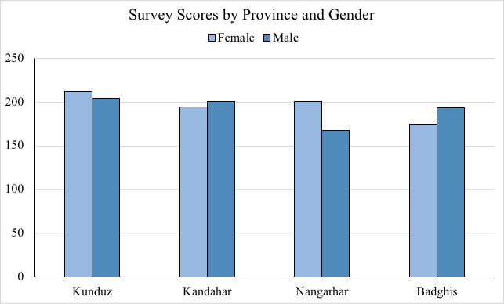
Figure 2 Scores by Province and Gender

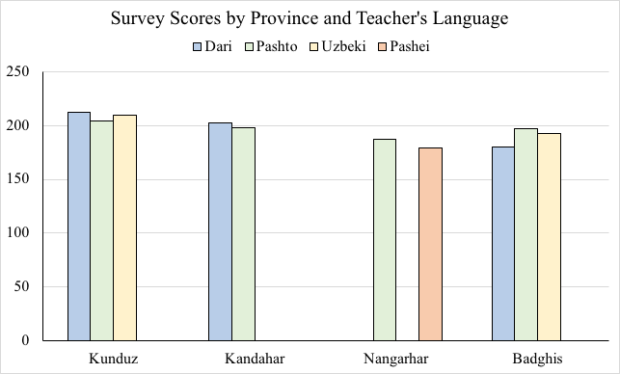
Figure 3 Scores by Province and Teacher's Language

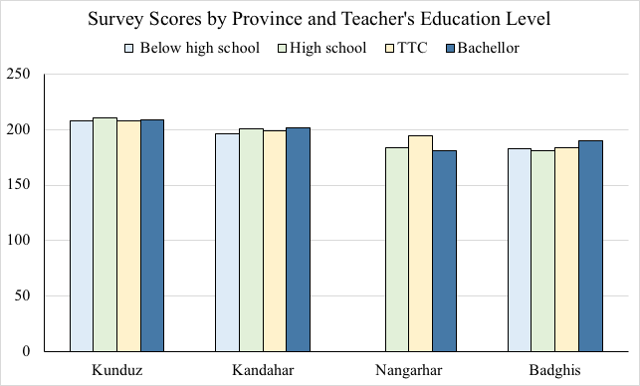
Figure 4 Scores by Province and Teacher's Education Level

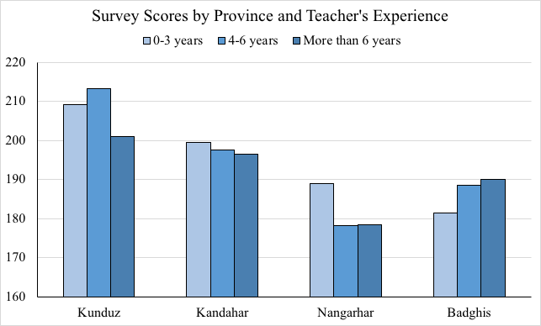
Figure 5 Scores by Province and Teacher's Experience

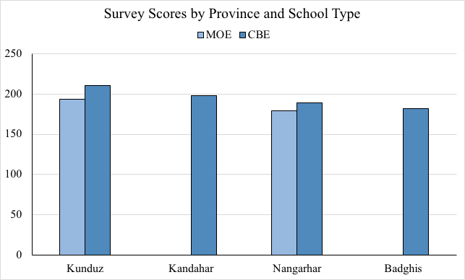
Figure 6 Scores by School Type

Schwarzer, Ralf, and Suhair Hallum. "Perceived Teacher Self‐Efficacy as a Predictor of Job Stress and Burnout: Mediation Analyses." Applied Psychology 57.S1 (2008): 152-71. {NOTE: this information is provided for context and will not appear in the survey questionnaire}
Boyle, G.J., Borg, M.G., Falzon, J.M. and Baglioni, A.J., Jr. (1995), A structural model of the dimensions of teacher stress. British Journal of Educational Psychology, 65: 49-67. doi:10.1111/j.2044-8279.1995.tb01130.x {NOTE: this information is provided for context and will not appear in the survey questionnaire}

